## CORE JAVA

## JAVAC (JAVA COMPILER)

* It checks the given program to find syntax mistakes.
* If there is any syntax mistakes then java compiler throws an error.
* The errors which is throw by javac are called as **compile time errors.**
* The java compiler generates **.class file** if there are no syntax errors in the program.

## JVM (JAVA VIRTUAL MACHINE)

* JVM is an interpreter which is going to
  1. Read one line of code.
  2. Understand it.
  3. Executes it.
* If JVM is not able to understand a line of code then JVM throws an error at runtime.
* The errors thrown by JVM are called as **runtime errors or exceptions.**

## JRE (JAVA RUNTIME ENVIRONMENT)

* It is used to setup the environment in with the help of operating system to execute the program of JVM.

## JDK (JAVA DEVELOPMENT KIT)

* It is a software package which contains java compiler, jvm and other necessary files which are required to compile and executes java programs.

## JAVA WORK FLOW

editor

Javac

(java compiler)

Byte code

JDK

|  |  |  |  |  |
| --- | --- | --- | --- | --- |
|  |  |  |  |  |
| PROCESSOR | | | | |
|  |  |  |  |  |

JRE

DEMO.JAVA DEMO.CLASS

# CHAPTER 1 : KEYWORDS, IDENTIFIERS & VARIABLES

## KEYWORDS

* They are reserved words which have a predefined meaning.
* It is **not possible to change the meaning** of keywords in any programming language.
* Keywords are used to define a class, declare a variables or define a method etc. in java.

## Keywords in Java

|  |  |  |  |  |
| --- | --- | --- | --- | --- |
| Abstract | Continue | For | New | Switch |
| Assert *** | Default | Goto* | Package | Synchorinised |
| Boolean | Do | If | Private | This |
| Break | Double | Implements | Protected | Throws |
| Byte | Else | Imports | Public | Throws |
| Case | Enum**** | Instanceof | Return | Transient |
| Catch | Extends | Int | Short | Try |
| Char | Final | Interface | Static | Void |
| Class | Finally | Long | Strictfp** | Volatile |
| Const* | Float | Native | Super | while |

* not used

** added in 1.2

*** added in 1.4

**** added in 5.0

## IDENTIFIERS :

* It is used to identify class or interface, methods, variables etc.

## Rules of Identifiers :

* Identifiers can be alphanumeric.
* Identifiers should not start with numbers.
* $ and _ (underscore) are the only two special character allow.
* An identifier can start with $ and _.
* Keywords can not be used as identifiers.

## VARIABLES :

* A variables is a **named memory location** which holds the value for the program.
* To use a variables we have to follow three steps :

1. Declaration
2. Initialization
3. Utilization (Usage)

## Declaration of a variables :

**Syntax :**

**Datatype variablename; Eg : int age;**

* It is a statement which defines what type of data will be stored in the given variables.

## Initialization of a variable : Syntax :

**Variable=value;**

**Eg: age=25;**

* It is a statement which is written to store the value into the variable using assignment operator.

## Utilization of a variables:

* Statements which are written to use the values of the variables are called as utilization.

## Primitive Data types in java

|  |  |  |  |  |
| --- | --- | --- | --- | --- |
|  |  |  |  | **Default value** |
| **Integer** | Byte | 8 bits | 1 byte | 0 |
| Short | 16 bits | 2 byte | 0 |
| Int | 32 bits | 4 bytes | 0 |
| Long | 64 bits | 8 bytes | Ol |
| **Decimal** | Float | 32 bits | 4 bytes | 0.0f |
| Double | 64 bits | 8 bytes | 0.0 |

|  |  |  |  |  |
| --- | --- | --- | --- | --- |
|  | Char | 16 bits | 2 bytes | Blank space |
|  | Boolean | 8 bits | 1 bytes | false |

**CHAPTER 2 : OPERATORS**

* It performs operations on the given operands and produce results.

## Arithmatic Operator

* To perform any arithmetic operator

## - +, -, *, /, %

Note- Variables of the program should not be printed with “double quotes”. Note – System.out.print – prints & keep cursor in same line.

System.out.println – Prints & makes the cursor to next line.

## Formula to get how much a datatype maximum and min value range

**-2n-1 to 2n-1-1 Eg : for bytes**

-27 to 27-1

-128 to 127 (bytes)

If we perform any arithmetic operation with the help of arithmetic operators with the help of arithmetic operators the result variables has to be decided by the following method.

## Max(int, type of 1st operand, type of 2nd operand) Program :

**(a)**

class Arithmetic

{

public static void main(String[] args)

{

System.out.println("Program start");

//declaration int a;

int b;

int res;

//initialization a=30;

b=60;

res=a+b;

System.out.println("Value of a");

System.out.println(a); System.out.println("value of b");

System.out.println(b); System.out.println("Addition of a and b");

System.out.println(res); System.out.println("Program end!");

}

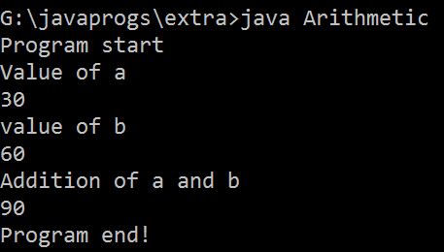}

## (b)

class Arithmetic2

{

public static void main(String[] args)

{

## int a=10; //declaration and initialization at same place

int b=20; int c=a+b;

System.out.println("value of a"+a); System.out.println("Value of b"+b); System.out.println("Addition of a and b"+c);

}

}

## (c )

class ArithmeticOperator

{

public static void main(String[] args)

{

int a=5; int b=10;

System.out.println(a>b); System.out.println(a>=b); System.out.println(a<b); System.out.println(a<=b); System.out.println(a==b); System.out.println(a!=b);

}}

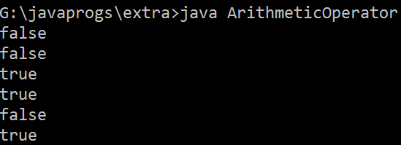

## Concatination Operator

* It helps in concatenating (joining) a string value with any other value.

## Combination of Concatination

* 2+ “hello” – 2hello
* “hello”+123 – hello123
* “hello” + “World” – helloworld
* 2+3+ “hello” – 5hello
* “hello”+2+3 – hello2+3 – hello23
* 2+ “hello”+3 – 2hello3

## Increment & Decrement Operator :

* Those operators are used to increase or decrease the value of a variable by 1 units.

## Increment Operator (++) :

* There are two types of increment operator.

## Pre-increment.

1. **Post-increment.**

* If you write post or pre increment operators with a variables independently without any mathematical of expressions then, both operators will have same results.

|  |  |
| --- | --- |
| **Pre Increment** | **Post increment** |
| First increment | Substitute |
| Substitute | Perform operation |
| Perform operation | Increment value |

* Increment operator can not be used with Boolean dataypes.
* Any value can not be used directly with increment operators.
* Note :

Char a1= ‘A’;

a1 = a1+1; //**can not write like this**

a1=66; a1= ‘B’

## V.V.I notes

|  |  |
| --- | --- |
| **Byte b1=10; B1++; S.o.p(b1);** | **Byte b1=10; B1=b1+1;**  **s.o.p(b1);** |
| **Does not show error** | **Show error just because of max function** |

**Program (a)**

class Increment

{

public static void main(String[] args)

{

System.out.println("Program start"); int a1=10;

int b1=10; int res;

System.out.println("a1 = "+a1); System.out.println("b1 = "+b1);

res=++a1 + 10; System.out.println("res = "+res);

res=b1++ + 10; System.out.println("res = "+res); System.out.println("a1 = "+a1); System.out.println("b1 = "+b1);

res=b1++ + 10; System.out.println("res = "+res); System.out.println("a1 = "+a1); System.out.println("b1 = "+b1);

res=b1++ + 10; System.out.println("res = "+res); System.out.println("a1 = "+a1); System.out.println("b1 = "+b1); System.out.println("Program end");

}}

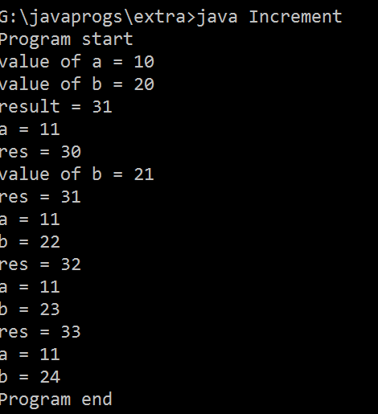

## (b)

class Increment1

{

public static void main(String[] args)

{

System.out.println("Hello World!"); int a1=10;

System.out.println("a1 = "+a1); a1++;

System.out.println( "a1 = "+a1);

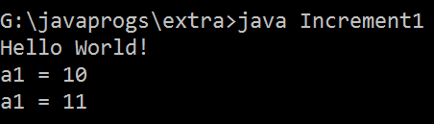}}

## (C)

class Increment2

{

public static void main(String[] args)

{

int a1=10; System.out.println(a1++); System.out.println(++a1);

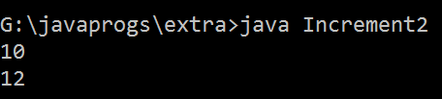}}

## (d)

class Increment3

{

public static void main(String[] args)

{

byte b1=10; b1++;

System.out.println(b1);}}

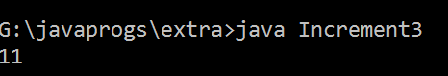

## Decrement Operator: (--)

* Those operators are used to decrease the value of a variable by 1 units.
* There are two types of decrement operator.

1. Pre-decrement
2. Post-decrement

* If you write post or pre decrement operators with a variables independently without any mathematical of expressions then, both operators will have same results.

|  |  |
| --- | --- |
| Pre decrement | Post decrement |
| First increment | Substitute |
| Substitute | Perform operation |
| Perform operation | Increment value |

* decrement operator can not be used with Boolean dataypes.
* Any value can not be used directly with decrement operators.
* Note :

Char a1= ‘B’; a1 = a1-1; a1=65;

a1= ‘A’

# CHAPTER 3 : FLOW CONTROL STATEMENT

* It is a statement which is used to control the execution flow of a program.
* There are two types of flow control statements.

1. Branching Statement (Decision making Statement)
2. Looping Statement

## Branching Statement (Decision Making)

* These statements are used to execute a group of statements based on a Boolean condition.
* The type of decision making are :-

1. If statement
2. If else statement
3. If else if statement
4. Switch case statement

## IF STATEMENT

* If statement executes gives groups of statements within its body only if the Boolean condition result is true.
* Syntax :

If(condition) – true

{

Statement ;

}

## PROGRAM

class IfStatement

{

public static void main(String[] args)

{

System.out.println("Program Start"); int v1=50;

if(v1>10)

{

System.out.println("v1 is greater than 10");

}

System.out.println("Program end");

}

}

## IF-ELSE STATEMENT

* Once the statements written in if block will be executed only if the Boolean condition is true and if Boolean is false then statements of else block will be executed.

## Syntax:

If(condition) true

{

}

Else

{

}

Statement;

Statement;

## Program

class IfElseStatement

{

public static void main(String... args)

{

int a=97;

if (a>b)

{

}

else

{

}

}}

System.out.println("print a");

System.out.println("print b");

## IF-ELSE-IF STATEMENT SYNTAX :

If(Boolean condition 1)

{

Statement;

}

Else if(condition 1 )

{

## Program

}

Else {}

Statement;

class Ifelseif

{

public static void main(String[] args)

{

System.out.println("Program Start"); int marks=25;

if(marks>79 && marks<=100)

{

System.out.println("first class distinction");

}

else if (marks>=60 && marks<=79)

{

System.out.println("first class ");

}

else if (marks>=50 && marks<=59)

{

System.out.println("second class ");

}

else if (marks>=35 && marks <=49)

{

System.out.println("third class ");

}

else if (marks>100)

{

}

else

{

}

}}

System.out.println("Invalid number");

System.out.println("You are fail");

## ** note : logical operator are used to combine multiple conditions.

|  |  |  |  |  |  |  |
| --- | --- | --- | --- | --- | --- | --- |
| **And operator (&&)** | | |  | **Or operator (||)** | | |
| C1 | C2 | Result |  | C1 | C2 | Result |
| T | T | T |  | T | T | T |
| T | F | F |  | T | F | T |
| F | T | F |  | F | T | T |
| F | F | F |  | F | F | F |

**SWITCH CASE**

* It is used whenever we have to compare the given value only equals (==) conditions.
* Switch case statements provides more readability for the program.
* It is not possible to compare the conditions other than equals conditions.
* Syntax : Switch(choice)

{

Case 1: Statement;

Break; Case 2: Statement;

Break; Default : Statement;

}

* Note : Break statement stop the execution of the given block at a given line of code. Writing break statement after default case is not mandatory in switch case statement.

## Program

class Switch

{

public static void main(String[] args)

{

System.out.println("Program Start"); char a='C';

switch(a)

{

case 'A': System.out.println("alphabet A "); break;

case 'C' : System.out.println("aphabet C "); break;

default : System.out.println("Invalid ");

}

}

}

## LOOPING STATEMENTS

* They are used to perform repetitive task in the given program with lesser lines of code.
* Different types of loops are :-

1. For loop
2. While loop
3. Do-while loop
4. For each loop /advanced/enhanced loop

## FOR LOOP (ITERATION) :

* One complete execution cycle of a loop is called as iteration.
* The number of iteration of a loop depends on the condition of the loop.
* Syntax :

For(initialization; condition; counter)

{

Statement;

}

* For loop is a type of loop which is used whenever the logical start and logical end is well defined.

## Basic Program :

Class Basic

{

Public static void main (String ar[])

{ (1) (2) (4)

For(int count=1; count<=3; count++)

{ (3)

System.out.println(“Hello World”);

}

}}

## Op – Hello World

**Hello World Hello World**

Iteration 1st – 1, 2, 3, 4 Iteration 2nd – 2,3,4, Iteration 3rd – 2,3,4

## Tracing :

|  |  |
| --- | --- |
| Count=1  Count<=3, 1<=3, true print hello world | |
| Count=2  Count<=3, 2<=3, true print hello world | |
| Count=3  Count<=3, 3<=3, true print hello world | |
| Count=4  Count<=3, 4<=3, false terminate | |
|  |  |

**Prgm ; wap to print 1 to 5**

Class Pgm2

{

Public static void main (String ar[])

{

For(int i=1; i<=5;i++)

{

System.out.println(i);

}

}}

## Tracing

|  |
| --- |
| I=1  1<=5 true print i=1 |

|  |
| --- |
| I=2  2<=5 return true print i=2 |
| I=3  3<=5 return true print i=3 |
| I=4  4<=5 return true print i=4 |
| I=5  5<=5 return true print i=5 |
| I=6  6<=5 return false for loop terminate |

Pgm : wap to print the numbers between 33 to 74 in descending order.

Class A

{

## Tracing

{

{

}}}

Public static void main (String ar[]) For (int i=74; i>=33;i--) System.out.println(i);

|  |
| --- |
| I=74  74>=33 true print i=74 |
| I=73  73>=33 true print i=73 |
| I=72  72>=33 return true print i=72 |
| I=32  32>=33 return false and terminate |

## Prgm : wap to display only even no between 1 to 100?

For(int i=1; i<=10;i++)

{

If(i%2==0)

{

S.O.P. (i);

}

}

## Tracing

|  |
| --- |
| I=1  I<=10, 1<=10 return true then if block execute and check the condition If(1%2==0) return false so it terminate and return back to for block |
| I=2 |

|  |
| --- |
| I<=10, 2<=10 return true then if block execute and check the condition  If(2%2==0) return true and print 2 and condition goes to again for loop block |
| I=3  I<=10, 3<=10 return true then if block execute and check the condition If(3%2==0) return false so it terminate and return back to for block |
| I=4  I<=10, 4<=10 return true then if block execute and check the condition If(4%2==0) return true and print 2 and condition goes to again for loop block  ----- |
| I=11  I<=10, 11<=10 return false so the for block is terminate and program is end. |

Pgm : wap to display number between 1 to 100 which are divisible by both 2 and 5.

For( int i=1; i<=100;i++)

{

If(i%2==0 && i%5==0)

{

System.out.println(i);

}}

## NESTED FOR LOOPS

* A for loop written within the body of another for loop is called as nested for loop.
* Syntax :

For(initialization; condition; counter)

{

## Pgrm :

For(initialization; condition; counter)

{

Statement ;

}

Statement

}}

Class A

{

Public static void main (String ar[])

{

For(int i=1;i<=3;i++)

{

System.out.println(“outer loop”); For(int j=1; j<=3;j++)

{

System.out.println(“inner loop”);}}}

## Tracing

|  |
| --- |
| I=1  I<=3, 1<=3 return true print outer loop and goes to inner loop J=1  J<=3, 1<=3 return true print inner loop J=2  J<=3, 2<=3 return true print inner loop J=3  J<=3, 3<=3 return true print inner loop J=4  J<=3; 4<=3 return false inner loop terminate and outer loop execute again |
| I=2  I<=3, 2<=3 return true print outer loop and goes to inner loop J=1  J<=3, 1<=3 return true print inner loop J=2  J<=3, 2<=3 return true print inner loop J=3  J<=3, 3<=3 return true print inner loop J=4  J<=3; 4<=3 return false inner loop terminate and outer loop execute again |
| I=3  I<=3, 3<=3 return true print outer loop and goes to inner loop J=1  J<=3, 1<=3 return true print inner loop J=2  J<=3, 2<=3 return true print inner loop J=3  J<=3, 3<=3 return true print inner loop J=4  J<=3; 4<=3 return false inner loop terminate and outer loop execute again |
| I=4  I<=3, 4<=3 return false and terminate outer loop |

**Prgm : wap to print pattern**

*****

*****

*****

For(int i=1;i<=3;i++)

{

For(int j=1;j<=3;j++)

{

System.out.print(“ * ”);

}

System.out.println(); // moves to next line

}

## Tracing

|  |
| --- |
| I=1  I<=3; 1<=3, return true , inner loop is executed J=1  J<=3;1<=3 return true print * J=2  J<=3;2<=3 return true print * J=3  J<=3;3<=3 return true print * J=4  J<=3;4<=3 return false and inner loop is terminated, condition again goes to outer for loop. |
| I=2  I<=3; 2<=3, return true , inner loop is executed J=1  J<=3;1<=3 return true print * J=2  J<=3;2<=3 return true print * J=3  J<=3;3<=3 return true print * J=4  J<=3;4<=3 return false and inner loop is terminated, condition again goes to outer for loop. |
| I=3  I<=3; 3<=3, return true , inner loop is executed J=1  J<=3;1<=3 return true print * J=2 |

|  |
| --- |
| J<=3;2<=3 return true print * J=3  J<=3;3<=3 return true print * J=4  J<=3;4<=3 return false and inner loop is terminated, condition again goes to outer for loop. |
| I=4  I<=3; 4<=3, return false, outer loop is terminated. |

**WHILE LOOP**

Syntax :

While(Boolean_condition)

{

Statement1;

}

* It is a type of looping statement. It is used whenever the logical start and logical end is not well defined.
* Pgm

Int count=1; While(count<=5)

{

System.out.println(count); Count;

}

## DO-WHILE LOOP

**Syntax :**

Do

{

Statement;

}

While(Boolean condition); Prgm :

Int count=1; Do

{

System.out.println(count); Count++;

}

While(count<=5);

# CHAPTER 4 : METHODS IN JAVA

* A method is named block of codes which perform a specific task and it may or may not return a value.

## Syntax

Access_specifier access_modifier return_type name(arg list)

{

Statement; Return;

}

* The return type of the method can be any primitive datatype or class type or void.
* The return statement of the method is used to return the control from method back to calling method
* **Calling method** : A method which is calling another method is known as calling method.
* A method which is called by another method is known as **called method**.
* Every method should be written within only the scope or body of a class.
* No methods will be executed without calling the method.
* If a method is expecting the arguments then you should call the same method by passing the required values matching the datatype.

## Program : Wap to print circumference of circle, perimeter of square, volume of a cube, total surface area of cylinder, and simple interest using method.

class Assignment

{

public static void Circum(double rad)

{

Double cir=2*3.142*rad; System.out.println("circumeferance of a circle is "+cir); return;

}

public static void Square(double side)

{

double perimeter=4*side;

System.out.println("perimeter of a square " + perimeter); return;

}

public static void Cylinder(double rad, double h)

{

double area=2*3.142*rad *(rad+h);

System.out.println("Total surface area of a cylinder is "+area); return;

}

public static void Cube(double side)

{

double volume=side*side*side; System.out.println("Volume of a cube is = " +volume); return;

}

public static void SimpleInterest(double p, double r, double t)

{

double si=(p*r*t)/100; System.out.println("Simple Interest is " + si); return;

}

public static void main(String[] args)

{

Circum(5); Square(5); Cylinder(5,7); Cube(5);

SimpleInterest(1000, 2, 2);

}

}

* If you declare the return type of the methods as **void** then the **method returns only the control** from called method to back o calling method.
* If the return type of the method is void then the written statement will be written by the compiler even if the programmer miss it.

## METHOD WITH RETURN VALUE

* If a method is returning a value then the return type of the method should be a primitive datatype or a class type matching the returned value.
* If a method is returning a value then you should store the returned value within a variables matching the return type of the method.
* From a method we can return only one **single value.**

## Pgm : WAP TO PRINT AVG OF A NUMBER USING METHOD

class Methods

{

public static double calcArea(int a, int b, int c)

{

double avg; avg=(a+b+c)/3; return avg;

}

public static void main(String[] args)

{

double res=calcArea(10,20,30); System.out.println(“res = ” + res*2); double res1=calcArea(20,10,30); System.out.println(“res1 = ” +res1*0.3);

}}

## Op – res = 60.0

**Res1= 9.0**

**METHODS WITH NO ARGUMENTS:**

Class pgm3

{

Public static void displayMsg()

{

S.O.P. (“Hello”);

S.O.P. (“good morning”);

}

Public static void main (String ar[])

{

displayMsg(); displayMsg();

}}

# CHAPTER 5 : ARRAYS (BASICS)

* An array is **homogeneous group** of elements which has **fixed size and index**.
* Using array we can manage the data easily to perform different operations.

## Array Declaration Syntax :

Datatype [] array_name; Eg : int [] marks;

Or Datatype array_name[]; Int marks[];

## Array Creation Syntax :

Array_name = new datatype [size]; Eg marks = new int[5];

Bucket

Index 0 1 2 3 4

## To Declare and Create Array in Single line Syntax :

**Datatype arrayname [] = new datatype [size];**

Eg int marks[]=new int[5];

* After array creation every bucket of the array will be initialize with **default values** according to datatype of the array. For eg. If the datatype of an array is int then all the bucket will be filled with 0. Or if the datatype of an array is Boolean then all the bucket will be filled with false.

## Initialize Array Syntax :

Arrayname[index]=value;

For eg: marks[0]=20;

## Pgm

class Array

{

public static void main(String[] args)

{

int marks[]=new int[5]; marks[0]=67; marks[1]=20; marks[2]=62; marks[3]=85; marks[4]=55;

for(int index=0; index<5; index++)

{

System.out.println(marks[index]);

}

}}

## Op – 67 20 62 85 55

**Length (variables of array):**

* It contains count of number of bucket present in the given array.

## Notes :

* If you know the size of the array and the data to be stored in the array in advance then you can declare and initialize the array in same line.

## Syntax :

**Datatype[] arrayname = {val1, val2….};**

**pgm**

class Array1

{

public static void main(String[] args)

{

String [] days={"mon", "tue", "wed", "thurs", "fri", "sat", "sun"}; for (int index=0;index<days.length;index++ )

{

System.out.println(days[index);

}}}

## ArrayIndexOutOfBoundsException

* Whenever we try to add the elements to array **execiding the size of array**

then JVM throws ArrayIndexOutOfBoundsException.

* If you try to retrieve the elements from the array **execiding the size of the last index of the array** then JVM throws ArrayIndexOutOfBoundsException.

## Pgm

**//wap of array to find first middle and last element of an array**

class Array2

{

public static void printNum(int[] a1)

{

int first=0;

int last=a1.length-1; int mid=last/2;

System.out.println( "first = " +a1[first]); System.out.println( "last = " +a1[last]); System.out.println( "mid = " +a1[mid]);

}

public static void main (String ar[])

{

int num[]={5,1,2,3,5};

printNum(num);

}}

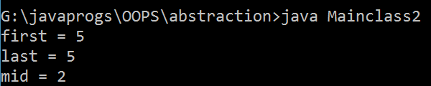

## (ii)

**//wap of array to find first middle and last element of an array**

class Array3

{

public static void printNum(int[] a1)

{

int first=0;

int last=a1.length-1; int mid=last/2;

System.out.println( "first element = " + a1[first]); System.out.println( "last element = " + a1[last]); System.out.println("Mid = " a1[mid]);

}

public static void main (String ar[])

{

int num[]={5,1}; printNum(num);

}}

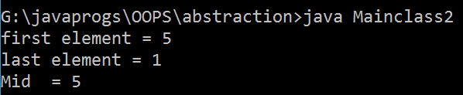

## Notes :

**First Index = 0;**

**Last Index = length -1; Middle Index = last index /2;**

**CHAPTER 6 : STRING IN JAVA (BASICS)**

* A string is group of characters which is written within the double quotes.
* Internally the string will be created with the help of character array.

## Methods of String

1. **Length() –** it returns count of number of character present in the given string.

Eg. S1.length();

1. **Equals()** – this method compares every character present in the given two strings and returns true. If they are same else it returns false.

String s1= “jspider”; String s2= “jspider”; String s3 = “JSPIDER”; S1.equals(s2)- return true;

S1.equals(s3)- return false ;

1. **equalsIgnoreCase()** – this method compares every character in the given two strings by **ignoring their case.** And return true if they are same, else it returns false.

String s1= “jspider”; String s2 = “JSPIDER”;

S1.equalsIgnoreCase(s2)- return true;

1. **charAt () - // charAt(index) –** This method returns the character present at the given index.

S1.charAt(4) – return d ;

1. **toCharArray() –** This function or this method returns the array representation of the given string.

Char arr[] = s1.toCharArray();

## Program

class StringBasic

{

public static void main(String[] args)

{

String s1="jspider"; String s2="jspider"; String s3="JSPIDER";

int len = s1.length(); System.out.println("Length of String = " +len);

boolean res1=s1.equals(s2); System.out.println("Equals or not = " +res1);

boolean res2=s1.equals(s3); System.out.println("Equals or not = " +res2);

boolean res3=s1.equalsIgnoreCase(s3); System.out.println("Equals or not = " +res1);

char c1=s1.charAt(4); System.out.println("Character at index = " +c1);

char [] ar1=s1.toCharArray();

for(int index=0; index<ar1.length;index++)

{

System.out.print(ar1[index]);

}

}}

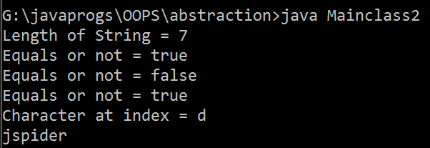

# OBJECT ORIENTED PROGRAMMING SYSTEM CHAPTER 1 : CLASS & OBJECTS

**OBJECTS :** Any entity which has states and behaviour is called as objects. For eg. Pen, account, building.

|  |  |  |  |  |  |
| --- | --- | --- | --- | --- | --- |
| **Pen** | | **Account** | | **Student** | |
| **State** | **Behaviour** | **State** | **Behaviour** | **State** | **Behaviour** |
| Color | Writing | a/c no. | Debit | Name | Studying |
| Brand | Drawing | Type of ac | Credit | Id | Exam |
| Shape | Pointing | Bank name | Payment | Gender | Reading |
| Price | ….. | Balance  …. etc | ….. | Age | writing |

## CLASS : -

* A class is blueprint of an objects.
* A class contains or defines states and behaviours of an objects.
* The states of the class are called as data members and the behaviours of the objects are called as function members.
* The data members of the class are represented by variables and the functions members of the class are represented by methods.

## JAVA NAMING CONVENTION :

**Class :**

* Any entity in java which starts with upper case declared with the keyword class is called as java class.
* Class names should be nouns, in mixed case with first letter of each internal word capitalize.

Eg. Account, AccountName;

## Interface :

* Any entity in java which starts with upper case and declared with the keyword interface is called java interface.
* Interface name should be capitalize like class name.
* Eg. : interface Storing, interface RunnableInterface

## Methods :

* It defines the action which is performed on data members of the class.
* Methods should be in mixed case with the first letter lower case, with the first letter of each internal word capitalize.
* Eg : run(), getData()

## Variables :

* Variables should be declared in mixed case with a lowercase first letter.

Internal words starts with capital letters.

* Eg: i, c, myWidth;

## Constants :

* The constants should be all uppercase with words separated by underscore (“ _” ).
* Eg. MIN_WIDTH = 5;

The members of class be classified into two types :

1. Static Members (b) Non-Static members

## Static members

* Any members of the class which is declared using static keyword is called as static members.

## Static Members present in Same Class:

* If a static method is trying to access the static members present in the same class then it can refer to them directly with the name of static member.

## Program

class Demo

{

static int v1=100; public static void test()

{

System.out.println("this is test() of demo class");

}

public static void main (String ar[])

{

System.out.println("V1 is = " + v1); test();

}}

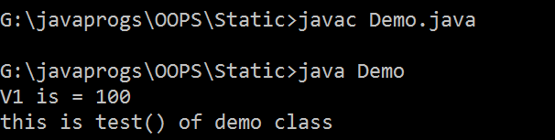

## Program 2

class Demo

{

int v1=100; public static void test()

{

System.out.println("this is test() of demo class");

}

public static void main (String ar[])

{

System.out.println("V1 is = " + v1); test();

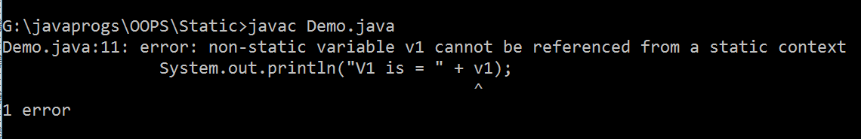}}

## Note : - A non static variable can not be referenced by a static context.

Note : **

* Within one java program we can write any number of class.
* If a program contains multiple classes then the class which contains main method should be used as filename.

## Static Members Present in Different Class :

* We can access static members of different class using the classname with dot(.) operator followed by member name.
* Syntax :

## className.memberName; className.memberFunction();

**Note : we can not use static member in different class directly. If we use it throw error.**

**Program**

**// static member used by static method use in different class directly.**

class Demo

{

static int v1=100; public static void test()

{

System.out.println("this is test() of demo class");

}}

class MainClass

{

public static void main (String ar[])

{

System.out.println("V1 is = " + v1); test();

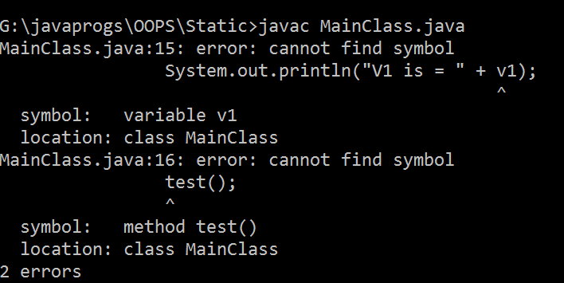}}

## Program :

**// static member used by static method use in different class by classname.member**

class Demo

{

static int v1=100; public static void test()

{

System.out.println("this is test() of demo class");

}}

class MainClass2

{

public static void main (String ar[])

{

System.out.println("V1 is = " + Demo.v1); Demo.test();

}}

## NON-STATIC MEMBERS :

* Any member of the class which is declared without using static keyword is called as non-static members.
* We can access non-static members of a class only by creating the object for the class.

## Object creation

**Syntax :**

**New className()**

Eg.

New Sample()

Here New is a keyword which creates a new object and Sample() is a **constructor call** which copy all the non-static member to object.

* A non static method can access non-static data members or non static function members present in the same class without creating any object.

## Program : calling non-static member and method from main method in a single class by not creating any object

class Abc

{

int z1=123;

public void view()

{

System.out.println("this is view() of Abc"); System.out.println("value of a = " + z1);

}

public static void main(String[] args)

{

System.out.println("Z1 = " + new Abc().z1); new Abc().view();

}}

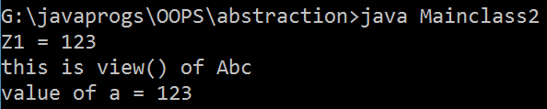

## Program :

**// use of non static members and function in other class**

class Mainclass

{

double k1=123.45; public void count()

{

System.out.println("this is view() of Demo");

}}

class Mainclass2

{

public static void main(String[] args)

{

System.out.println("Program Strts "); System.out.println("k1 = " + new Mainclass().k1); new Mainclass().count(); System.out.println("Progrm end " );

}

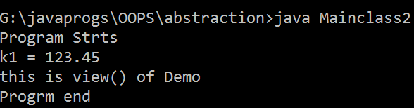}

## Program // static member used by static method use in same class

class Demo

{

static int v1=100; public static void test()

{

System.out.println("this is test() of demo class");

}

public static void main (String ar[])

{

System.out.println("V1 is = " + v1); test();

}}

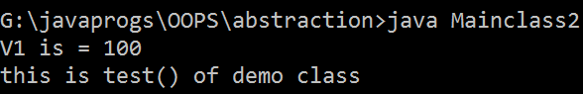

## Program // static member used by static method use in different class.

class Demo

{

static int v1=100; public static void test()

{

System.out.println("this is test() of demo class");

}}

class MainClass

{

public static void main (String ar[])

{

System.out.println("V1 is = " + Demo.v1); Demo.test();

}}

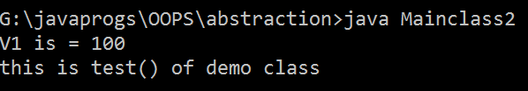

# CHAPTER 2 : REFERENCE VARIABLES

Demo d1 = new Demo ();

* It is a type of variables which is used to store the **address of the objects.**

class RefVariable

{

public static void main(String[] args)

{

RefVariable r = new RefVariable(); System.out.println( " Address of Variable r = " +r);

}}

## // output Address of variable r = RefVariable@6073f712

* **Within a reference variables we can not store any primitive data values.**

class RefVariable

{

public static void main(String[] args)

{

int r = new RefVariable(); // **it throw error here**

System.out.println( " Address of Variable r = " +r);

}

}

## Multiple reference variable can point to same objects.

Demo r1 = new Demo(); Demo r2 = r1;

class RefVariable

{

public static void main(String[] args)

{

RefVariable r = new RefVariable(); RefVariable r2=r;

System.out.println( " Address of Variable r = " +r); System.out.println( " Address of Variable r1 = " +r2);

}

}

## // output Address of variable r = RefVariable@6073f712

**// output Address of variable r2 = RefVariable@6073f712**

* **If multiple reference variables are pointing to same object then changes done through one reference variables will impact other reference variables.**

class RefVariable

{

int r = 20;

public static void main(String[] args)

{

RefVariable r1 = new RefVariable();

System.out.println( " value of r1 = " +r1.r);

r1.r=30; .//reinitalize the value of r by using the object System.out.println( " Address of Variable r = " +r1.r);

RefVariable r2 = r1; System.out.println("Value of r2 = " +r2.r);

}

}

* Static members are called as class members because they can be accessed using the classname.
* Non static members are called as instance members because they can be accessed only by creating the object or instance.
* Static members of the class will have only one copy in the memory.

Static int v1 = 50;

/S.O.P (Sample.v1); Sample.V1=50;

* Non-static members will have multiple copies in the memory depending on number of objects created.

Int v1= 100;

S.O.P ( new Simple().V1);

S.O.P (new Simple().V2);

## Program

class Account

{

int actno=12345; String name = "Dinga";

String branch = "basvangudi"; double balance = 5000;

String type = "Savings";

static String bankName = "ICICi";

public void deposit(int amt)

{

balance = balance+amt;

}

public void withdraw (int amt)

{

balance = balance-amt;

}

public void checkBalance()

{

System.out.println(" Avaialable balance "+balance);

}

public void showAccount()

{

System.out.println("act no = "+actno); System.out.println("name = "+name); System.out.println("brnch = "+branch); System.out.println("balance = "+balance); System.out.println("acount type = "+type);

System.out.println("acount type = "+bankName);

}

}

class MainAccount

{

public static void main (String ar[])

{

Account a1=new Account(); a1.checkBalance(); System.out.println(); a1.deposit(5000); a1.checkBalance();

System.out.println(); a1.withdraw (2000); System.out.println(); a1.checkBalance();

a1.showAccount();

}

}

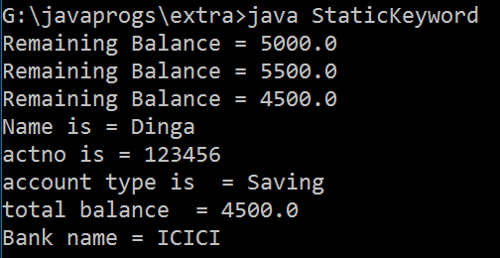

## GLOBAL AND LOCAL VARIABLES

**VARIABLES**

GLOBAL LOCAL

STATIC NON-STATIC PRIMITIVE REFERENCE PRIMITIVE REFERENCE

PRIMITIVE REFERENCE

## GLOBAL VARIABLES

* A variables which is declared within the scope of the class is called as global variables.
* Global variables can be accessed by all the methods present in the present in the same class.

## LOCAL VARIABLES

* Any variables which is declare within the method declaration or method definition are called as local variables.
* Local variables can be accessed only within the methods in which they are declared.
* Local variables can not be declared as static or non static.

## Program : Declaration of local and global variables

class Abc

{

int z1=123; // global variables public static void view()

{

int y = 20; // local variables System.out.println("Value of y = " +y)

}

public static void main(String[] args)

{

System.out.println("Z1 = " + new Abc().z1); new Abc().view();

}}

## Program : local variable can not used outside the method.

class Abc

{

int z1=123;

public void view()

{

int a = 20;

System.out.println("this is view() of Abc"); System.out.println("value of a = " + z1); System.out.println("value of a = " + a);

}

public static void main(String[] args)

{

System.out.println("Z1 = " + new Abc().z1);

new Abc().view();

System.out.println("value of a = " + a); // **throws an error**

}

}

## If variables and local variables have same names then the compiler always give the preference to local variables.

class Abc

{

static int z1=123;

public static void main(String[] args)

{

int z1=400; System.out.println("Z1 = " + z1);

}

}

## // output z1 = 400

* **If we want to use both variables together then use classname.variablename**

class Abc

{

static int z1=123;

public static void main(String[] args)

{

int z1=400; System.out.println("Z1 = " + z1);

System.out.println("Z1 = " + Abc.z1);

}

}

## // output z1 = 400

**// output z1 = 123; Important notes :**

* Using the object of class we can access both static and non static members of the class.
* It is strictly not recommended to access static members of the class using objects.
* Global variables (both static and non-static) will be initialized by the compiler with the default values depending on the datatype.

## Local variables should be initialized by the programmer explicitly.

**Program**

class Global2

{

static double x1 ;

public static void main(String[] args) { int z1;

System.out.println("Value of x1 = "+x1); System.out.println("Value of z1 = " + z1);

## /* here z1 is not initialized so it show an error. but for x1 it does not show any error.

**it take default value of x1 according to theri data type.*/**

}

}

## DECLARING CONSTANTS :

* Final keyword is used to declare constants in java.
* If you declare any variables with final keyword then it can not be re- initialized.
* If you declare any class with final keyword then the class can not be inheritated.
* If you declare any method with final keyword then it can not be overridden.

## Program

class Constants

{

final double PI=3.142;

public void area1 (int a)

{

double ar= PI*a*a;

System.out.println("Area of 1st Circle" + ar);

}

public void area2 (int a)

{

double ar= PI*a*a;

System.out.println("Area of 1st Circle" + ar);

}

public static void main(String[] args)

{

Constants c=new Constants(); c.area1(5);

c.area2(10);

}

}

## Note : we can not re-initialize any constant value. If we do then it throw an error

Program

class Constants

{

final double PI=3.142;

public void area1 (int a)

{

## PI=4525; here it throw error as cannot assign a value to final variables.

double ar= PI*a*a;

System.out.println("Area of 1st Circle" + ar);

}

public static void main(String[] args)

{

Constants c=new Constants(); c.area1(5);

}

}

## JVM ARCHITECTURE

STATIC POOL

METHOD AREA

HEAP

STATCK

**Stack**

* Any method which is in execution state will be present in stack.

## Method Area

* It contains method definition of both static and non-static methods.

## Static Pool

* It contains static members in the respective static pools of the respective classes.

## Heap

* Every object which is created using new operator will be present in heap area.

## Program

class Sample

{

static int v1 = 351; double v2 = 2.5; public static void test()

{

System.out.println("This is test()"); return;

}

public void test1()

{

System.out.println("this is test1()");

}

}

class Jvm

{

public static void main(String[] args)

{

System.out.println("Value of V1 = " + Sample.v1); Sample.test();

Sample s = new Sample(); System.out.println("Value of V2 " + s.v2); s.test1();

}

}

**Static pool**

Sample.class

Test() V1=351

Psvm()

Jvm.class

{

…..

}

**Method area**

{ ……

}

**Stack**

**Heap**

Binding here

Psvm()

{ S S2

}

V=2.35

Test1()

V=2.35

Test1()

Javac Jvm. Java

Jvm.class

Sample.clas s

Jvm.class

Java Jvm

## Important Notes :

* JVM starts the execution of the program by **calling classloader** to load the .class file to the memory.
* The class loader copies all the **static members** of the given class **to static pool** into the respective static pools of classes.
* Once class loader loads the class file JVM calls method for the execution.
* If the given class do not contain main method or main method not defined as **public static void main (String ar[])** then JVM will throw a runtime errors.
* JVM binds method declaration to method definition and loads it into the stack and executes the methods.
* If the main method is referring to static members of different class or if we are creating an object of a different class then the corresponding .class file of the given class will be loaded into the memory.
* Once the method completes the execution will be removed out of stack.
* Once the program completes the execution **JVM calls the classloader** to unload the .class file from the memory.
* The class loader removes all static members present in static pool.
* JVM also calls the **garbage collector** to remove all the objects present in the heap memory.

# CHAPTER 3 : CONSTRUCTOR IN JAVA

* Constructor is a special type of method which has same name as the classname.
* Every java class must and should have a constructor.
* If the programmer do not write a constructor then compiler writes default constructor implicitely.
* Constructor can not be declared as static.
* Constructor can not be declared as final.
* If you write return type for a constructor then it will be considered as a normal method.
* We can write return statement within the constructor body.
* The constructor can be executed only by creating an objects.
* Constructors can not be called explicitely using the object.
* Constructor are of two types : (a) zero or default constructor (b) parameterized constructor.

## If a programmer writes the constructor explicitely then the compiler do not write default constructor implicitely.

**Program for simple constructor**

class Sample

{

public Sample()

{

System.out.println("This is sample const...");

}

}

class SimpleConstructor

{

public static void main(String[] args)

{

Sample s = new Sample();

}

}

## -op- This is sample const…

**//if we dont initialize the member then it print the default value.**

class Sample

{

String name; int id; double sal;

public Sample()

{

}

public void display()

{

System.out.println(" name is = " + name);; System.out.println(" id is = " + id);; System.out.println(" salary is = " + sal);;

}

}

class DefaultValue

{

public static void main(String[] args)

{

Sample s = new Sample(); s.display();

}

}

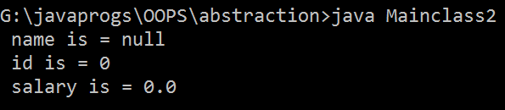

## Constructor are used to initialize the data members (static and non static) of the class.

**Parameterized Constructor**

class Sample

{

String name; int id; double sal;

public Sample(String a, int b, double c)

{

// System.out.println("This is sample const..."); name=a;

id=b; sal=c; return;

}

public void display()

{

System.out.println(" name is = " + name);; System.out.println(" id is = " + id);; System.out.println(" salary is = " + sal);;

}

}

class ParameterizedConstructor

{

public static void main(String[] args)

{

Sample s = new Sample("Ajay", 101, 2000); s.display();

Sample s2 = new Sample("Rohit", 102, 2500); s2.display();

}

}

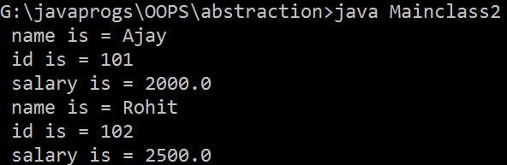

# CHAPTER 4 : THIS KEYWORD AND THIS STATEMENT()

## This keyword

* **It is used to differentiate between local and global variables whenever they have same names.**

class Sample

{

String name; int id; double sal;

public Sample(String name, int id, double sal)

{

// System.out.println("This is sample const..."); this.name=name;

this.id=id;

this.sal=sal; return;

}

public void display()

{

System.out.println(" name is = " + name);; System.out.println(" id is = " + id);; System.out.println(" salary is = " + sal);;

}}

class ThisOperator

{

public static void main(String[] args)

{

Sample s = new Sample("Ajay", 101, 2000); s.display();

Sample s2 = new Sample("Rohit", 102, 2500); s2.display();

}}



* This keyword is a special **type of reference variables** which always points to active or current instance of the class.

## This keyword can not be used within the static method.

* This keyword can be used only within the non-static methods and constructors of the class.

## // we can not like do this, it print the default values of global variables.

class Demoa

{

String name; int id; double sal;

public Demoa(String name, int id, double sal)

{

name=name; id=id; sal=sal;

}

public void disp()

{

System.out.println("name is = "+this.name); System.out.println("id is = "+this.id); System.out.println("sal is = "+this.sal);

}

public static void main(String[] args)

{

Demoa a = new Demoa("ajay", 101, 1020.05); a.disp();

}

}

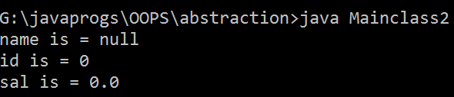

## Program

**//use of this keyword**

class SampleThis

{

int x1; double y1;

public SampleThis()

{

System.out.println("this is sample()");

}

public void test()

{

System.out.println("this = "+this);

}

public static void main(String[] args) { SampleThis s1=new SampleThis(); SampleThis s2=new SampleThis(); System.out.println(" s1 = "+s1); s1.test();

System.out.println(" s2 = "+s2); s2.test();

s1.test();

}}

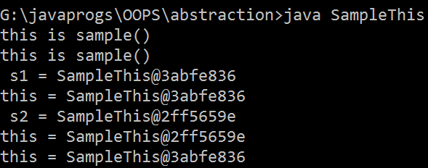

## This keyword differentiate between global and local variables.

For eg :

SampleThis s1=new SampleThis(); this S.O.P.(s1);

S1.test() ;

SampleThis s2=new SampleThis(); S.O.P.(s2); this

S2.test() ;

X1=0 Y1=0

Test()

{ s.op.(this)

}

X1=0 Y1=0

Test()

{ s.op.(this)

}

In the above example firstly this keyword references to s1 object because at that time it is active. But when s2 is active this keyword reference to s2 object.

## Constructor Overloading

* Developing multiple constructor within the same class which differ in
  1. No. of arguments
  2. Datatypes of arguments
  3. Sequence of arguments. Is called as constructor overloading.

## Program

class ConstructorOverloading

{

public ConstructorOverloading()

{

System.out.println("this is zero argument constructor");

}

public ConstructorOverloading(int a)

{

System.out.println("this is int a constructor");

}

public ConstructorOverloading(double a)

{

System.out.println("this is double a constructor");

}

public ConstructorOverloading(int a, double b)

{

System.out.println("this is int a, double b");

}

public ConstructorOverloading(double b, int a)

{

System.out.println("this is double b, int a ");

}

public static void main(String[] args)

{

ConstructorOverloading c1=new ConstructorOverloading(); ConstructorOverloading c2=new ConstructorOverloading(5); ConstructorOverloading c3=new ConstructorOverloading(10.2); ConstructorOverloading c4=new ConstructorOverloading(5,10.2); ConstructorOverloading c5=new ConstructorOverloading(2.5, 7);

}

}

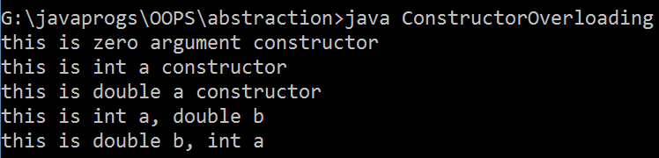

* Constructor overloading is helpful in providing flexibility for the users to create the objects.
* Constructor overloading is the best example for compile time polymorphism.

## This() statement

* **It is used to call one constructor from another constructor which are present in same class.**

class Sample

{

public Sample()

{

this(10); **// call the argumented constructor**

System.out.println("this is zero -a argument const");

}

public Sample(int a)

{

System.out.println("This is int a const...");

}

}

class ThisStatement

{

public static void main(String[] args) { Sample s=new Sample();

}

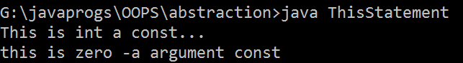}

## This() statement should be written as first statement within the constructor body.

public Sample()

{

this(10); **//** call the argumented constructor System.out.println("this is zero -a argument const"); This(10); **if we write like this then it throw error.**

}

public Sample(int a)

{

System.out.println("This is int a const...");

}

## We can not write multiple this() statement within the constructor body.

public Sample()

{

this(10); **//** call the argumented constructor

## this(20); // if we write like this it throws an error

System.out.println("this is zero -a argument const");

}

public Sample(int a)

{

System.out.println("This is int a const...");

}

## The called constructor can not call back calling constructor using this() statement because it leads to recursive constructor invocation error.

public Sample()

{

this(10); **//** call the argumented constructor System.out.println("this is zero -a argument const");

}

public Sample(int a)

{

## This(); // if we call like this then it throw error.

System.out.println("This is int a const...");

}

## The constructor can not call itself with this statement, because it leads to recursive constructor invocation.

public Sample()

{

## this(); // calling itself which throws an recursive constructor invocation

System.out.println("this is zero -a argument const");

}

public Sample(int a)

{

System.out.println("This is int a const...");

}

## Simple this() statement program

class Sample

{

public Sample()

{

this(10);

System.out.println("this is zero argument const");

}

public Sample(int a)

{

System.out.println("This is int a const...");

}

}

class ThisStatement

{

public static void main(String[] args) { Sample s=new Sample();

}}



## RELATION BETWEEN CLASSES IN JAVA

* The relations between the classes helps in achieving two goals.

1. Reduce no. of lines of code.
2. Code reusuability

* There are two types of relations.

(i) Has-A relation (ii) Is-A relation

## Has-A Relation:

* It is a type of relation which is created based on the dependency of one object on the another object.
* It is of two types : (i) Aggreation (ii) Composition

Has-A

Has –A

omposition

**student**

Aggregation

Library

College

## Aggregation :

C

* It is a type of Has-A relation where existence of one object is not dependent on another object.
* The aggregation is achieved by creating a static reference variable pointing to the object of another class.

## Program

class Sample

{

String name; int id;

int nbo; String branch;

public Sample(String name, int id, int nbo, String branch)

{

this.name=name; this.id=id; this.nbo=nbo; this.branch=branch;

}

public void showDetails()

{

class Library

{

System.out.println("Name = "+name); System.out.println(" id = " + id); System.out.println ( " no of book issued " +nbo); System.out.println(" branch = "+branch);

}}

## /*creating a static reference variable of class Sample where s1 points to object of Sample()*/

static Sample s1 = new Sample("aatif", 101, 2, "cse"); public static void issueBook()

{

}

}

class Program1

{

System.out.println("book is issued to "+s1.name); s1.nbo++;

public static void main(String[] args)

{

## //calling the methods of sample class by using the object

Library.s1.showDetails(); Library.issueBook();

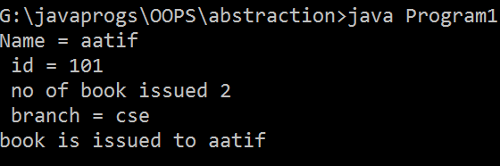}}

Note : System.out.println() is the best example of aggregation has-A relation which helps in hide the class. Here println() method is the method of printStream class.

## Composition

* It is a type of Has-A relation where existence of one object is dependent on another object.
* The aggregation is achieved by creating a **non-static reference variable**

pointing to the object of another class.

## Program

class Attachment

{

String name; double size; String type;

public Attachment(String name, double size, String type)

{

this.name=name; this.size=size; this.type=type;

}

public void showDetails()

{

System.out.println(" Attachment name = "+name); System.out.println("File size = "+size +"kb"); System.out.println("File type = "+type);

}

}

class Email

{

String sender; String subject; String msg;

Attachment a1=new Attachment("file1", 2.5, "txt" ); public Email(String sender, String subject, String msg)

{

this.sender=sender; this.subject=subject; this.msg=msg;

}

public void openMail()

{

System.out.println(" sender name = "+sender); System.out.println("subject = "+subject); System.out.println("msg = "+msg);

} }

class Composition

{

public static void main(String[] args)

{

Email e1=new Email[("A](mailto:Abc@gmail.com)b[c@](mailto:Abc@gmail.com)g[mail.com](mailto:Abc@gmail.com)", "java language", "hello");

e1.openMail(); e1.a1.showDetails();

}}

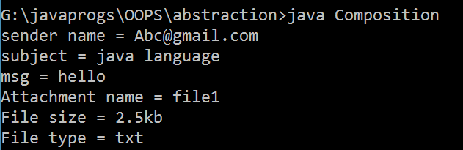

## Class Diagram

* It is a pictorial representation of a class.
* Class diagram helps in low level design (LLD) of the application.

|  |
| --- |
| **Class Name** |
| **Data member :data type Data member2 : data type**  **…**  **…** |
| **Classname()**  **methodName1 : return type methodName2: return type** |

|  |
| --- |
| **employee** |
| **name :string id: int sal:double deptno:int** |
| **Employee(name, id, sal, deptno) showDetail : void** |

Eg:

Eg of account class

|  |
| --- |
| **Account** |
| **Actno : int**  **Name : string Branch : string Balance : double Type : String**  **Bankname : string** |
| **Deposit(int amt) : void Withdraw (int amt) : void checkBalance : void showAcnt : void** |

## Representation of Has-A relation using class Diagram

|  |
| --- |
| **Library** |
| **S1 : library** |
| **issueBooks : void** |

|  |  |
| --- | --- |
| 1:n | **Student** |
| **Name : string Id : int**  **Mob : int**  **Branch : String** |
| Aggregation |
| **Student(name, id, mob, branch) showDetails : void** |



|  |
| --- |
| **Email** |
| **A1 : attachment Sender : string Subject : string Msg : string** |
| **Email (sender, subject, msg) openMail : void** |

|  |  |
| --- | --- |
| 1:n | **Attachment** |
| **Name : string Size : int Type : String** |
| Composition |
| **Attachment(name, size, type) showDetails : void** |

# CHAPTER 5 : INHERITANCE IN JAVA (IS-A RELATION)

* One class acquiring the properties of another class is called as inheritance.
* The class from where the properties are inherited is called as super class, base class or parent class.
* The class which is inheriting properties from another class is called as subclass, derived class or child class.
* Inheritance between the classes is achieved with the help of **extends**

keywords.

* Using the child class objects we can access properties of both child class and parent class.
* We can access both static and non-static members of the parent class from child class object.

## Simple Program

class Parent

{

int x1=50;

public void display()

{

System.out.println("this is display() of parent class");

}

}

class Child extends Parent

{

int y1=100;

public void test()

{

System.out.println("this is test() method of child

class");

}

}

class SimpleInheritance

{

public static void main(String[] args)

{

Child c1=new Child(); c1.display();

System.out.println("Value of x1 = "+c1.x1); c1.test();

System.out.println("Value of y1 = "+c1.y1);

}

}

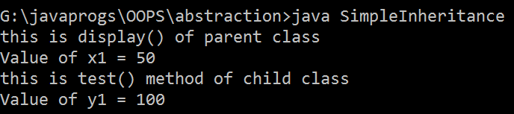

## Final class can not be inherited.

final class Super1 **// it can not be inherited**

{

int a =50;

}

class Child extends Super1

{

int d=10;

public void test()

{

System.out.println("this is child class " +d);

}}

class FinalClass{

public static void main(String[] args) { Child c = new Child();

c.test();

}}

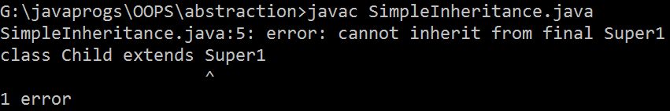

## Private members, data members and functions members can not be inherited.

class Super1

{

private int a =50;

}

class Child extends Super1

{

int d=10;

public void test()

{

System.out.println("this is child class " +d); System.out.println("this is super class" + a);

## // here it return error as a has private access in super

}}

class FinalClass{

public static void main(String[] args) { Child c = new Child();

c.test();

}

}

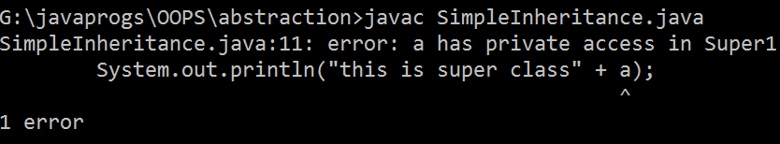

## Constructor of super class can not be inherited to subclass. Because constructor should be in a same class.

* **Subclass can inherit final data members but it can not re-initialize them.**

class Super1

{

final int A =50;

class Child extends Super1

{

int d=10;

public void test()

{

System.out.println("this is child class " +d); System.out.println("this is super class " + A);

}}

class FinalClass{

public static void main(String[] args) { Child c = new Child();

c.test();

## c.A=60; /* here it throws an error that final value can not be reinitialize */

System.out.println(c.A);

}

}

## Subclass can inherit final method of super class but can not override it.

* The types of inheritance are :

1. Single Inheritance
2. Multi-level inheritance
3. Multiple inheritance
4. Hierarchical inheritance
5. Hybrid inheritance

## Single Inheritance

* One subclass acquiring or inheriting properties of one superclass is called as single inheritance.

Parent

child

## Program

class Super1

{

int a =50;

}

class Child extends Super1

{

int d=10;

public void test()

{

System.out.println("this is child class " +d); System.out.println("this is super class " + a);

}}

class FinalClass{

public static void main(String[] args) { Child c = new Child();

c.test();

}}

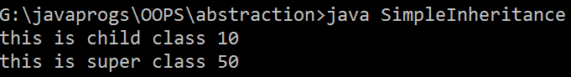

## Multi-level inheritance

* One sub-class inheriting from one super class and that super class is inheriting from another super class is called as multilevel inheritance.

Class v1

Class v2 extends v1

Class v3 extends v2

## Program

class WhatsappV1

{

public void msg()

{

System.out.println("this is msg ()");

}

}

class WhatsappV2 extends WhatsappV1

{

public void voiceMsg()

{

System.out.println("this is voice msg " );

}}

class WhatsappV3 extends WhatsappV2

{

public void video()

{

System.out.println("This is video ()");

}

}

class MultilevelInheritance{

public static void main(String[] args) { WhatsappV3 v=new WhatsappV3(); v.msg();

* 1. oiceMsg();
  2. deo();

## only object creation to see which class to call which method

WhatsappV2 v2= new WhatsappV2(); v2.msg();

v2.voiceMsg();

WhatsappV1 v1= new WhatsappV1(); v1.msg();

}

}

## Multiple Inheritance

* One subclass inheriting from two or more superclass is called as multiple inheritance.



Subclass

SuperClass 2

SuperClass 1

## Java does not support multiple inheritance Hierarchical inheritance :

* One superclass extended by two or more subclass is called as hierarchical inheritance.

Superclass

|  |  |  |  |  |
| --- | --- | --- | --- | --- |
|  |  | | |  |
| subclass | |  | Subclass | |

* Using hierarchical inheritance we can achieve **generalization.**
* Defining the common methods and variables of sublclass in one superclass is called as **Generalization.**
* Developing methods and variable specific to one class is called as

## specialization.

**Program**

class Account

{

public void createAccount()

{

System.out.println("Your account is created");

}

}

class SavingAcnt extends Account

{

public void showSavings ()

{

System.out.println("Your saving account is 2000");

}

}

class LoanAcnt extends Account

{

public void showLoan()

{

System.out.println("Your pending loan is 3000");

}

}

class HierarchialInheritance

{

public static void main(String[] args)

{

LoanAcnt l = new LoanAcnt(); l.createAccount(); l.showLoan();

SavingAcnt s = new SavingAcnt(); s.createAccount(); s.showSavings();

}

}

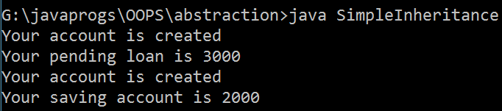

## Hybrid Inheritance

* In this this combination of different type of inheritance.



LoanAcnt

savingAcount

Acnt

## SUPER(); STATEMENT

Car loan

Home loan

* **It is used to call the super class constructor from subclass constructor.**

class Super1

{

public Super1()

{

System.out.println("this is super constructor");

}

}

class Base extends Super

{

public Base()

{

super();

System.out.println("this is base constructor");

}

}

class SuperStatement

{

public static void main(String[] args) {

Base b = new Base();

}}

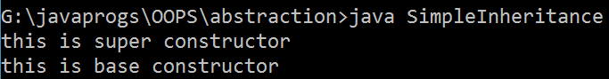

* Super statement can be written explicitely by the programmer or implicitely by the compiler.

## Super(); statement should be written the first line of constructor body.

class Super1

{

public Super1(int a )

{

System.out.println("this is super constructor");

}

}

class Base extends Super

{

public Base()

{

System.out.println("this is base constructor");

## super(); // here it throws an error because super statement is always in first line

}

}

class SuperStatement

{

public static void main(String[] args) {

Base b = new Base();

}

}

## Multiple super statement within the same constructor body is not allowed.

class Super1

{

public Super1(int a )

{

System.out.println("this is super constructor");

}

}

class Base extends Super

{

public Base()

{

super();

## super(); // here it throws an error because super statement is always in first line

System.out.println("this is base constructor");

}}

class SuperStatement

{

public static void main(String[] args) {

Base b = new Base();

}}

## If the superclass contains only parameterized constructor then the programmer should write super statement explicitely and pass the required argument value.

**Program**

class Super1

{

public Super1(int a )

{

System.out.println("this is super constructor");

}

}

class Base extends Super1

{

public Base()

{

super(10); // **calling the argumented constructor**

System.out.println("this is base constructor");

}

}

class SimpleInheritance

{

public static void main(String[] args) { Base b = new Base();}}

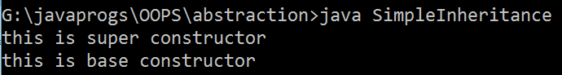

## If super class have constructor overloading then to call all these methods.

**Program**

class Super1

{

public Super1(int a)

{

this(10,20); //**call the constructor here**

System.out.println("this is super constructor");

}

public Super1(int a, int b)

{

System.out.println("this is ");

}}

class Base extends Super1

{

public Base()

{

super(10); // **calling the superclass constructor**

System.out.println("this is base constructor");

}}

class SimpleInheritance

{

public static void main(String[] args) { Base b = new Base();

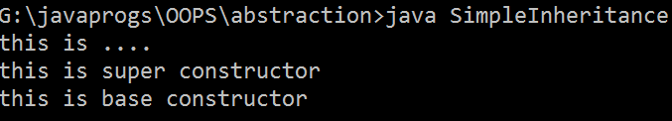}}

## Object class

* It is the supermost class in java. Every class in java directly or indirectly extends from object class.
* If the class is not extending from any class then the compiler makes the object class as superclass by writing “extends object” implicitely.

## Constructor chaining

* Subclass constructor calling super class constructor, superclass constructor calling object class constructor is called as constructor chaining.

## Note :

* **within the same constructor body it is not possible to write both this() statement**

class Super1 extends Object

{

public Super1()

{

System.out.println("this is super constructor");

}

}

class Base extends Super

{

public Base()

{

## be first line

}

}

this();

## super(); // here it throws an error that superl ine should

System.out.println("this is base constructor");

class SuperStatement

{

public static void main(String[] args) {

Base b = new Base();

}

}

## if the subclass and superclass have the members with same names then within the subclass methods the compiler gives preference for subclass members.

class Super1 extends Object

{

int a = 50;

}

class Base extends Super

{

double a = 60.0; public Base()

{

System.out.println("value of a = " + a); System.out.println("value of a = " + a);

## //output a = 60.0

}

}

class SuperStatement

{

public static void main(String[] args) {

Base b = new Base();

}

}

## Super Keyword

* It is a special type of reference variables which always points to super class object.
* Super keyword can not be written inside a static method.
* Super keyword is used to differentiate between subclass and super class member whenever we try to access them in subclass method.

class Super1 extends Object

{

int a = 50;

}

class Base extends Super1

{

double a = 60.0; public Base()

{

System.out.println("value of a = " + a); System.out.println("value of a = " + super.a);

// op - a = 60.0

// op - a = 50

}

}

class SuperStatement

{

public static void main(String[] args) {

Base b = new Base();

}

}

## WHY JAVA DOES NOT SUPPORT MULTIPLE INHERITANCE OR EXPLAIN DIAMOND PROBLEM IN JAVA

OBJECT CLASS

SUPERCLASS 1 TEST()

{}

SUPERCLASS 2 TEST()

{}

Subclass s1=new Subclass(); S1.test();

SUBCLASS

* It creates an ambiguity for the compiler to choose the path from where the properties of object class should be copied to subclass.
* To call constructor of two super-class two super(); statement are required and this is not supported in java.
* Note : multiple super statements are not allowed because super class object should be created only once
* If two super class contains method with same name and arguments and if you tried to call the method from subclass object, it results the ambiguity for the compiler which choose the method for execution.

# CHAPTER 6 : METHOD OVERLOADING

* Developing multiple methods with the same name within the same class which differs in

1. no. of arguments
2. data type of arguments
3. sequence of arguments

is called as method overloading.

## we can overload both static and non static methods.

class Graphsheet

{

public void drawPoint()

{

System.out.println("drawing poitn at 0,0");

}

public void drawPoint(int x, char cord)

{

System.out.println("drawing point at "+cord + " , "+x);

}

public static void drawPoint(int x, int y)

{

System.out.println("drawing point at " +x + " , " + y);

}

public static void main(String[] args)

{

Graphsheet g=new Graphsheet(); g.drawPoint();

g.drawPoint(10, 'X'); Graphsheet.drawPoint(10,20);

}

}

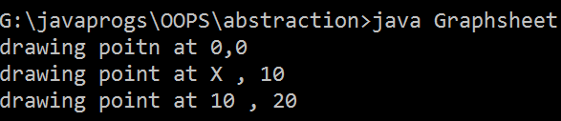

## Two overloaded method can have different return datatypes.

class Graphsheet

{

public void drawPoint() // **return type is void**

{

System.out.println("drawing poitn at 0,0");

}

public int drawPoint(int x, char cord) // **return type is int**

{

System.out.println("drawing point at "+cord + " , "+x); return 10;

}

public static void main(String[] args)

{

Graphsheet g=new Graphsheet(); g.drawPoint();

g.drawPoint(10, 'X');

}

}

* with the help of method overloading we can achieve code flexibility.
* Method overloading is the best example for compile time polymorphism
* The binding of method declaration to method definition is done at the compile time and hence it is called as compile time binding or early binding.
* Since the binding is done at the compile time it can not be changed at runtime and hence it is called as static binding.
* It makes easy for the programmer to remember the methods name and increase the readability of program.

## Disadvantage of Method Overloading

* The overloaded methods should have required java documents in order to understand the functionality of every overloaded method.

## Application of Method Overloading

* Whenever the project or application has same logic to be executed with different type of arguments then we go for method overloading.

## Program

class Graphsheet

{

public void drawPoint()

{

System.out.println("drawing poitn at 0,0");

}

public void drawPoint(int x, char cord)

{

System.out.println("drawing point at "+cord + " , "+x);

}

public void drawPoint(int x, int y)

{

System.out.println("drawing point at " +x + " , " + y);

}

public void drawPoint(double x, double y)

{

System.out.println("drawing point at "+x+ " ," + y);

}

public static void main(String[] args)

{

Graphsheet g=new Graphsheet(); g.drawPoint();

g.drawPoint(10, 'X'); g.drawPoint(10,20); g.drawPoint(10.2, 25.2);

}}

# CHAPTER 7 : METHOD OVERRIDING

* Subclass inheriting the method of super class and changing the method definition without changing method declaration (no. of arguments and method name should be same) according to subclass specificiation is called as Method Overriding.

## Program

class Superclass

{

public void count(int n)

{

for (int i=1; i<n;i++)

{

System.out.println(i);

}

}

}

class Sublcass extends Superclass

{

public void count(int n) // **METHOD DECLATION IS SAME**

{

for(int i=n;i>1;i--) // **CHANGE THE DEFINITION**

{

System.out.println(i); System.out.println();

}}

}

class MainOverride

{

public static void main(String[] args)

{

Superclass sup1=new Superclass(); sup1.count(10);

Sublcass sub1=new Sublcass(); sub1.count(5);}}

## @override :

* Override annotation helps in addition compile time verification in the subclass to ensure the programmer overriding is overriding the proper method of superclass.
* It will also improvise code readability.
* It is not mandatory to write @override.
* If we don’t write @override then if the method name in subclass different then it treat as a another method and not doing overriding.

## Program

class Superclass

{

public void disp()

{

System.out.println("this is disp method of superclass");

}

}

class Sublcass extends Superclass

{

## @Override // Here if we write anotation then only it differentiate between superclass and subclass method

public void count()

{

System.out.println("This is disp() method f subclass");

}

}

class MainOverride

{

public static void main(String[] args)

{

Superclass sup1=new Superclass(); sup1.disp();

Sublcass sub1=new Sublcass(); sub1.disp();

}

}

## If we don’t write @override annotation then it does not throw an error if superclass and subclass method is different in name.

class Superclass

{

public void disp()

{

System.out.println("this is disp method of superclass");

}

}

class Sublcass extends Superclass

{

public void count() // here method is different

{

System.out.println("This is disp() method f subclass");

}

}

class MainOverride

{

public static void main(String[] args)

{

Superclass sup1=new Superclass(); sup1.disp();

Sublcass sub1=new Sublcass(); sub1.count();

}

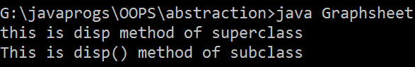}

## Note :

* **Static method can not be overridden. Program**

class Superclass

{

public static void disp()

{

System.out.println("this is disp method of superclass");

}

}

class Subclass extends Superclass

{

@Override

public static void disp()

{

System.out.println("This is disp() method f subclass");

}

}

class MainOverride

{

public static void main(String[] args)

{

Superclass.disp(); Subclass.disp();

}

}

## Here it throw a compile time error as method does not override or implement a method from a supertype.

* **If subclass and super class have same static methods with same declaration and same definition then it is called as method hiding.**

**Program :**

class Superclass

{

public static void disp()

{

System.out.println("this is disp() of superclass");

}

}

class Subclass extends Superclass

{

public static void disp()

{

System.out.println("This is disp() method of subclass");

}

}

class MainOverride

{

public static void main(String[] args)

{

Subclass.disp();

}

}

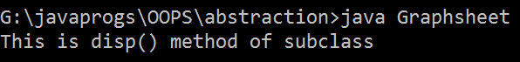

## Final method can be inherited but cannot be overridden. Program :

class Superclass

{

public final void disp()

{

System.out.println("this is disp method of superclass");

}

}

class Subclass extends Superclass

{

@Override

public final void disp()

{

System.out.println("This is disp() method f subclass");

}}

class MainOverride

{

public static void main(String[] args)

{

Superclass s1=new Superclass() ; s1.disp();

Subclass s2 = new Subclass(); s2.disp();

}}

## Here it throw an error that overridden method is final

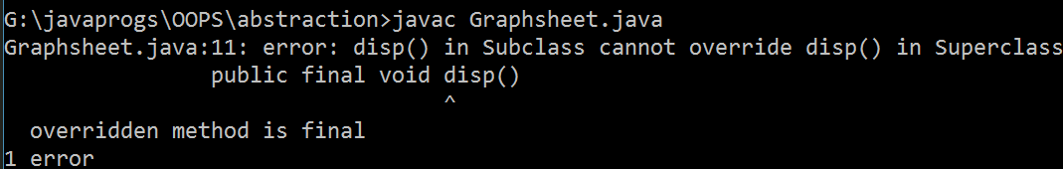

* **Private method can not be inherited and cannot be overridde**n.

**Program :**

class Superclass

{

private void disp()

{

System.out.println("this is disp method of superclass");

}

}

class Subclass extends Superclass

{

@Override

private final void disp()

{

System.out.println("This is disp() method f subclass");

}

}

class MainOverride

{

public static void main(String[] args)

{

Superclass s1=new Superclass() ; s1.disp();

Subclass s2 = new Subclass(); s2.disp();

}}

## //here it throw an error that it can not be override.

* Method Overriding is the best example **for Runtime Polymorphism.**
* The binding of method declaration to member definition is done at runtime and hence it is called as **late binding.**
* The binding can be changed dynamically at the runtime and hence it is also called as dynamic binding.

## Multilevel Override

class Whatsapp1

{

public void sentReport()

{

System.out.println("show one black tick");

}}

class Whatsapp2 extends Whatsapp1

{

public void sentReport()

{

System.out.println("show two black tick");

}}

class Whatsapp3 extends Whatsapp2

{

public void sentReport()

{

System.out.println("Two blue tick");

}}

class MultilevelOverride

{

public static void main(String[] args)

{

Whatsapp1 w1= new Whatsapp1(); w1.sentReport();

Whatsapp2 w2 = new Whatsapp2(); w2.sentReport();

Whatsapp3 w3=new Whatsapp3(); w3.sentReport();

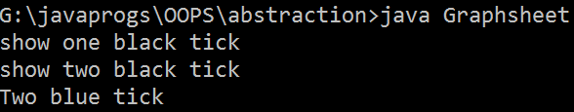}}

## HierarchialOverride

class AndroidOs

{

public void showHomeScreen()

{

System.out.println("show 5 icons");

}

}

class SamsungOs extends AndroidOs

{

public void showHomeScreen()

{

System.out.println("show 2 icons");

}

}

class RedmiOs extends AndroidOs

{

public void showHomeScreen()

{

System.out.println("show 6 icons");

}

}

class MotoOs extends AndroidOs

{

public void showHomeScreen()

{

System.out.println("show 10 icons");

}

public void motoUpdate()

{

System.out.println("show Update for moto only");

}

}

class HierarchialOverride

{

public static void main(String[] args)

{

AndroidOs a1 = new AndroidOs(); a1.showHomeScreen();

SamsungOs s1 = new SamsungOs(); s1.showHomeScreen();

MotoOs m1 = new MotoOs(); m1.showHomeScreen(); m1.motoUpdate();

RedmiOs r1 = new RedmiOs(); r1.showHomeScreen();

}

}

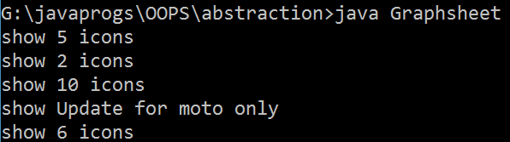

## Note :

**\*\***

* **if subclass and superclass contains method with same name but different arguments then the subclass will contain 2 overloaded methods.**

**Program :**

class Superclass

{

public void disp()

{

System.out.println("this is disp() of superclass");

}

public void disp(int n)

{

System.out.println("this is disp(int n) of superclass");

}

}

class Subclass extends Superclass

{

@Override

public void disp(int n)

{

System.out.println("This is disp() method f subclass");

}

}

class MainOverride

{

public static void main(String[] args)

{

Superclass s1=new Superclass(); s1.disp(10);

Subclass s2 = new Subclass();

s2.disp();

s2.disp(5);

}

}

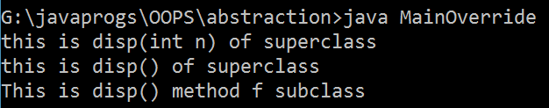

## To achieve method overriding inheritance is mandatory. Program :

class Superclass

{

public void disp()

{

System.out.println("this is disp method of superclass");

}

}

class Subclass

{

@Override

public final void disp()

{

System.out.println("This is disp() method f subclass");

}

}

class MainOverride

{

public static void main(String[] args)

{

Superclass s1=new Superclass() ; s1.disp();

Subclass s2 = new Subclass(); s2.disp();

}

}

## // here there is no inheritance between subclass and superclass so there is no overridden happen between them.

* From the subclass object if you (programmer) try to call overridden method you (programmer) always get overridden implementation of the method.

## Program

class Superclass

{

public void disp()

{

System.out.println("this is disp() of superclass");

}

}

class Subclass extends Superclass

{

//@Override public void disp()

{

System.out.println("This is disp() method of subclass");

}

}

class MainOverride

{

public static void main(String[] args)

{

Subclass s1=new Subclass(); s1.disp();

}

}

## //output of this program is this is disp() method of subclass, because it call always overridden method.

* If we want to execute the overridden implementation of the method and original implementation o the method present in superclass then we can use super keyword from the subclass method to call superclass method.

## Program

class SuperClass

{

public void view()

{

System.out.println("This is view() of SuperClass");

}

public void disp()

{

System.out.println("This is display() of SuperClass");

}

}

class Subclass extends SuperClass

{

public void view()

{

super.view();

System.out.println("this is the view() of Subclass");

}

public void disp(int n)

{

System.out.println("this is the disp(int n) of

subclass");

}

}

class SuperClassOverride

{

public static void main(String[] args)

{

Subclass ref1=new Subclass(); ref1.view();

ref1.disp(); ref1.disp(10);

}

}

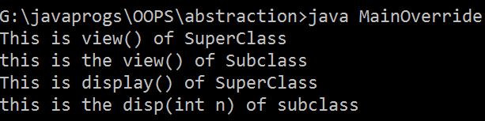

# CHAPTER 8 : TYPE CASTING

* Converting one type to another type is called as typecasting.
* It is of two type

1. Primitive casting
2. Derived Casting

## Primitive Casting

* Converting one primitive type of another primitive type is called as primitive casting.

**widening**

int

32 bits

float

32 bits

long

64 bits

double

64 bits

**narrowing**

Byte 8 bits

char 16 bits

short 16 bits

Primitive Casting is of two type :

1. Widening
2. Narrowing

## Widening

* Converting a lower datatype value to higher datatype value is called as widening.
* Widening will be done by compiler implicitely.

## Program

class TypeCasting

{

public static void main(String[] args)

{

int x1=20; double y1=x1;

System.out.println("x1 = "+x1); System.out.println("y1 = "+y1);

}

}

## o/p – x1=20

**y1 = 20.0**

**Narrowing :**

* Converting a higher data type value to lower datatype value is called as Narrowing.
* Narrowing should done by the programmer explicitly by writing casting statement.

## Type Casting Syntax :

**(datatype) value/variables ;**

* Narrowing always results in loss of data.

## Program

class TypeCastingLossOfData

{

public static void main(String[] args)

{

int x1=127;

byte y1=(byte) x1; System.out.println("x1 = "+x1); System.out.println("y1 = "+y1);

int a=240;

byte b = (byte)a; System.out.println("a = "+a); System.out.println("b = "+b);

}

## } // in the above program while in 1st it does not loss of data because byte holds the data upto 128 bytes but in the second there is loss of data because we want o store 240 in byte, but the capacity of byte is only 128.

Op :

X1 = 127

Y1= 127

A= 240

## B= -16 // here loss of data

**Program :**

class TypeCasting

{

public static void main(String[] args)

{

double x1=20; int y1=(int)x1;

System.out.println("x1 = "+x1); System.out.println("y1 = "+y1);

}

}

o/p – x1=20.0

y1 = 20

## If we directly doing narrowing then it throws an error Program :

class TypeCasting

{

public static void main(String[] args)

{

double x1=20; int y1=x1;

System.out.println("x1 = "+x1); System.out.println("y1 = "+y1);

}

}

## //it throws an error as possible loss of precision Simple typeCasing Program

class TypeCasting

{

public static void main(String[] args)

{

int a=20;

double b= a; // widening System.out.println("a = "+a); System.out.println("b = "+b);

double x1=20;

int y1=(int) x1; // narrowing System.out.println("x1 = "+x1); System.out.println("y1 = "+y1);

}

}

## Op– x1=20

**y1 = 20.0 x1=20.0 y1 = 20**

* **If you try to convert a character to integer then integer variable will be containing Unicode value for the given character.**

**Program**

class CharacterTypeCasting

{

public static void main(String[] args)

{

char c1 = 'A';

int i = c1; // widening System.out.println("c1 = "+c1); System.out.println("i = " + i);

int j = 77;

char c2 = (char)j; // narrowing System.out.println(" j = " + j); System.out.println( " c2 = " + c2);

}

}

## Program : Write a Function or method which converts any given string to lower case and print the same.

* **For a method expecting primitive value we can pass the same primitive datatype value and all its lower primitive datatype value.**

**Program**

class Mainclass13

{

public static void test(int x )

{

System.out.println("this is test(int x) of sample");

}

public static void main(String[] args)

{

byte s = 10; test(s);

short a = 52; test(a);

int b=25; test(b); }}

-

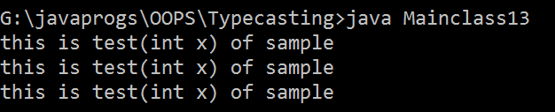

b

## For a method expecting primitive value then if we pass the higher primitive datatype value then it throws an error.

**Program**

class Mainclass13

{

public static void test(int x )

{

System.out.println("this is test(int x) of sample");

}

public static void main(String[] args)

{

double d = 10.5; test(d);

long l = 25.3; test(l);

}

}

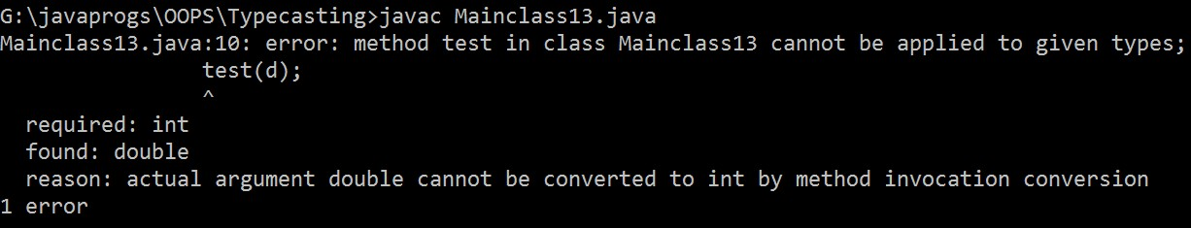

## If a class contains two overloaded methods one expecting lower datatype value, other expecting higher datatype value and if you pass a lower datatype value to call the method then always method with lower datatype value will be executed.

**Program**

class Over

{

public static void test(int x )

{

System.out.println("This is test(int x) "); System.out.println("print x = " + x);

}

public static void test(double x )

{

System.out.println("This is test(double x)"); System.out.println("print x = " + x);

}

public static void main(String[] args)

{

int v1=10; test(v1);

}

}

## // op : this is test(int x )

**// print x = 10 Derived Casting**

* Converting one reference type to another reference type is called as derived casting.
* Derived Casting is of two type :
  1. Upcasting
  2. Downcasting

## Upcasting

* **Converting subclass or childclass reference to superclass or parent class reference is called as upcasing.**

**Program**

class SuperClass

{

public void test()

{

System.out.println("This is test() ");

}

}

class Subclass extends SuperClass

{

public void view()

{

System.out.println("This is view()");

}

}

class Upcasting

{

public static void main(String[] args)

{

SuperClass sup1 = new Subclass(); //**Upcasting** sup1.test();

## or we can also write like this

Subclass sub1 = new Subclass(); SuperClass sup2=sub1; **// Upcasting** sup2.test();

}

}

## // op : this is test

* **Using upcasted reference variables can access only superclass or parent class property.**

**Program**

class SuperClass

{

public void test()

{

System.out.println("This is test() ");

}

}

class Subclass extends SuperClass

{

public void view()

{

System.out.println("This is view()");

}

}

class Upcasting

{

public static void main(String[] args)

{

SuperClass sup1 = new Subclass();

## sup1.view(); /* here it throw an error as cannot find the symbol because Superclass reference can only access the superclass method not a subclass method. */

}

}

* Upcasting will be done by the compiler implicitly.
* Upcasting is achieved by storing the address of child class object into parent class reference variable.

SuperClass sup1 = new Subclass();

In the above line sup1 is the reference variable which store the address of Sublclass object

## Downcasting

* Converting the upcasted reference back to subclass reference is called as downcasting.

## Downcasting should be done by the programmer explicitly by writing casting statement.

**Program**

class SuperClass

{

public void test()

{

System.out.println("This is test() ");

}

}

class Subclass extends SuperClass

{

public void view()

{

System.out.println("This is view()");

}

}

class Upcasting

{

public static void main(String[] args)

{

SuperClass sup1 = new Subclass();

Subclass sub1 = (Subclass)sup1; // **downcasting, done by writing downcasting statment**

sub1.test();

sub1.view();

}}

* We can downcast only upcasted reference. If we downcast directly superclass into subclass then JVM throws an exception as **ClassCastException** at runtime.

## Program

class SuperClass

{

public void test()

{

System.out.println("This is test() ");

}

}

class Subclass extends SuperClass

{

public void view()

{

System.out.println("This is view()");

}

}

class Upcasting

{

public static void main(String[] args)

{

SuperClass sup1 = new SuperClass();

Subclass sub1 = (Subclass)sup1; **// downcast directly superclass without upcasting**

sub1.test();

sub1.view();

}}



## Derived Downcasting with Multilevel Inheritance

class SuperClass

{

public void display()

{

System.out.println("this is display() of SuperClass");

}}

class SuperClass2 extends SuperClass

{

public void click()

{

System.out.println("this is click() method of SuperClass2");

}

}

class Subclass extends SuperClass2

{

public void count()

{

System.out.println("this is count() of Subclass");

}}

class SuperClass1

{

public static void main(String[] args)

{

System.out.println("Program start ");

SuperClass2 ref1=new Subclass(); //upcasting ref1.click();

ref1.display(); System.out.println();

SuperClass ref2 = new Subclass(); //upcsting ref2.display();

System.out.println();

Subclass ref3 = (Subclass) ref1; // downcasting ref3.click();

ref3.display();

ref3.count(); System.out.println();

SuperClass2 ref4 = (SuperClass2) ref2; // downcasting ref4.display();

ref4.click(); System.out.println();

Subclass ref5= (Subclass) ref2; ref5.display();

ref5.click();

ref5.count(); System.out.println("program end ");

}}

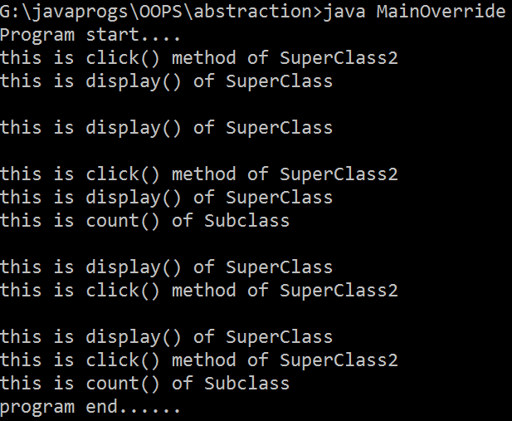

* If you try to downcast a reference to the class type which do not contain the properties of given class then JVM throws **ClassCastException** at runtime.

## Program

class Mouse

{

public void click()

{

System.out.println("mouse button clicked");

}}

class Pendrive

{

public void read()

{

System.out.println("reading data from pendrive");

}

public void write()

{

System.out.println("Write data to pendrive");

}

}

class Usb_Port

{

public static void connect(Object obj)

{

Mouse ref1=(Mouse)obj; ref1.click();

}

}

class MainClass5

{

public static void main(String[] args)

{

Mouse m1= new Mouse(); Pendrive p1=new Pendrive(); Usb_Port.connect(m1);

Usb_Port.connect(p1); // **here it throw runtime error as ClassCastException as Pendrive class can not cast to Mouse Class**

}

}

* We can avoid ClassCastExcpetion by using **instanceof operator.**

## Instanceof operator checks if the given reference contains the property of given class and return true if the properties are present else it return false.

**Program**

class Mouse

{

public void click()

{

System.out.println("mouse button clicked");

}

}

class Pendrive

{

public void read()

{

System.out.println("reading data from pendrive");

}

public void write()

{

System.out.println("Write data to pendrive");

}

}

class Usb_Port

{

public static void connect(Object obj)

{

## // to overcome ClassCastException exception use instanceof Operator

if(obj instanceof Mouse == true)

{

Mouse ref1=(Mouse)obj; ref1.click();

}

else

{

}

}

}

Pendrive ref = (Pendrive)obj; ref.read();

ref.write();

class MainClass

{

public static void main(String[] args)

{

Mouse m1= new Mouse(); Pendrive p1=new Pendrive(); Usb_Port.connect(m1); Usb_Port.connect(p1);

}

}

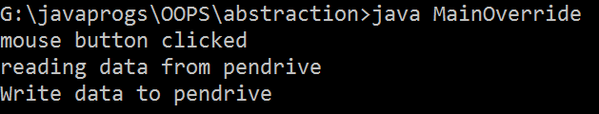

* If you want to relate to unrelated classes then you can use **Object Class** as the common superclass to perform derived casting, achieve runtime polymorphism

## Program

public static void connect(Object obj)

## // here Object is the SuperClass of Mouse and Pendrive Class.

* **If a method expecting superclass reference then for the same method you can pass reference of superclass and all its subclass.**

**Program**

class Mouse

{

public void click()

{

System.out.println("mouse button clicked");

}

}

class Pendrive

{

public void read()

{

System.out.println("reading data from pendrive");

}

public void write()

{

System.out.println("Write data to pendrive");

}

}

class Usb_Port

{

public static void connect(Object obj)

{

System.out.println("this is object obj of Usb_Port1");

}}

class Mainclass15

{

public static void main(String[] args)

{

Mouse m1= new Mouse();

Usb_Port.connect(m1); // **pass the subclass reference to connect method which expecting superclass reference**

Pendrive p1 = new Pendrive();// **pass the subclass reference to connect method which expecting superclass reference**

Usb_Port.connect(p1);

Object obj=new Object();

Usb_Port.connect(obj); **// pass the superclass reference to connect method which expecting superclass reference**

}}

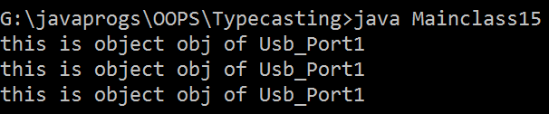-

-

-

-

-

* If there are two overloaded methods in a class one expecting superclass reference and the other method expecting subclass reference and if you pass subclass reference to call the method then always method with subclass reference will be executed.

## Program

class Mouse

{

public void click()

{

System.out.println("mouse button clicked");

}

}

class Pendrive

{

public void read()

{

System.out.println("reading data from pendrive");

}

public void write()

{

System.out.println("Write data to pendrive");

}

}

class Usb_Port

{

public static void connect (Mouse obj)

{

System.out.println("this is connect (Mouse obj)");

}

public static void connect(Object obj)

{

System.out.println("this is connect (Object obj");

}

}

class MainClass

{

public static void main(String[] args)

{

Mouse m1= new Mouse(); Usb_Port.connect(m1);

}

}

## // op - this is connect (Mouse Obj)

**CHAPTER 9 : ABSTRACT CLASS AND ABSTRACT METHOD**

* A method which has only declaration and no definition is called as abstract method.
* A method which has declaration as well as definition is called as

## concrete method.

* If a method is abstract then it should be declared using abstract keyword.
* A class which is declared with abstract keyword is called as abstract class.
* If a class contains atleast one abstract method then the class must be declared as abstract.

## Program

abstract class Sample // **if we don’t declare class as abstract then it throw an error as class Sample is not abstract and not override abstract method test().**

{

abstract public void test(); **// this is an abstract method**

}

class Mainclass

{

public static void main(String[] args)

{

System.out.println("Program start"); System.out.println("Program end ");

}

}

* Abstract class can contain :

(i) Only abstract method or only concrete methods or both abstract and concrete method.

abstract class Sample

{

abstract public void test(); **//abstract method**

public void count() **// concrete method**

{

System.out.println("this is count() of sample");

}

}

class Mainclass2

{

public static void main(String[] args)

{

System.out.println("program start ");

}

}

* It is impossible to create objects for abstract class.

## Program

abstract class Sample

{

abstract public void test(); //abstract method public void count() // concrete method

{

System.out.println("this is count() of sample");

}

}

class Mainclass2

{

public static void main(String[] args)

{

System.out.println("program start ");

Sample s= new Sample(); // **here object is created but it throw an error**

s.count();

}

}

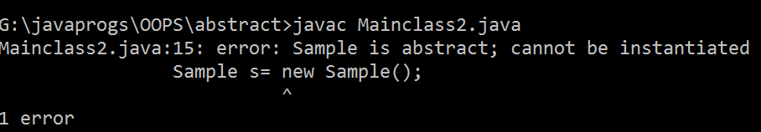

## The concrete methods of abstract class can be static or non static.

**Program**

abstract class Sample

{

abstract public void test();

public static void count() // **static concrete method**

{

System.out.println("this is count() of sample");

}

public void disp() // **non-static concrete method**

{

System.out.println("this is disp() of sample");

}

}

class Mainclass6

{

public static void main(String[] args)

{

System.out.println("Program start"); System.out.println("Program end ");

}

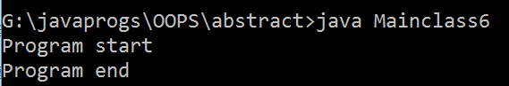}

* The data members of abstract class can be static or non-static.

Program

abstract class Sample

{

static int x = 50; //**static data members** int b = 20; // **non static data members** abstract public void test();

}

class Mainclass6

{

public static void main(String[] args)

{

System.out.println("Program start"); System.out.println("Program end ");

}

}

## Op – Program Start Program end

* If a class is extending an abstract class the subclass should override all the abstract methods of superclass.

## Program

**//to access non static member of abstract class 2nd solution abstract class Sample**

{

int x = 50;

abstract public void test(); public void count()

{

System.out.println("this is count() of sample");

}}

class Demo extends Sample

{ @Override

public void test() // **override the method of abstract class**

{

System.out.println("Overriding test method of Sample in Demo");

}

}

class Mainclass8

{

public static void main(String[] args)

{

System.out.println("Program start"); Demo d1 = new Demo(); d1.count();

System.out.println("value of x = "+d1.x); System.out.println("Program end ");

}

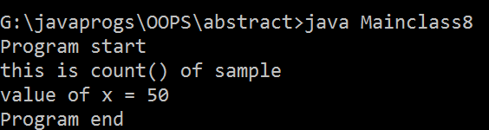}

* If the class do not override the abstract methods of super class then the class should be declared as abstract.

## Program

abstract class Super

{

abstract public void test();

}

abstract class Sub extends Super

{

}

class ab extends Sub

{

public void test()

{

System.out.println("this is test()");

}

}

class Practice

{

public static void main(String[] args) { ab a = new ab();

a.test();

}

}

* Abstract class do not declared as final. It throw a compile time error.

## Program

**// can not be define as final**

final abstract class Sample

{

abstract public void test(); public void count()

{

System.out.println("this is count() of sample");

}}

class Mainclass9

{

public static void main(String[] args)

{

System.out.println("Program start");

System.out.println("Program end ");

}

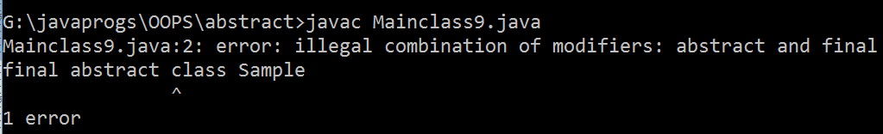}

* Abstract method can not be declared as static, because static method can not be overridden. It throw a compile time error.

## Program

abstract class Sample

{

abstract public static void test(); /**/ can not declare abstract method as static**

public void count()

{

System.out.println("this is count() of sample");

}}

class Mainclass9

{

public static void main(String[] args)

{

System.out.println("Program start");

System.out.println("Program end ");

}

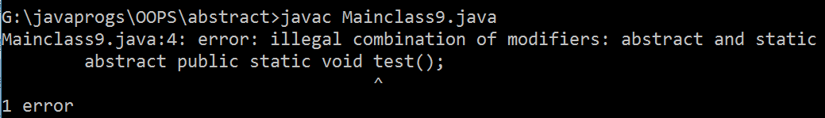}

* abstract method can not be declared as final, because final method method can not be overridden.

## Program

abstract class Sample

{

abstract public final void test(); // **can’t define abstract method as final it throw a compile time error**

public void count()

{

System.out.println("this is count() of sample");

}}

class Mainclass9

{

public static void main(String[] args)

{

System.out.println("Program start"); System.out.println("Program end ");

}

}

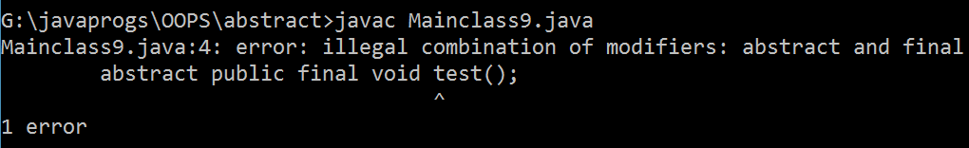

* abstract methods can not be declared as private because private method can not be overridden, or cant be inherited.

## Program

abstract class Sample

{ abstract private void test(); public void count()

{

System.out.println("this is count() of sample");

}}

class Mainclass9

{ public static void main(String[] args)

{ System.out.println("Program start"); System.out.println("Program end ");

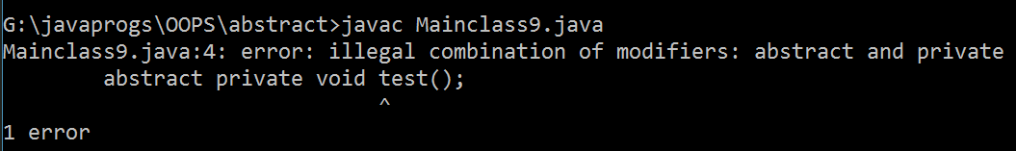

}}

## Abstract class can not be declared as private.

**Program**

private abstract class Sample

{

abstract public void test(); public void count()

{

System.out.println("this is count() of sample");

}}

class Mainclass9

{ public static void main(String[] args)

{

System.out.println("Program start"); System.out.println("Program end ");

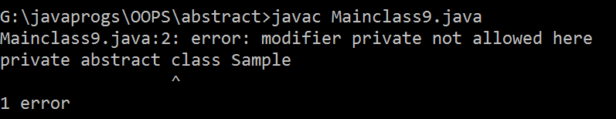}}

## the static member of abstract class directly call by using classname.datamember name

**Program**

abstract class Sample

{

static int x = 50;

abstract public void test();

}

class Mainclass12

{

public static void main(String[] args)

{

System.out.println("value of x " + Sample.x);

}

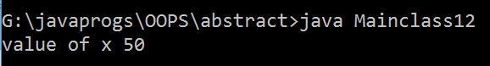}

## The non-static members of abstract class can be access only by creating the object of subclass.

**Program**

abstract class Sample

{

static int x = 50;

abstract public void test(); public void count()

{

System.out.println("this is count() of sample");

}}

class Demo extends Sample

{

@Override public void test()

{

System.out.println("this is test() of sample class ");

}}

class Mainclass7

{

public static void main(String[] args)

{

System.out.println("value of x = "+Sample.x); Demo d=new Demo();

d.test();

d.count();

}}

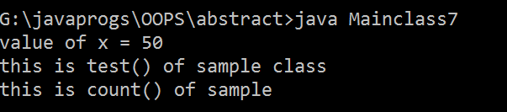

## we can create a reference variable for an abstract class. Program

abstract class RefVar

{

abstract public void test();

public static void main(String[] args)

{

System.out.println("program start"); RefVar r ; **// reference variable.**

}

}

* the abstract class reference variables are used to achieve

1. Derived Casting
2. Runtime Polymorphism

## Multilevel Abstract Program

abstract class Account

{

public void createAccount()

{

System.out.println("Account is created");

}

abstract public void getAcntSmt();

}

class Saving extends Account{ @Override

public void getAcntSmt()

{

System.out.println("statement of saving account");

}

}

class Loan extends Account

{

public void getAcntSmt()

{

System.out.println("Statment of loan account");

}

}

class Fd extends Account

{

public void getAcntSmt()

{

System.out.println("Statment of FD account");

}

}

class MultilevelInheritance

{

public static void main(String[] args) {

Saving s = new Saving(); s.createAccount(); s.getAcntSmt();

Loan l = new Loan(); l.createAccount(); l.getAcntSmt();

Fd f = new Fd(); f.createAccount(); f.getAcntSmt();

}

}

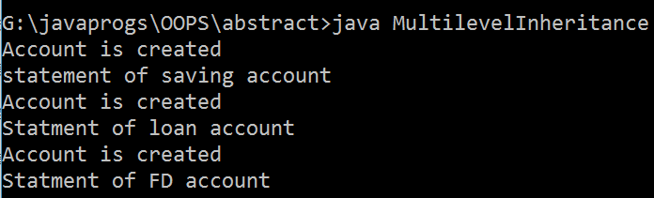

# CHAPTER 10 : INTERFACE

* It is a type of class where the methods are by default abstract and the datamembers are by default static and final.

1. methods are default abstract

## Program

interface Run

{

public void test();

}

class Mainclass2 implements Run

{

public void test()

{

System.out.println("hello");

}

public static void main(String[] args) { System.out.println("program start");}}

1. data members are default static

## Program

interface Run

{

int a =10; //default take as static static int b = 20;

public void test();

}

class Mainclass2 implements Run

{

public void test()

{

System.out.println("hello");

}

public static void main(String[] args) { System.out.println("program start"); System.out.println("value of a " + Run.a); System.out.println("value of b " + Run.b);

}

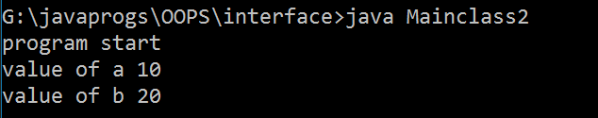}

1. data members are default final

## Program

interface Run

{

int a =10; //default take as static static int b = 20;

public void test();

}

class Mainclass2 implements Run

{

public void test()

{

System.out.println("hello");

}

public static void main(String[] args) { System.out.println("program start"); Run.a=20; // here it throw an error System.out.println("value of a " + a); System.out.println("value of b " + b);

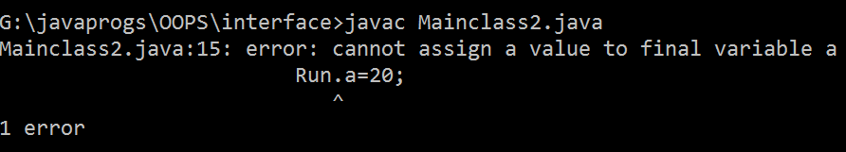}}

* It is imposible to create object for interface.

## Program

interface Run

{

public void test();

}

class Mainclass2 implements Run

{

public void test()

{

System.out.println("hello");

}

public static void main(String[] args) { System.out.println("program start");

Run r = new Run(); //**creating the object**

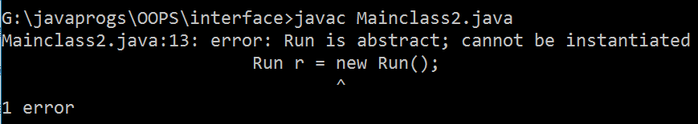}}

* we can create reference variable or interface which is used to achieve

1. runtime polymorphism
2. Derived Casting

## Program

interface Run

{

public void test();

}

class Mainclass2 implements Run

{

public void test()

{

System.out.println("hello");

}

public static void main(String[] args) { System.out.println("program start"); Run r ; // creating a reference variable

}

## } op – hello

* a class can inherit from an interface by using **implements** keyword only.

## Program

interface Run

{

public void test();

}

class Mainclass2 implements Run // **use the interface here**

{

public void test()

{

System.out.println("hello");

}

public static void main(String[] args) { }}

* if a class implements from an interface then the class should override every abstract method of the interface.

## override every abstract method

interface Run

{

public void disp(); public void test();

}

class Mainclass2 implements Run

{

public void disp()

{

System.out.println("this is disp");;

}

public void test()

{

System.out.println("this is test");

}

public static void main(String[] args) { Mainclass2 m = new Mainclass2(); m.disp();

m.test();

## } } op- this is disp

**This is test**

1. **if don’t override every abstract method**

interface Run

{

public void disp(); public void test();

}

class Mainclass2 implements Run

{

public void disp()

{

System.out.println("this is disp"); } public static void main(String[] args) {

Mainclass2 m = new Mainclass2(); m.disp();

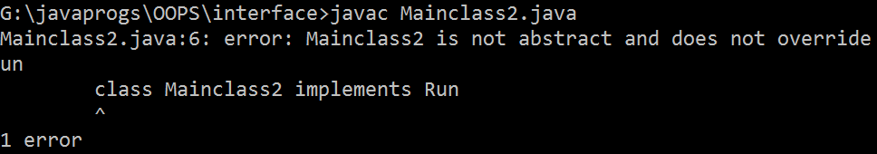}}

* Till j.D.k. 1.7 it was not possible to write concrete method inside the interface.

## Program

interface Run

{

public void disp() **// it throws an error**

{

}}

class Mainclass2 implements Run

{

public static void main(String[] args) {

}}

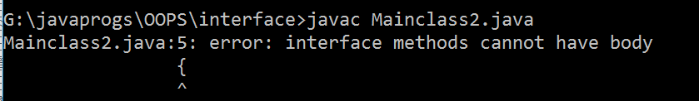

## interface do not extends from any class (not even object class)

* **interface do not have any constructor.**

**Program**

interface Run

{

Run() // interface dont have a constructor

{

}

}

class Sub implements Run

{

}

class Mainclass7

{

public static void main(String[] args) {

}}

* one interface can only extends another interface but can not implements it.

## Program

interface Run

{

}

interface Run1 extends Run{

}

class Sub implements Run, Run1

{

}

class Mainclass7

{

public static void main(String[] args) { System.out.println("Program Start");

}}

## Op- Program Start

* **if we write implements instead of extends then it throw an error**

Program

interface Run

{

}

interface Run1 implements Run{

}

class Sub implements Run, Run1

{

}

class Mainclass7

{

public static void main(String[] args) { System.out.println("Program Start");

}}

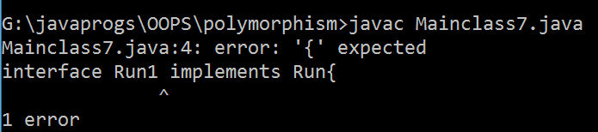

* A class can extends one class and implements an interface at the same time.

Program

interface Run

{

}

class Super

{

}

class Sub extends Super implements Run //**here extending a class and implementing a interface at same time**

{

}

class Mainclass7

{

public static void main(String[] args) { System.out.println("Program Start");

}}

## Op- Program Start

* **One class implements any number of interfaces.**

**Program**

interface Run

{

}

interface Run1

{}

interface Run2

{}

class Sub implements Run, Run1, Run2 // **implementing morethan one interface at a time**

{

}

class Mainclass7

{

public static void main(String[] args) { System.out.println("Program Start");

}}

## Op- Program Start

* One interface can extends any number of interface.

## Program

interface Run

{

}

interface Run1

{}

interface Run2 extends Run, Run1 // **interface extending morethan one interface**

{}

class Sub implements Run2

{

}

class Mainclass7

{

public static void main(String[] args) { System.out.println("Program Start");

}}

## Op – Program Start

Class Diagram of interface

Extends

Implements ( doted …. Line arrow)

<<Run>>

Test();



Sample

count();

<<Run1>>

## Program

interface Run

{

public void test();

}

interface Run1 extends Run

{

public void disp();

}

class Sample implements Run1

{

public void test()

{

System.out.println("This is test method");

}

public void disp()

{

System.out.println("This is disp method");

}

}

class Mainclass8

{

public static void main(String[] args) { Sample s = new Sample(); s.test();

s.disp();

}

}

## Op – this is test method This is disp method

**Multiple inheritance using interface Program**

interface Run

{

public void test();

}

interface Run1

{

public void disp();

}

class Sample implements Run1, Run

{

public void test()

{

System.out.println("This is test method");

}

public void disp()

{

System.out.println("This is disp method");

}

}

class Mainclass8

{

public static void main(String[] args) { Sample s = new Sample(); s.test();

s.disp();

}

}

## Op – this is test method This is disp method

**Marker interface**

* An interface which do not contain any methods is called as master interface

## Program

interface Run

{

}

## Functional interface

* An interface which contains only one abstract method is called as functional interface.

## Program

interface Run

{

public void disp();

}

# CHAPTER 11 : POLYMORPHISM

* One entity showing different behaviours at different places is called as polymorphism.
* Polymorphism helps in code flexibility
* There are two type of polymorphism.
  1. Compile time polymorphism
  2. Runtime polymorphism

## Compile time polymorphism

* Binding the method declaration to method definition by the compiler at compile time based on the arguments is called as compile time polymorphism.
* It is also called as static binding.
* Eg. Method overloading and constructor overloading

## Runtime polymorphism

* Binding the method declaration to method definition by the jvm at run time based on the object is called as runtime polymorphism.
* It is also called as dynamic binding.
* Eg. Method overriding.

**Note :**

**Using an upcasted reference if you call an overridden method then you always get overridden implementation on subclass implementation.**

* To achieve runtime polymorphism we have to follow three steps :

1. Inheritance
2. Method overriding
3. Upcasting

## Program

class Superclass

{

public void test()

{

System.out.println("this is test(");

}

}

class Subclass extends Superclass // **inheritance**

{

public void test() // **method overriding**

{

System.out.println("overriding of test () in subclass");

}

}

class Mainclass1

{

public static void main(String[] args) {

Superclass sup1= new Subclass(); // **upcasting**

sup1.test();

}

}

## Op – overriding of test() in subclass

* **To show code flexibility using polymorphism**

**Program**

interface card

{

public void makePayment();

}

class Debit implements card

{

public void makePayment()

{

System.out.println("payment done by Debit");

}

}

class Credit implements card

{

public void makePayment()

{

System.out.println("payment done by credit");

}

}

class Swipemachine

{

public static void swipe(card c)

{

c.makePayment();

}

}

class Mainclass10

{

public static void main(String[] args) { Credit c = new Credit(); Swipemachine.swipe(c);

Debit d = new Debit(); Swipemachine.swipe(d);}}

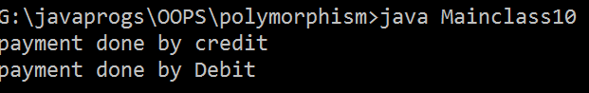

# ABSTRACTION

* Hiding the implementation details of the class and exposing only the behaviours or services is called as abstraction.
* To achieve abstraction we have to follow three steps :

1. Generalize the methods of implementation class and store them inside the interface.

## Program

interface Account

{

public void deposit(); public void withdraw();

}

class Saving implements Account

{

public void deposit()

{

System.out.println("Money is deposit in saving account");

}

public void withdraw()

{

System.out.println("money is withdraw from saving

account");

}

}

class Fd implements Account

{

public void deposit()

{

System.out.println("money is deposit in FD account");

}

public void withdraw()

{

System.out.println("money is withdraw from FD account");

}

}

1. Create the object of implementation class and store the address in interface reference variable.

## Program

class AcntMgr

{

public static Account createAcnt(char type)

{

Account a1; // **interface reference**

if(type=='S')

{

## a1 = new Saving(); //create he object of implementation class and store the address in interface reference

return a1;

}

else

{

}}}

a1 = new Fd(); return a1;

1. Use the interface reference variables to access the methods of implementation class.

## Program

Account a1 = AcntMgr.createAcnt('S'); //**access the method of implementation class using interface reference**

a1.deposit(); a1.withdraw(); }}

* Using abstraction we can developed APIs(Application Programming Interface)
* Using abstraction we can achieve **Loose Coupling.**
* To achieve loose coupling we have to create three layers :

1. Object implementation layer
2. Object creation layer
3. Object utilization layer.

## Program

interface Account

{

public void deposit(); public void withdraw();

}

class Saving implements Account

{

public void deposit()

{

System.out.println("Money is deposit in saving account");

}

public void withdraw()

{

System.out.println("money is withdraw from saving

account");

}

}

class Fd implements Account

{

public void deposit()

{

System.out.println("money is deposit in FD account");

}

public void withdraw()

{

System.out.println("money is withdraw from FD account");

}

}

class AcntMgr

{

public static Account createAcnt(char type)

{

Account a1; if(type=='S')

{

}

else

{

}}}

class Mainclass1

{

a1 = new Saving(); return a1;

a1 = new Fd(); return a1;

public static void main(String[] args)

{

Account a1 = AcntMgr.createAcnt('S'); a1.deposit();

a1.withdraw(); }}

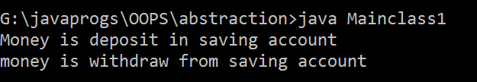

# JAVA PACKAGES

BIN

SRC

GMAIL

|  |  |  |  |  |  |
| --- | --- | --- | --- | --- | --- |
|  | | |  | | |
|  |  | | | |  |
| INBOX | |  | | SENT | |

|  |  |  |  |  |  |
| --- | --- | --- | --- | --- | --- |
|  | | |  | | |
|  |  | | | |  |
| INBOX | |  | | SENT | |

DELETE. JAVA

DELETE. JAVA

DELETE. CLASS

DELETE. CLASS

* A package is a group of classes and interface which is specific to one module or features the project.

## Advantage:

* Maintenance of the application source code is easy.
* It avoids naming collision.
* It provides security for the class and its members with the help of access specifiers.

## Note –

* The package name should be in the reverse order of domain .

## Syntax :

Domainname.appname.modulename Domainname.companyname.appname.modulename

* For eg : Com.gmail.inbox;
* Package names should be always written in lower case.
* To access the properties of a class or to create the object of the class present in different package we can use two different approaches.

1. Using fully qualified classname
2. Using import statement

## Fully Qualified classname

* A classname which is written with its package name is called as fully qualified classname
* Syntax : Domain.app.module.classname

Eg: Com.gmail.inbox.demo

## Program 1st package

package com.gmail.inbox; public class Demo {

public static void test()

{

System.out.println("test() from com.gmail.inbox; ");

}}

**Program 2nd package** package com.gmail.sent; public class Demo {

public static void test()

{

System.out.println("test() from com.gmail.inbox; ");

}

}

## Program 3rd to use both package

package com.gmail.run;

import com.gmail.inbox.Demo;

public class Mainclass {

public static void main(String[] args) { Demo.test(); com.gmail.sent.Demo.test();

}

}

## Op - test() from com.gmail.inbox; test () of com.gmail.sent;

* If we have two packages with same name and same classname, in this case we have to use both import statement and fully qualified classname together. If we only use two import statement then it show a compile time error.

# ACCESS SPECIFIER

visibility

PUBLIC

PROTECTED

PACKAGE LEVEL

PRIVATE

security

* Access specifier are use to provide security for the clases and its members by controlling visibility.

## Public :

* If you declare any entity with public access specifier then it can be accessed from the classes present in same package or different package.
* Public classes and its members will have highest visilibty and lowest security.

## Used in same package .

package com.jspider.pkg1; public class Demo

{

public int v1=100; public void test()

{

System.out.println( "this is public void test()");

}

}

## 2nd Program which use the first package

package com.jspider.pkg1; // **if we use public datamembers or methods in same package and in different class then there is no need of using any import statement or fully qualified classname. We can directly use**

public class Sample {

public static void main(String[] args) { Demo d = new Demo(); System.out.println("v1 = " + d.v1); d.test();

}

}

## Op- v1 = 100

**this is public void test()**

* **Used in different package**

(i) It is mandatory to use import or fully qualified classname when we want to access the members and methods of different packages. If we don’t do it, then it throw a compile time error.

package com.jspider.pkg2; import com.jspider.pkg1.Demo; public class Run {

public static void main (String ar[])

{

Demo d1 = new Demo(); d1.test();

System.out.println("v1 = " + d1.v1);

}}

## Protected :

**Op- v1 = 100**

**this is public void test()**

* If you declare any entity with protected access specifier then it can be accessed from the classes present in the same package.
* It is partially visibile to another packages.

## Used in same packages Program 1

package com.jspider.pkg3; public class Demo1 {

protected int a = 10; protected void test()

{

System.out.println("protected test() from com.jspider.pkg3; ");

}}

## Program 2

package com.jspider.pkg3; public class Sample1 {

public static void main(String[] args) { Demo1 d1= new Demo1(); System.out.println("v1 = " +d1.a); d1.test();

}}

## Op - v1 = 10

**protected test() from com.jspider.pkg3;**

* **Used in different package without inheritance**

package com.jspider.pkg4; import com.jspider.pkg3.Demo1; public class Run1 {

public static void main(String[] args) {

System.out.println("a = " + d1.a); **/throw an error**

## d1.test(); // here it throw an error because protected members and methods can’t not be accessed directly by another packages. }}

* The class present in different packages can accessed protected members only by inheritance and creating the object of subclass.

## Program

package com.jspider.pkg4; import com.jspider.pkg3.Demo1;

public class Run1 extends Demo1{

public static void main(String[] args) { Run1 d1= new Run1(); System.out.println("a = " + d1.a); d1.test();

}}

## Op - a = 10

**protected test() from com.jspider.pkg3;**

**Package-level :**

* If you declare any entity without any access specifier keyword then those members are considered as package level members.
* Package level members can be accessed only by classes present in same packages.

## Used in same packages Program

package com.jspider.pkglevel; public class PkgLevel1 {

int v=20; void test()

{

## Program 2

System.out.println("this is pkglevel test()");

}}

package com.jspider.pkglevel; public class Pkglevel2 {

public static void main(String[] args) { System.out.println("a = " +PkgLevel1.v); PkgLevel1.test();

}} **op a = 20**

## this is pkglevel test()

* **Used in different packages**

Program

package com.jspider.pkglevel2;

import com.jspider.pkglevel.PkgLevel1; public class Run2 {

public static void main(String[] args) { PkgLevel1 pk = new PkgLevel1(); System.out.println("a = " + PkgLevel1.a); PkgLevel1.test();

}

}

## // in this program it throw an error because a datamember or methods defined with package-level specifier can not be accessed from different packages.

**Private**

* If you declare any entity as private specifier then it can be accessed only within the class in which the members are declared.
* Compared to other access specifier private members will have highest security and lowest visibility.

## Used in same class Program

package com.jspider.privates; public class Demo1 {

private int a = 20; private void test()

{

System.out.println("a = " + a);

}

public static void main(String[] args) { Demo1 d= new Demo1(); d.test();

}}

## Op – a = 20

* **Used in same package in different class**

Program

package com.jspider.privates; public class Sample1 {

public static void main(String[] args) {

Demo1 d = new Demo1(); System.out.println("a = " +a); a.test();

}

## } // here it throw a compile time error, because private members and methods of a class can not accessed in another class in same packages also.

* **Used in different packages Program**

package com.jspider.privates2; import com.jspider.privates.Demo1; public class Run3 {

public static void main(String[] args) { Demo1 d = new Demo1(); System.out.println("a = " +a); a.test();

}}

## // here it throw a compile time error, because private members and methods of a class can not accessed in another class in different packages also.

* The subclass can not reduce the visibility of inherited method from superclass. the superclass can only increase the visibility of inherited method from superclass.

|  |  |
| --- | --- |
| superclass | subclass |
| public | public |
| protected | public  protected |
| pkg-level | pkg-level  public protected |
| private | can’nt be inherited |

## if try to reduce the visibility then it throw an error Program

package com.jspider.pkg3; class Base

{

public void Base()

{

System.out.println("this is const");

}

}

class Child extends Base

{

protected void Base() **// here it throw an error**

{

System.out.println("this is overriding");

}}

public class Demo1 {

public static void main(String[] args) {

Child b = new Child(); b.Base();

}

}

## to increase the visilibility of method

package com.jspider.pkg3; class Base

{

void Base()

{

System.out.println("this is const");

}

}

class Child extends Base

{

protected void Base()

{

System.out.println("this is overriding");

}

}

public class Demo1 {

public static void main(String[] args) {

Child b = new Child(); b.Base();

}

}

## op – this is overriding

* 1. **ENCAPSULATION**
* Providing the security for data members and declaring them as private and provided acchess through getters and setters (public method) is called as encapsulation.

## Program

class Account

{

private int actno = 1234; // **data members are private**

private double bal;

}

* Encapsulatiion is used to provide security for the data members against invalid data.

## (i) It means that in a scenario where we want to enter the amount in bank account. So it can not be in negative value. To overcome this challenge encapusulation helps

* The set method is used to **initialize or re-initialize** the data members. Usually set methods do not return any value and hence the retury type of the set method is usually void.

## Program

public void setBal(double amt)

{ if(amt>0)

{

## members }

else

{

}}

bal=bal+amt; **// initialize and re-intialize data**

System.out.println("invalid amount");

* getMethod should return the value of the data members. The return type of get method depdends on datatype of the data members whose value is returned from getMethod.

## Program

public double getBal(int actno)

{

if(actno==1234)

{

return bal;

}

else

{

}

}

return -777;

* Using encapsulation the control over the data members of the class remains in the same class.

## Program

package com.jsp.encapsulation;

class Account

{

private int actno = 1234; private double bal;

public void setBal(double amt)

{

if(amt>0)

{

}

else

{

}

}

bal=bal+amt;

System.out.println("invalid amount");

public double getBal(int actno)

{

if(actno==1234)

{

}

else

{

}

}

return bal;

return -777;

public int showAcnt(int pin)

{

if(pin==1234)

{

return actno;

}

else

{

}

}

}

return -777;

public class Mainclass {

public static void main(String[] args) { Account a = new Account(); System.out.println("For valid value"); a.setBal(2000);

double d1= a.getBal(1234); System.out.println("balance = "+d1); int i = a.showAcnt(1234); System.out.println("Acount no = " +i); System.out.println(" ");

System.out.println("For invalid value"); a.setBal(-2000);

double d2= a.getBal(12345); System.out.println("balance = "+d2); int i1 = a.showAcnt(12345); System.out.println("Acount no = " +i1);

}

}

Op-

## For valid value balance = 2000.0 Acount no = 1234

**---------**

**For invalid value invalid amount balance = -777.0 Acount no = -777**

* 1. **NESTED CLASS**
* A class which is written within the body of another class is called as nested class.

## Program

class Outerclass

{

class Nested // **class inside a class**

{

}

}

* Nested class are of two types : (A)Static Nested Class (B)Inner class
* A nested class which is declared with static keyword is called as static nested class.

## Program

class Outerclass

{

static class Nested // **static nested class**

{

}

}

* A nested class which is declared without static keyword is called as inner class.

## Program

class Outerclass

{

class InnerClass

{

}

}

## Static Nested Class

* If you want to access the members of static nested classes or you want to create object of static nested class then there are two approaches :

1. Using fully qualified classname
2. Using import statement
3. by using fully qualified classname

## Program

package com.jsp.innerclass; class OuterClass

{

static int v1 = 10;

static class StaticNestedClass

{

static double z1 = 2.142; public void count()

{

System.out.println("this is count() of StaticNestedClass");

System.out.println("V1 = "+v1); System.out.println("z1 = " +z1);

}}}

public class Mainclass1 {

public static void main(String[] args) { System.out.println(com.jsp.innerclass.OuterClass.StaticNestedClass.z1);

## // 1st execution from here 2.142

com.jsp.innerclass.OuterClass.StaticNestedClass ref1 = new com.jsp.innerclass.OuterClass.StaticNestedClass(); ref1.count(); **//print all the statement**

}

} op –

## 2.142

**this is count() of StaticNestedClass V1 = 10**

**z1 = 2.142**

1. by using import statement

## Program

package com.jsp.innerclass;

## import com.jsp.innerclass.OuterClass.StaticNestedClass;

class OuterClass

{

static int v1 = 10;

static class StaticNestedClass

{

static double z1 = 2.142; public void count()

{

System.out.println("this is count() of StaticNestedClass");

System.out.println("V1 = "+v1); System.out.println("z1 = " +z1);

}}}

public class Mainclass1 {

public static void main(String[] args) {

System.out.println(StaticNestedClass.z1);

op –

StaticNestedClass ref1 = new StaticNestedClass(); ref1.count();

}

}

## 2.142

**this is count() of StaticNestedClass V1 = 10**

**z1 = 2.142**

* The outerclass behaves like package for static nested class.

## Program

com.jsp.innerclass.**OuterClass**.StaticNestedClass;

* Members of static nested class can be of two types.
  1. static members
  2. non- static members

## Program

package com.jsp.innerclass;

import com.jsp.innerclass.OuterClass.StaticNestedClass; class OuterClass

{

static class StaticNestedClass

{

static double z1 = 2.142; //static data members int a = 20; // non static data members

public void count()

{

System.out.println("this is count() of StaticNestedClass"); System.out.println("a = "+a); System.out.println("z1 = " +z1);

}

}

}

public class Mainclass1 {

public static void main(String[] args) { StaticNestedClass ref1 = new StaticNestedClass(); ref1.count();

}

## } op - this is count() of StaticNestedClass V1 = 10

**z1 = 2.142**

* The static members of static nested class can be accessed by the classname.
* The non-static members of static nested class can be accessed by creating the object.

## Program

package com.jsp.innerclass;

import com.jsp.innerclass.OuterClass.StaticNestedClass; class OuterClass

{

static class StaticNestedClass

{

static double z1 = 2.142; int a = 20;

public void count()

{

System.out.println("this is count() of StaticNestedClass"); System.out.println("a = "+a); System.out.println("z1 = " +z1);

}

}

}

public class Mainclass1 {

public static void main(String[] args) { StaticNestedClass ref1 = new StaticNestedClass();

ref1.count(); // **calling the non-static method using object**

System.out.println("static data members " +StaticNestedClass.z1);

## //calling the static data members

System.out.println(ref1.a); // **calling the non-static data members**

}}

## op-

**this is count() of StaticNestedClass V1 = 10**

**z1 = 2.142**

**static data members 2.142 10 // why it throw exception**

* A static nested class can access all the properties of outerclass directly and the outerclass can access all the properties of static nested class by using classname and creating the object.

## A static nested class can access all the properties of outerclass directly

**Program**

package com.jsp.innerclass;

import com.jsp.innerclass.OuterClass.StaticNestedClass; class OuterClass

{

static int v1 = 10; **//static data members**

int b=20; **// non static data members**

static class StaticNestedClass

{

static double z1 = 2.142; public void count()

{

System.out.println("this is count() of StaticNestedClass"); System.out.println("V1 = "+v1); **// directly used static v1 of outerclass** System.out.println("z1 = " +z1);

System.out.println("b = " +new OuterClass().b); /**/using non-static b of outerclass by creating object**

}}}

public class Mainclass {

public static void main(String[] args) { StaticNestedClass ref1 = new StaticNestedClass(); ref1.count();

}}

## op-

**this is count() of StaticNestedClass V1 = 10**

**z1 = 2.142**

**b = 20**

1. **outerclass can access all the properties of static nested class by using classname and creating the object.**

**Program**

package com.jsp.innerclass;

import com.jsp.innerclass.OuterClass.StaticNestedClass; class OuterClass

{ static int v1 = 10; int b=20;

public static void test()

{

System.out.println("this is test() of outerclass"); System.out.println("V1 = "+v1);

System.out.println("z1 = " + StaticNestedClass.z1); **//static data members of staticNestedClass accessed by using classname in outerclass.**

StaticNestedClass sn1 = new StaticNestedClass();

## sn1.count(); // non static methods of staticNestedClass accessed by using object by outerclass }

static class StaticNestedClass

{

static double z1 = 2.142; public void count()

{

System.out.println("this is count() of StaticNestedClass"); System.out.println("z1 = " +z1);

}}}

public class Mainclass {

public static void main(String[] args) { OuterClass.test();

}}

op –

## this is test() of outerclass V1 = 10

**z1 = 2.142**

**this is count() of StaticNestedClass z1 = 2.142**

* Using outerclass object we can not access the properties of static nested class.
* Using static nested class object, it is not possible to access the properties of outerclass.

## Program

package com.jsp.innerclass;

import com.jsp.innerclass.OuterClass.StaticNestedClass; class OuterClass

{

static int v1 = 10; int b=20;

public static void test()

{

System.out.println("this is test() of outerclass");

}

static class StaticNestedClass

{

double z1 = 2.142; public void count()

{

System.out.println("this is count() of StaticNestedClass");

}}}

public class Mainclass {

public static void main(String[] args) { StaticNestedClass ref1 = new StaticNestedClass(); ref1.test(); **// here it throw an error**

System.out.println(ref1.b); // **here it throw an error**

OuterClass ref2 = new OuterClass(); ref2.count(); // **here it throw an error**

System.out.println(ref2.z1); **// here it throw an error**

}}

## Innerclass

* A nested class which is declared without using static keyword is called as innerclass.

## Program

class Outerclass

{

class InnerClass

{

}

}

* The datamembers of innerclass can be declared only non-static can not be declared as static.

## Program

class Outerclass

{

class Innerclass

{

int a = 20;

static int b=30; **// here it throw an error**

}

}

* If you want to declare any static data members within the innerclass then it must be declared as final.

## Program

class Outerclass

{

class Innerclass

{

int a = 20;

static final int b=30; **// here it don’t throw an error**

}

}

* The function member of innerclass can never be declared as static.

## Program

class Outerclass

{

class Innerclass

{

public void disp()

{

}

public static void test() **// here it throw an error**

{

}}}

* The outerclass and innerclass can accessed each other property.
* The outerclass can access innerclass static member using classname and non-static members by creating the object.

## Program

package com.jsp.innerclass; class SubOuterClass

{

int b = 30;

public void count()

{

System.out.println("b = "+b);

System.out.println("b = "+Innerclass.c); // **calling the static data members of innerclass by using classname**

Innerclass i = new Innerclass(); System.out.println("a = " + i.a);

## i.disp();// calling the non-static method of innerclass by creating the object of innerclass

}

class Innerclass

{

int a = 20;

static final int c=50; public void disp()

{

System.out.println("this is innerclass disp"); System.out.println("a = "+a); System.out.println("c = "+c);

}

}

}

public class Sample {

public static void main(String[] args) {

SubOuterClass ref1 = new SubOuterClass(); ref1.count();

}}

## op

**b = 30**

**b = 50**

**a = 20**

**this is innerclass disp a = 20**

**c = 50**

* The innerclass object can be created only after creating the object of outerclass because the constructor of inner class can be accessed only through the object of outerclass.
* To create the object of innerclass or to accessed static members of innerclass we have two approaches.

1. fully qualified classname
2. using import statement

## fully qualified classname

**Using import statement Program**

package com.jsp.innerclass;

## import com.jsp.innerclass.SubOuterClass.Innerclass;

class SubOuterClass

{

int b = 30; class Innerclass

{

int a = 20;

static final int c=50; public void disp()

{

System.out.println("this is innerclass disp");

System.out.println("a = "+a); System.out.println("c = "+c); System.out.println("b = " +b);

}

}}

public class Sample

{

public static void main(String[] args) {

SubOuterClass ref1 = new SubOuterClass(); **// creating the object of outerclass**

Innerclass ref2 = **ref1**.new Innerclass(); **// by using the reference variable of outerclass create the object of innerclass**

## ref2.disp();

}} **op –**

## this is innerclass disp a = 20

**c = 50**

**b = 30**

**Anonymous Inner Class**

* It is a type of innerclass while exists or created without any name.
* The name of anonymous innerclass is decided by the compiler at the compiler time.
* The instance or object of anonymous innerclass will be created only once at the runtime.

## Program

package com.jspider.pkg1; class Superclass

{

public void count(int num)

{

for (int i = 1; i<=num; i++)

{

System.out.println(i);

}}}

public class Mainclass4 { public Mainclass4() {

Superclass ref1= new Superclass()

{

int d1=13; @Override

public void count(int num)

{

for (int i=num; i>=1;i--)

{

System.out.print(i);

}}};

ref1.count(5);

}}

## op- 5 4 3 2 1

**Using interface Program**

package com.jspider.pkg1; interface Run

{

public void disp();

}

public class Anonymous {

public static void main (String ar[])

{

Run r = new Run()

{

@Override public void disp()

{

System.out.println("hi");

}

};

r.disp();}} **op – hi**

## Using interface Program

package com.jspider.pkg1; interface Run

{ public void disp(); } public class Anonymous {

public static void main (String ar[])

{ new Run()

{@Override public void disp()

{

System.out.println("hi");

}

}.disp(); }} **op - hi**

## Interface Enhancement

**JDK 1.8-9 FEATURES**

* As part of JDK 1.8 enhancement interfaces supports concrete methods.
* The concrete methods of interface can be of only two types :

1. static
2. Default

## Program

interface Run

{

public static void disp()

{

}

public default void test()

{

}}

public class Sample {

public static void main(String[] args)

{

}}

* we can call static methods of interfaces by using interface name with dot operator.

## Program

package com.jspider.jdk8; interface Run

{ public static void disp()

{

System.out.println("this is disp");

}

public default void test()

{

}}

public class Sample {

public static void main(String[] args) {

## Run.disp(); // to call the static method

}**} op – this is disp**

* Static methods of interface can not be accessed from the object of implementation class.
* To access default method of interface firstly any class should have override all the method of interface. By creating the implementation class object only we can accessed the default method of interface.

## Program

package com.jspider.jdk8; interface Run

{

public static void disp()

{

System.out.println("this is disp");

}

public default void test()

{

System.out.println("this is test");

}

}

class Demo implements Run

{

}

public class Sample {

public static void main(String[] args) { Run.disp();

Demo d = new Demo();

## d.test(); access the default method of interface by object

d.disp(); **// it throw an error because we can not access the static method of interface by using object.**

}}

* If a class is implementing two interfaces and if both interfaces contains same abstract method with same name and arguments then the implementation class should override the abstract method only once.

## Program

package com.jspider.jdk8; interface Run

{

public void disp();

}

interface Run1

{

public void disp();

}

class Demo implements Run, Run1

{

@Override public void disp()

{

System.out.println("this is overriding method");

}

}

public class Sample {

public static void main(String[] args) { Demo d = new Demo(); d.disp();

}

## } op –this is overriding method

* If a class implements two interfaces which contains same default method which have same name and same arguments then the implementation class should override the default method to resolve the ambiguity.

## Program

**same as it last program**

* if you want to call the super interface implementation of a default method then you can call the method with following syntax.

syntax :

interfacename.super.methodname;

Program package practice;

interface Run

{

public default void disp()

{

System.out.println("hello");

}

}

interface Run1

{

public default void disp()

{

System.out.println("hi");

}

}

class C implements Run, Run1

{

public void disp()

{

Run.super.disp(); // **calling the super interface**

Run1.super.disp();

}}

public class Test {

public static void main(String[] args) { C c = new C ();

c.disp();

}} op – hello

hi

* If a class implements two interfaces which contains same static methods which have same name and arguments then we can differentialte with the help of interface name to call those methods.

## Program

package practice; interface Run

{

public static void disp()

{

System.out.println("hello");

}

}

interface Run1

{

public static void disp()

{

System.out.println("hi");

}

}

public class Test {

public static void main(String[] args) { Run.disp();

Run1.disp(); // calling static method of interface

}}

# FUNCTIONAL PROGRAMMING

* Passing a function as the argument to another function is called as functional programming.
* functional programming in java can be done only with the help of functional interface.

## LAMBDA FUNCTION/EXPRESSION

* It is an anonymous function which written to give the implementation for abstract method class present in functional interface.
* Syntax :

interface_name refvar = (arglist) ->

{ };

## -> - it is called as lambda operator

**Program**

package practice; interface Run

{

public void disp();

}

public class Test {

public static void main(String[] args) { Run r = ()->

{

System.out.println("this is lambda function");

};

r.disp();

## }} op – this is lambda function Lambda Function with return value Program

package practice; interface Run

{

public int add(int a, int b);

}

public class Test {

public static void main(String[] args) {

Run r = (int a, int b)-> //**passing the arguments**

{

int c= a+b; return c;

};

int res = r.add(10,20); // **return a value and save it in a variable**

System.out.println("res = "+res); }}

## op – res = 30

**Functional Programming with Lambda**

package practice; interface Run

{

public void draw();

}

class ShapeDrawer

{

public static void drawAnyThing(Run r)



{

r.draw();

}

}

public class Test {

public static void main(String[] args) { Run r = ()->

{

System.out.println("drawing square");

}; Run r1 = ()->

{

System.out.println("drawing rectangle");

};

ShapeDrawer.drawAnyThing(r); // **passing the reference variable of a method to another method**

ShapeDrawer.drawAnyThing(r1);

## }} op – drawing square

**drawing rectangle**

**JAVA LIBRARY**

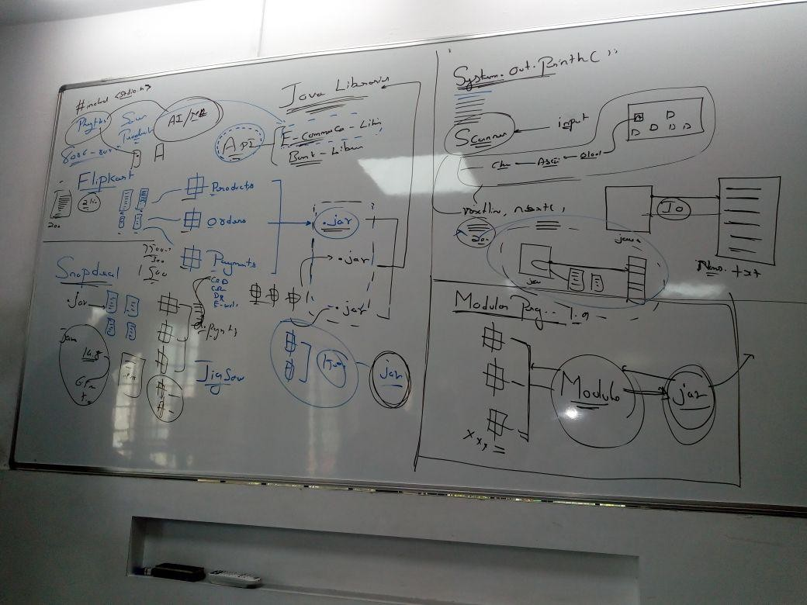

* It is a group of jar file(API) which consists of classes which are used to perform basic or advance level operation in java program
* As part of JDK-9 java introduces modular programming.

## Module

* A module is logical group of packages related to one jar file.
* By using modular we can eliminate the unnecessary packages from the jar files.
* The modular programming JDK-9 was introduced as part of **Jigsaw project**

# Inbuilt Packages Java.lang.package

* java lang package contains the classes and interfaces which are required to write simple java program or to develop complicated java application

## Object Class

* It is the supermost class in java
* Every class directly or indirectly inherits from object class.
* Object class is present in java.lang.package.
* Every methods of Object class is non-static.

## Methods of Object Class :

* hashcode() - int
* toString() - String
* equals(Object ref) - Boolean
* wait() - void -final
* wait(long mills) - void final
* wait(long mills, int num) void final
* notify() - void final
* notifyAll() - void final
* finalize() - void
* clone() - Object
* getClass() - Object final

## hashCode()

* This method returns hashcode value of the given object
* hashCode value is an unique integer value which is generated based on the address of the objct.

## Program

package com.inbuiltpackages.library; public class Mainclass {

public static void main(String[] args) { Object obj1 = new Object(); Object obj2 = new Object();

int h1=obj1.hashCode(); int h2 = obj2.hashCode();

System.out.println("h1 = " +h1); System.out.println("h2 = "+h2);

## }} - op - h1 = 1603195447

**h2 = 792791759**

**toString() –**

* This methods returns string representation of the object.
* The string representation of object contains :

1. fully qualified classname
2. @ character
3. hexadecimal value of hashcode.

## syntax

fullyqualifiedclassname@hexadecimal of hashcode eg: java.lang.Object@4352625

## Program

package com.inbuiltpackages.library; public class Mainclass {

public static void main(String[] args) {

Object obj1 = new Object(); String str = obj1.toString(); System.out.println("str = " +str); System.out.println(obj1);

}

## } op - str = java.lang.Object@5f8ed237

* **Question :** What happens if you try to print a reference variables?
* **Ans :** println() methods implicitely calls toString() method and prints the returned string values.

Object obj = new Object(); string representation

System.out.println(obj);

toString()

## implicitely calls

**Program**

package com.inbuiltpackages.library; public class Mainclass {

public static void main(String[] args) { Object obj1 = new Object(); Object obj2 = new Object();

System.out.println("obj1 = " +obj1); System.out.println("obj2 = " +obj2);

}

## } op - obj1 = java.lang.Object@5f8ed237 obj2 = java.lang.Object@2f410acf

**equals(Object ref)**

* This method compares hashCode value of given two object and returns true if they are equals else it returns false it depends on hashCode.

Program

package com.inbuiltpackages.library; public class Mainclass {

public static void main(String[] args) {

Object obj1 = new Object(); Object obj2 = new Object(); boolean b1 = obj1.equals(obj2); System.out.println(b1);

boolean b2 = obj1.equals(obj1); System.out.println(b2);

}

}

# STRING CLASS (JDK 1.0)

* String is a class which is used to store string values within the string object.
* Note : String value are internally stored in character Array.
* String class is immediate subclass of Object class.

## Program

java.lang.Object java.lang.String

* String class is final class and it can not be inherited.
* String class implements :

1. Serializable
2. comparable
3. charSequence interfaces.

## Program

public final class String extends Object

implements Serializable, Comparable<String>, CharSequence

* **hashCode()** method of object class is overridden in String class which returns an integer value i.e. generated based on ASCII value of characters present in given String values.

## Program

package com.jsp.string; public class Mainclass {

public static void main(String[] args) { String str = new String("hello"); String str2 = new String("hello"); int h1 = str.hashCode();

int h2 = str.hashCode(); System.out.println("h1 = "+h1); System.out.println("h1 = "+h2);

}}

## op –

**h1 = 99162322**

**h2 = 99162322**

* toString() method ob object class is overridden in String class (by the developer of String class) which returns string value present in given string object.

Program

package com.jsp.string; public class Mainclass {

public static void main(String[] args) {

}}

## op –

String str = new String("hello"); String str2 = new String("hello"); String s1 = str.toString();

String s2 = str2.toString(); System.out.println("s1 = "+s1); System.out.println("s2 = "+s2); System.out.println("str = "+str);

## s1 = hello s2 = hello str = hello

* equals() method of object class is overridden in string class which returns true if both string contains same characters else return false.

## Program

package com.jsp.string; public class Mainclass {

public static void main(String[] args) { String str = new String("hello"); String str2 = new String("hello"); String str3 = new String("hey"); boolean b1 = str.equals(str2); boolean b2 = str2.equals(str3); System.out.println("b1 = " + b1); System.out.println("b2 = " +b2);

## }} op - b1 = true

**b2 = false**

* In java string object can be created in two ways :

1. Using new Oprator
2. Without using new operator
3. String object can be also created using concatenation Operator.

String str = new String(“hello”); String s1 = “java”;

String s2 = “java” + str;

* String object are stored in a special memory area called String pool.
* The string pool has two parts :

1. constant pool
2. non-constant pool

* The String object which are created using new operator are stored in non- constant pool.
* Within non-constant pool duplicated are allowed.
* String object which are created without using new operator will be stored in constant pool.
* Within constant pool duplicated are **not allowed**

var + var; var + “ ”;

“ ” + var;

* Using any one of the above combination the resultant string created will be stored in non-constant pool.
* **“ ” + “ ” ;** this is stored in constant pool.

## Program

package com.jsp.string; public class Mainclass2 {

public static void main(String[] args) {

String str1 = new String("java"); **//creating string object** String str2 = " java"; **//creating string object** String str3 = "java"+str2; **//creating string object**

String s1 = new String("java"); String s2 = "java";

String s3 = new String("java");

String s4= "java"; String s5 = "j2ee"; String s6= s1+s5; String s7 = "java"+s5;

String s8 = "java" + "j2ee"; String s9 = "javaj2ee";

System.out.println(s1==s2); //false System.out.println(s1==s3); //false System.out.println(s2==s4); //true System.out.println(s6==s7); // false System.out.println(s8==s9); // true

}

}

constant pool (duplicate not allowed)

## s2 s8

**s8**

non- constant pool (duplicate allowed)

javaj2ee

java

**s4 s9**

j2ee

**s5**

non-constant pool(duplicate allowed)

**s1**

javaj2ee

java

java

**S6**

**s3**

javaj2ee

**S7**

**String Pool**

**Question : String class is immutable class explain ?**

* if you try to change the existing string object, instead of changing the given object a new object will be created with the changes. The reference variable stops pointin to new object.
* The given object now becomes dereferences.
* 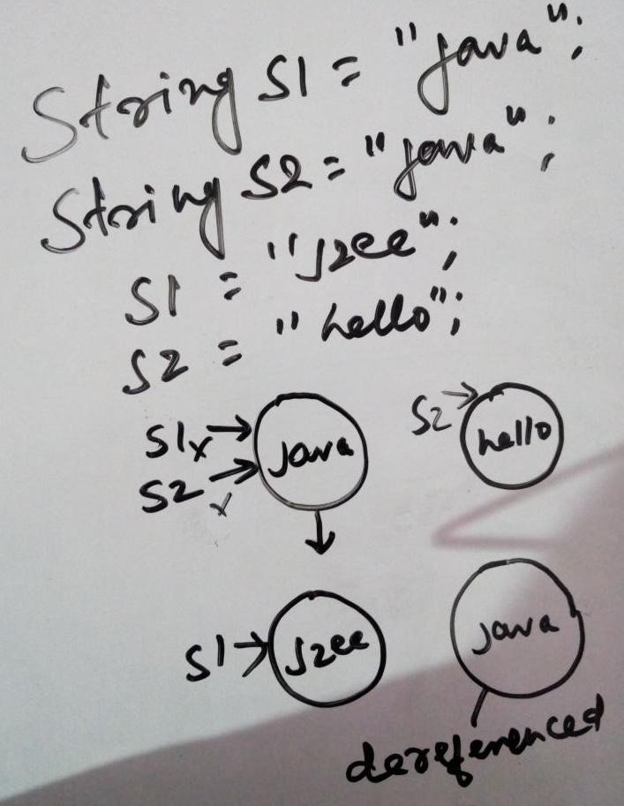only the object is created without using new keyword is immutable.

## Advantages :

* If you referenced variables pointing to same string object then changes done from one reference variable will not effect other reference variables.

## Disadvantages :

* The dereferenced object wil be present in the heap memory for the future use but these referenced object if not controlled results in **OutOfMemoryError**

## Program

package com.jsp.string; public class StringBuffer1 {

public static String firstHalf(String str)

{

int mid = (str.length()-1)/2; String res=" ";

for(int i =0; i<=mid; i++)

{

res = res+str.charAt(i); System.out.println(res); System.out.println(i);

}

return res;

}

public static void main(String[] args)

{

String s1 = new String("aaaaaabbbbbbbbbbbbb"); firstHalf(s1);

}}

## // here 8 derefenced object are created.

* To overcome disadvantages of immutable property of string class java introduced two new classes.
  1. StringBuffer
  2. StringBuilder

**String Function Program** package strings;

public class Mainclass3 {

public static void main(String[] args) { String a = "hello";

String b = "hello";

String c = new String("hello"); String d = "HELLO";

String e = "Jspider java class";

System.out.println("length = "+a.**length()**); //5 System.out.println(a==b); // true System.out.println(a==c); // false System.out.println(a.**equals(b)**); // true System.out.println(a.equals(c)); //true System.out.println(a.equals(d)); // false System.out.println(a.**equalsIgnoreCase**(d)); //true

System.out.println(a.**charAt(2));** //1 System.out.println(a.**concat**(" " +b)); //hello hello System.out.println(a+" " + " "+ b); //hello hello

System.out.println(a.**indexOf("**l")); //2 System.out.println(a.indexOf("l", 1)); //2

System.out.println(a.indexOf("l", 3)); //3 System.out.println(a.**lastIndexOf**("l")); //3

System.out.println(a.**toUpperCase**()); //HELLO System.out.println(d.**toLowerCase**()); //hello

System.out.println(a.**substring**(3)); //lo System.out.println(e.substring(2,10)); //pider ja

System.out.println(a.**compareTo**(d)); // 32 System.out.println(a.**compareToIgnoreCase**(b)); //0

String f = " hello "; System.out.println(f.**trim());** //hello

System.out.println(a.**replace**("h", "w")); //wello

}}

## StringBuffer(JDK 1.0 )

* It is the immediate subclass of object class.
* StringBuffer class is present in java.lang.package
* StringBuffer implements serializable, appendable and charSequence interface.
* StringBuffer class is declared as final and it can not be inherited.
* StringBuffer is mutable class.
* StringBuffer objects can be created only by using new operator.
* StringBuffer is thread-safe class.
* Every method of StringBuffer is synchronized.

## StringBuffer Function

package strings;

public class Mainclass4 {

public static void main(String[] args) {

StringBuffer s = new StringBuffer("javayou"); System.out.println(s.length()); //7 System.out.println(s.capacity());//23

s.**append**("friend"); System.out.println(s); //javayoufriend

s.**insert**(4, "for"); System.out.println(s);//javaforyoufriend

char c [] = {'a', 'a', 't','i','f'}; s.insert(16, c);

System.out.println(s);//javaforyoufriendaatif System.out.println(s.**charAt**(2)); //v

StringBuffer sb = new StringBuffer("javaworld"); sb.**delete**(3, 5);

System.out.println(sb); //javorld

StringBuffer sb1 = new StringBuffer("javaworld"); sb1.deleteCharAt(4);

System.out.println(sb1); //javaorld

StringBuffer sb2 = new StringBuffer("java"); System.out.println(sb2.**reverse**()); //avaj

}

}

**toString()** of object class is overridden in StringBuffer class which returns the string value present in the given StringBuffer Object.

## //inheriting property of object class

package com.jsp.string; public class Mainclass4 {

public static void main(String[] args) {

StringBuffer sb1 = new StringBuffer("hello"); StringBuffer sb2 = new StringBuffer("hello"); int h1 = sb1.hashCode(); **// not overriden**

int h2 = sb2.hashCode(); System.out.println("h1 = "+h1); System.out.println("h2 = "+h2);

String str = sb1.toString(); // **overriden**

System.out.println(sb1);

boolean b1 = sb1.equals(sb2); **// not overriden**

System.out.println(b1);

}

}

## op –

**h1 = 792791759**

**h2 = 1191747167**

**hello false**

**StringBuilder (jdk 1.5)**

* StringBuilder is not thread safe class.
* The methods of StringBuilder class are not synchronize.
* It is the immediate subclass of object class.
* StringBuilder class is present in java.lang.package
* StringBuilder implements serializable, appendable and charSequence interface.
* StringBuilder class is declared as final and it can not be inherited.
* StringBuilder is mutable class.
* StringBuilder objects can be created only by using new operator.
* StringBuilder is not a thread-safe class.
* Every method of StringBuilder is not **synchronized**.

**toString()** of object class is overridden in StringBuilder class which returns the string value present in the given StringBuffer Object.

## //inheriting property of object class

package com.jsp.string; public class Mainclass4 {

public static void main(String[] args) {

StringBuilder sb1 = new StringBuilder("hello"); StringBuilder sb2 = new StringBuilder("hello"); int h1 = sb1.hashCode(); // **not overriden**

int h2 = sb2.hashCode(); System.out.println("h1 = "+h1); System.out.println("h2 = "+h2);

String str = sb1.toString(); // **overriden**

System.out.println(sb1);

}

} **op –**

## Differences

boolean b1 = sb1.equals(sb2); // **not overriden**

System.out.println(b1);

## h1 = 1603195447

**h2 = 792791759**

**hello false**

|  |  |  |
| --- | --- | --- |
| **String** | **StringBuffer** | **StringBuilder** |
| immutable class | Mutable class | Mutable class |
| Not thread safe class | thread safe class | not thread safe |
| methods are not synchronized | methods are  synchronized | methods are not synchronized |
| Objects can be created  with or without using new operator | objects can be created  only by using new Operator | objects can be created  only by using new Operator |
| hashcode(), toString(),  equals() of object class are overridden | only toString() of object class is overriden | only toString() of object class is overriden |

**EXCEPTION HANDLING**

* Exception is an unexpected event which occurs at runtime due to unexpected operations perform by a line of code.
* Exceptions occurs only at runtime.

(i) checked Exception (ii) Unchecked Exception

* Whenever there is an exception JVM creates the objects of the corresponding exception class.
* JVM will **throw** the exception to the method which created the exception. If the method is not able to handle the exception then JVM will terminate the method and removes it from stack.
* 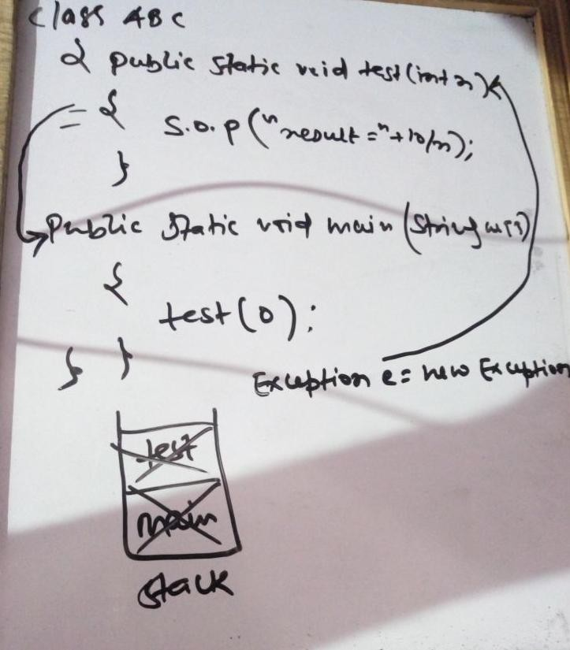JVM will now pass the exception object to the calling method and if the calling method is not able to handle the exception objects then it will be terminated and removed from the stack.
* JVM calls default exception handler to handle an unhandled exception.
* **Default Exception handler** will handle the exception and prints three messages on the screen.

1. Name of the exception class
2. Extra Message
3. Stack Trace

Exception in thread "main" **java.lang.ArithmeticException**: / **by zero**

at com.object.exception.Mainclass4.**test(Mainclass4.java:7)**

at com.object.exception.Mainclass4.**main(Mainclass4.java:12)**

## Program

package com.object.exception; public class Mainclass4 {

public static void test(int n)

{

System.out.println(10/n);

}

public static void main(String[] args)

{

System.out.println("program start"); test(0); System.out.println("program end");

}

}

**op -** Exception in thread "main" **java.lang.ArithmeticException**: / **by zero**

at com.object.exception.Mainclass4.**test(Mainclass4.java:7)**

at com.object.exception.Mainclass4.**main(Mainclass4.java:12) Exception Hierarchy**

Throwable



Error (System Level) Exception (Program Level) OutOfMemoryError LinkageError



Runtime Interupted IOException SqlException .. Exception Exception



ClassCast Arithmatic IllegalArgument IndexOutOfBoundException … Exception Exception Exception

ArrayIndexOutOfBoundException

## try and catch block

try

{ risky codes; } catch (Exception ref_var)

{ Alternate codes; }

* try block contains all riskyline of codes which may throw an exception.
* catch block contains all the alternate codes that should be executed on the event of exception.

## Program

package com.object.exception; public class Mainclass {

public static void test(int n)

{

System.out.println("enter test()"); try

{

System.out.println("result : "+10/n); // **risky line of code**

}

catch(ArithmeticException ref)

{

System.out.println("caught Arithmetic Exception"); System.out.println("invalid number for division");

**//alternate code** } System.out.println("exit test()");

}

public static void main(String[] args) { System.out.println("Program start"); test(0);

System.out.println("Program ends");

}}

## op - Program start enter test()

**caught Arithmetic Exception invalid number for division exit test()**

**Program ends**

* If a line of code throws an exception within the try block then the rest of codes within the try block will be invalid and does not execute.

## Program

package com.object.exception; public class Mainclass6 {

public static void test(int n)

{

System.out.println("enter test"); try

{

System.out.println("result : "+10/n); System.out.println("hello"); // **this line of code is not printed**

}

catch(ArithmeticException ref)

{

System.out.println("caught Arithmetic Exception"); System.out.println("invalid number for division");

}

System.out.println("exit test()");

}

public static void main(String[] args) {

}

}

## op-

System.out.println("Program start"); test(0);

System.out.println("Program ends");

## Program start enter test

**caught Arithmetic Exception invalid number for division exit test()**

**Program ends**

**try with multiple catch block**

* for a single try block we can write any number of catch blocks.

## Program

package com.object.exception; public class Mainclass {

public static void test(int n)

{

int a1 [] = {10,20,30};

System.out.println("enter test"); try **// one try block**

{

System.out.println("result : "+10/n); System.out.println("array element : "+a1[n]);

}

catch(ArithmeticException ref) **// multiple catch statement**

{

System.out.println("caught Arithmetic Exception"); System.out.println("invalid number for division");

}

catch(ArrayIndexOutOfBoundsException ref2) **// multiple catch statement**

{

System.out.println("ArrayIndexOutOfBoundsException"); System.out.println("invalid index");}

System.out.println("exit test()");

}

public static void main(String[] args) { System.out.println("Program start"); test(5);

System.out.println("Program ends");

}}

## op - Program start enter test result : 2

**ArrayIndexOutOfBoundsException invalid index**

**exit test() Program ends**

**Generic try-catch block Program**

package com.object.exception; public class Mainclass2 {

public static void test(int n)

{

System.out.println("enter test"); int a1 [] = {10,20,30};

String s1 = "hello";

Object obj = s1; // **upcasting of string into object class**

try

{

System.out.println("result : "+10/n); System.out.println("array element : "+a1[n]);

StringBuffer sb1 = (StringBuffer)obj; **//direct downcasting of object class into StringBuffer throw ClassCastException**

## }

catch(Exception e)

{

e.printStackTrace();

}

}

public static void main(String[] args) { System.out.println("Program start"); test(2);

System.out.println("Program ends");

}}

## Program start enter test result : 5

**array element : 30**

**java.lang.ClassCastException: java.base/java.lang.String cannot be cast to java.base/java.lang.StringBuffer**

**at com.object.exception.Mainclass2.test(Mainclass2.java:16) at com.object.exception.Mainclass2.main(Mainclass2.java:27)**

**Program ends**

**printStackTrace()**

* This methods print three msg.

1. Name of the exception class.
2. Extra Message
3. Stack Trace.

## Program

catch(Exception e)

{

e.printStackTrace();

}

## Checked Exception

* Exceptions which are checked by the compiler at compile time are called as checked exceptions.
* All the exceptions which are immediate subclass (ignore Runtime Exception) are checked Exceptions.
* eg. InteruptedException, IOException, SqlException

## Program

package com.object.exception; public class Mainclass4 {

public static void test(int n)

{

## Thread.sleep(1000); // checked Exception at compiletime

}

public static void main(String[] args)

{

System.out.println("program start"); test(0); System.out.println("program end");

}}

**op-** Exception in thread "main" program start java.lang.Error: Unresolved compilation problem:

Unhandled exception type **InterruptedException**

at com.object.exception.Mainclass4.test(Mainclass4.java:7)

at com.object.exception.Mainclass4.main(Mainclass4.java:12)

## Unchecked Exception

* Exceptions which are not checked by the compiler at compile time are called as unchecked Exceptions.
* All the exceptions which are subclass of RuntimeExceptionClass are unchecked exception.

## Exceptions Propogation:

* Passing the exceptions object from called method to calling method is known as Exception Propogation.
* Unchecked exceptions will be propagated implicitely by JVM.
* we can handle the exceptions of called methods in calling method.

## Program

package com.object.exception; public class Mainclass4 {

public static void test(int n) // **called method**

{

System.out.println("result = "+10/n);

}

public static void main(String[] args)

{

System.out.println("program start");

## try // handle the exception in calling method

{

test(0);

}

catch (ArithmeticException ae)

{

ae.printStackTrace();

}

System.out.println("program end");

}}

## Op

program start

java.lang.ArithmeticException: / by zero

at com.object.exception.Mainclass4.test(Mainclass4.java:7)

at com.object.exception.Mainclass4.main(Mainclass4.java:14) program end

## throws keyword :

* throws keyword is used to propagate checked exceptions from called method to calling method explicitely.
* throws keyword should be written with method declaration.
* Using throws keyword we can propagate both checked and unchecked exceptions.

## Program

package com.object.exception; public class Mainclass3 {

public static void test(int n) **throws** Exception

{

System.out.println("enter test"); System.out.println("result : "+10/n); System.out.println("exit test"); **Thread.sleep(2000);** //**checked exception**

}

public static void main(String[] args) { System.out.println("Program Start"); try

{

test(0);

}

catch (Exception e)

{

e.printStackTrace();

}

## object :

System.out.println("Program end");

}}

java.lang.ArithmeticException: / by zero Program Start

enter test

at com.object.exception.Mainclass3.test(Mainclass3.java:8)

at com.object.exception.Mainclass3.main(Mainclass3.java:18) Program end

* we can also call number of methods from calling propagated try block

## Program

package practice; public class Abc

{

public static void test(int x)

{

System.out.println("result ="+10/x);

}

public static void count(int y)

{

int a[]= {10,20,30};

System.out.println(a[y]);

}

public static void main(String[] args) {

try

{

}

test(10); **//calling the method**

count(5); **//calling the method**

catch(Exception e)

{

}

}

op –

e.printStackTrace();

}

result =1

java.lang.ArrayIndexOutOfBoundsException: 5 at practice.Abc.count(Abc.java:12)

at practice.Abc.main(Abc.java:20)

## throw keyword

* throw keyword is used to throw the exceptions explicitely.
* throw keyword is written within the method definition.

## Program

public double getBal(int actno)

{

if(this.actno==actno)

{

}

else

{

return bal;

String msg = "invalid actno";

IllegalArgumentException ie = new IllegalArgumentException(msg); throw ie; **// throw keyword inside a method**

}}}

* After throw keyword it is not possible to write any other line of codes.

## Program

public double getBal(int actno)

{

if(this.actno==actno)

{

}

else

{

return bal;

String msg = "invalid actno";

IllegalArgumentException ie = new IllegalArgumentException(msg); throw ie;

System.out.println("hello"); **// throw a compile time error**

}}}

* we can pass extra message about the exception with the constructor of exception class.

## Program

String msg = "invalid actno";

IllegalArgumentException ie = new IllegalArgumentException(msg);

## Program

package com.object.exception; class Account1

{

private int actno=1234;; private double bal=520.5;

public double getBal(int actno)

{

if(this.actno==actno)

{

}

else

{

return bal;

String msg = "invalid actno";

IllegalArgumentException ie = new IllegalArgumentException(msg);

throw ie;

}

}}

public class Mainclass8

{

public static void main (String ar[])

{

Account a = new Account(); double b = a.getBal(1234); System.out.println("balance ="+b);

}

}

## output – balance = 520.5

**DATA STRUCUTRE**

* It is a particular way of arranging the data to use them efficiently in the programs.
* Data Strucutre are of two types :

1. Linear Data Structure
2. Non Linear Data Structure

## Linear Data Structure

* It is a type of data structure where the data is stored one next to another in a linear order or sequences. eg, stack, queue, linked list

## Non- Linear Data Structure

* It is a type of data structure where the data is stored according to some relation. eg, tree, graph

## Linear Data Structure Array

* Array is an object in java.
* To create an array we always use new operator.
* The array variable is actually a reference variable which always points to array object.
* The size of the array can be specified using byte, short and int.
* If you specifiy an arraysize with –ve number then jvm throws negative array size exception at runtime.

## Program

public class Mainclass {

public static void main(String[] args) {

int s1= -2; // array can not be in negative size int [] a2=new int[s1]; System.out.println(a2.length);

}}

**op - Exception in thread "main" java.lang.NegativeArraySizeException at com.ds.arrays.Mainclass.main(Mainclass.java:11)**

* An array can be declared as zero. This array have zero bucket and it is not possible to store any data inside this array.

## Program

package com.ds.arrays; public class Mainclass {

public static void main(String[] args) {

int s3= 0; // **array can be declared with 0**

int [] a3=new int[s3];

a3[0]= 10; // **but we can not store any value**

System.out.println(a3.length);

}}

**op-Exception in thread "main" java.lang.ArrayIndexOutOfBoundsException: 0 at com.ds.arrays.Mainclass.main(Mainclass.java:16)**

## Stack Program

**package** com.ds.stack;

**class** MyStack {

**private final int** DEFAULT_SIZE = 5;

**private int** [] stack ; **private int** size = 0; **private int** top = -1;

**private int** capacity=0; // to display the holded element_user used

**public** MyStack()

{

stack = **new int** [DEFAULT_SIZE]; capacity = DEFAULT_SIZE;

}

**public** MyStack(**int** user_size)

{

stack = **new int** [user_size]; capacity = user_size;

}

**public boolean** push (**int** value)

{

**if** (size != stack.length)

{

stack [++top]= value; size ++; //

}

**else**

{

}

}

## return true;

**return false**;

**public int** pop()

{

**if**(size !=0)

{

}

**else**

{

size--;

**return** stack [top--];

String msg = "stack is empty";

IndexOutOfBoundsException e1 = **new** IndexOutOfBoundsException(msg);

**throw** e1;

}

}

**public int** getsize ()

{

**return** size;

}

**public int** getCapacity()

{

**return** capacity;

}

}

**public class** Test {

**public static void** main(String[] args)

{

Mainclass m = **new** Mainclass();

## boolean b;

**for** (**int** i =0; i<m.getCapacity();i++)

{

b=m.push(225); System.***out***.println(b);

}

**for**(**int** i=0;i<m.getCapacity();i++ )

{

**int** a =m.pop();

System.***out***.println(a);

}

}

}

/* in the case of pop element if you use getsize() then in this case every element is not printed

* because at a when i becomes greater than size because every time size get decremented
* and for loop terminated, thats y we use m.getCapacity() because capacity remains same
* as the size and does not change.

* */

## Queue

**op – true true true true true 225**

**225**

**225**

**225**

**225**

**package** com.ds.queue;

**class** MyQueue1 {

**private final int** DEFAULT_SIZE = 5;

**private int**[] queue; **private int** size = 0; **private int** start = -1; **private int** capacity = 0; **private int** end = -1;

**public** MyQueue1()

{

queue= **new int** [DEFAULT_SIZE]; //initialize the array capacity = DEFAULT_SIZE;// store default size into capacity

}

**public** MyQueue1(**int** user_size)

{

queue = **new int** [user_size]; // intialize the array capacity = user_size; // store user size into capacity

}

**public boolean** eQueue(**int** value)

{

**if**(size!=queue.length)//check the size of queue

{

}

**else**

{

}

}

queue[++end]=value; // add the element into queue size++; // increment the size

**return true**; //

**return false**;

**public int** dequeue()

{

{

}

**else**

{

**if**(size !=0)// check the size of queue

**int** v1 = queue[++start]; // dequeue element size--; // decrement the size of queue **return** v1;

String msg = "queue is empty";

IndexOutOfBoundsException e1 = **new** IndexOutOfBoundsException(msg);

**throw** e1;

}

}

**public int** size() // to get access of private data members

{

**return** size;

}

**public int** getCapacity()

{

**return** capacity;

}

}

**public class** test {

**public static void** main(String[] args) { MyQueue m1 = **new** MyQueue();

**boolean** b1;

**for**(**int** i=0; i<=m1.getCapacity(); i++)

{

b1=m1.eQueue(10); b1=m1.eQueue(20); b1=m1.eQueue(30); System.***out***.println(b1);

}

**for**(**int** i=0; i<m1.getCapacity();i++)

{

## LinkedList

}}}

System.***out***.println(m1.dequeue());

## op- true false false false false false 10

**20**

**30**

**10**

**20**

Nodes Linked List Has-A



Node

data : int

next : node size : int

Linked List

1:n

Composition

- A Node can be considered as an object which contains two parts.

(i) Data (ii) Address of next node

Address of next node

Data

## Program

**package** com.ds.linkedlist;

**class** Node1 {

**int** data; Node next;

**public** Node1(**int** data)

{

**this**.data=data;

}

**public void** setNext(Node next)

{

**this**.next=next;

}

**public** Node getNext()

{

**return** next;

}

}

**class** MyLinkedList1 {

**private int** size=0; **private** Node first; **private** Node last;

**public** MyLinkedList1()

{

first=**null**; last=**null**;

}

**public boolean** addToLast(**int** value)

{

Node n1= **new** Node(value);// create the object of node class size++; // update size whenever an object is created **if**(first==**null**) // if the size is null

{

first=n1; // last=n1;

}

**else**

{

}

last.setNext(n1); last=n1;

**return true**;

}

**public int** getValue(**int** position)

{

**if**(position<=size)

{

**if**(position==1)

{

**return** first.data;

}

}

**else**

{

**else if** (position==size)

{

**return** last.data;

Node temp =first.getNext();

**for**(**int** i=2;i<position;i++)

{

temp=temp.getNext();

}

**return** temp.data;

}

}

**else**

{

String msg = "invalid position"; IllegalArgumentException ie = **new** IllegalArgumentException(msg);

**throw** ie;

}

}

**public int** size()

{

**return** size;

}

}

**public class** Test {

**public static void** main(String[] args) {

MyLinkedList m1 = **new** MyLinkedList(); m1.addToLast(20);

m1.addToLast(40); m1.addToLast(60); m1.addToLast(80); m1.addToLast(100); m1.addToLast(120); m1.addToLast(140);

**int** v1 = m1.getValue(2); System.***out***.println(v1);

System.***out***.println(" ");

**int** sz = m1.size();

**for**(**int** i =1; i<=sz;i++)

{

}}}

**int** v2 = m1.getValue(i); System.***out***.println(v2);

## op – 40

**------------ 20**

**40**

**60**

**80**

**100**

**120**

**140**

**OBJECT ARRAY**

* It is a type of array where every bucket of the array represents a reference variable of the given class or interface.
* Syntax :

classname [] ref_var = new classname[size]; eg :

Employee [] e1 = new Employee[5]; e1[0]=new Employee(“blake”, 1234); e1[0].name;

ref_Var



**0 1**

**2**

**3**

**4**

**5**

name =

blake id= 1234

|  |  |  |  |  |  |
| --- | --- | --- | --- | --- | --- |
|  |  |  |  |  |  |

## Program

package com.arry.objectarray; class Employee

{

String name; int id; double bal;

Employee(String name, int id, double bal)

{

this.name=name; this.id=id; this.bal=bal;

}}

public class Mainclass {

public static void main(String[] args) { Employee[] emplist = new Employee[2];

emplist[0]= new Employee("blake", 142,252.5); emplist[1]= new Employee("Martin", 122,525.5);

processSalary(emplist);

}

public static void processSalary(Employee[] emp)

{

for(int i=0; i<emp.length;i++)

{

## eg :

}}}

System.out.println("name = "+emp[i].name); System.out.println("Id = "+emp[i].id); System.out.println(" ");

## Program 2

name = blake Id = 142

-----------

name = Martin Id = 122

-----------

package com.arry.objectarray; class VehicleCar

{

String model; String name; double price;

VehicleCar(String model, String name, double price)

{

this.model=model; this.name=name; this.price=price;

}

@Override

public String toString()

{

return "Model = " +model + "Name = "+ name + " price = " +price ;

}}

class VehicleBike

{

String model; String name; double price;

VehicleBike(String model, String name, double price)

{

this.model=model; this.name=name; this.price=price;

}

@Override

public String toString()

{

return "Model = " + model + " Name = "+name + " price = " +price ;

}

}

class Mainclass

{

public static void main(String[] args) {

Object [] vList = new Object[4];

vList[0]= new VehicleCar("honda", " city", 25.2); vList[1]= new VehicleCar("hyundai", "i20", 8.20); vList[2]= new VehicleBike("KTM", "Duke", 1.75); vList[3]= new VehicleBike("Royal", "Classic", 2.75); showVehicleDetails(vList);

}

public static void showVehicleDetails(Object[] ref)

{

}}

## output

for(int i = 0; i<ref.length;i++) System.out.println(ref[i]);

Model = hondaName = city price = 25.2 Model = hyundaiName = i20 price = 8.2 Model = KTM Name = Duke price = 1.75 Model = Royal Name = Classic price = 2.75

---------

## Collection

**COLLECTION FRAMEWORK**

* A collection is group of references which is represented as one entity.
* collections a growable in nature and the size of collection can be changed at runtime.
* Collections supports heterogeneous data.
* Every collection will have atleast one underlying data structure.
* Every collection will have inbuilt methods which are useful to perform basic or advance operation on the data present in the collections.
* Collection framework is built in java to help the programmers and provide the API which will abstract the effort of building the data structure.

## Collection Framework

* It is a group of class and interfaceswhich is present in java.util packages to perform operation on dynamic data

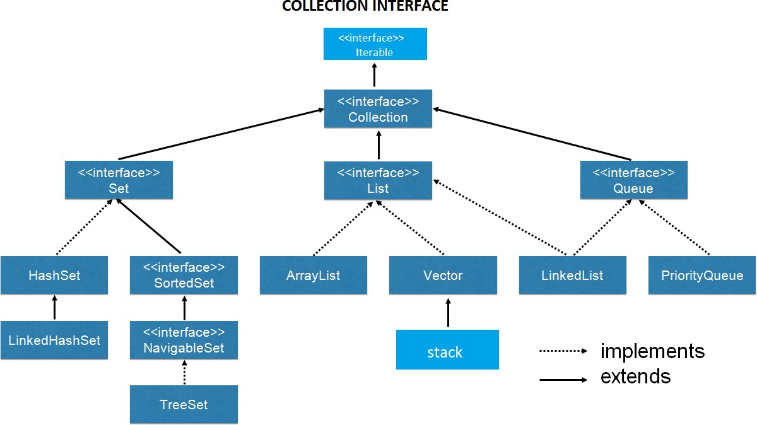

# LIST

## Types of List

* ArrayList
* Linked List
* Stack
* Vector

## Features of List

* Duplicates are allowed
* Indexed type collection
* Multiple Null values are allowed.
* Insertion order is preserved.

## ArrayList (JDK 1.2)

* Arraylist implements list, collection, iterable seralizable, cloneable and random access interfaces.
* The underline data structure for arraylist is resizable array.
* The time required to retrieve first element or last element of arraylist is always constant or same.

## Constructor

* **Arraylist()**

Construct an empty list with an initial capacity of ten.

## Arraylist(int intial capacity)

Construct an empty list with the specified intial capacity.

## Arraylist(Collection e)

This Constructor creates a list by converting given collection.

## Program 1

package com.ds.collectionframework; class Employee

{

String name; int id; double sal;

Employee(String name, int id, double sal)

{ this.name=name;

this.id=id; this.sal=sal;

} }

## Program2 to usitilize it

//arraylist Program

package com.ds.collectionframework; import java.util.ArrayList;

public class Mainclass {

public static void main(String[] args) { ArrayList emplist = new ArrayList();

emplist.add(new Employee ("Blake", 1234, 2341.3));

emplist.add(new Employee ("Sundar", 1274, 2346.3)); processSalary(emplist);

}

public static void processSalary(ArrayList ref)

{

for (int i =0; i<ref.size(); i++)

{

}}}

## Functions of ArrayList

Employee e1 = (Employee) ref.get(i); System.out.println("name = "+e1.name); System.out.println("salary = "+e1.sal);

package com.jsp.arraylist;

import java.util.*;

public class Mainclass2 {

public static void main(String[] args) {

ArrayList a = new ArrayList(); System.out.println("initial size = "+a.size());

## //initial size = 0

a.add("aatif");

a.add("salman"); System.out.println("size "+a.size());

## // size = 2

System.out.println("elements present "+a);

**//elements present [aatif, salman]** a.remove("salman"); System.out.println("elements present "+a);

**//elements present [aatif]** a.add("salman"); System.out.println("elements present "+a);

**//elements present [aatif, salman]** a.add(0,"satya"); System.out.println("elements present "+a);

## //elements present [satya, aatif, salman]

* 1. emove(0);

System.out.println("elements present "+a);

## //elements present [aatif, salman]

* 1. et(1, "sadaf"); System.out.println("elements present "+a);

## //elements present [aatif, sadaf]

int pos= a.indexOf("aatif"); System.out.println("position of = "+pos);

## //posiition of = 0

int pos1= a.indexOf("preeti"); System.out.println("position of = "+pos1);

## //position of = -1

String sb = (String) a.get(1); //upcasted to object type System.out.println("at index = " +sb);

## //at index = sadaf

Boolean b = a.contains("salman"); System.out.println(b); // returns false a.clear();

System.out.println("Elements after clear " +a);

## //elements after clear = []; empty

}}

## When there is two type of data stored in Arraylist Program

package com.ds.collectionframework; import java.util.*;

abstract class A

{

String model; String name; double price;

public abstract String toString();

}

class Car extends A

{

public Car(String model, String name, double price)

{

this.model=model; this.name=name; this.price=price;

}

@Override

public String toString()

{

return "Model = " + model + " Name = "+name + " price = " +price ;

}

}

class Bike extends A

{

public Bike(String model, String name, double price)

{

this.model=model; this.name=name; this.price=price;

}

@Override

public String toString()

{

return "Model = " + model + " Name = "+name + " price = " +price ;

}

}

public class Mainclass3 {

public static void main(String[] args) {

ArrayList vlist = new ArrayList();

vlist.add(new VehicleCar("honda", " city", 25.2)); vlist.add(new VehicleCar("hyundai", "i20", 8.20)); vlist.add(new VehicleBike("KTM", "Duke", 1.75)); vlist.add(new VehicleBike("Royal", "Classic", 2.75));

showVehicleDetails(vlist);

}

public static void showVehicleDetails(ArrayList ref)

{

for(int i=0; i<ref.size();i++)

{

if (ref.get(i)instanceof VehicleCar)

{

op-

}}}}

}

else

{

VehicleCar c1 = (VehicleCar)ref.get(i); System.out.println(c1);

VehicleBike b1 = (VehicleBike)ref.get(i); System.out.println(b1);

## Model = hondaName = city price = 25.2 Model = hyundaiName = i20 price = 8.2 Model = KTM Name = Duke price = 1.75 Model = Royal Name = Classic price = 2.75

**or Program 1st program**

package com.ds.collectionframework; class VehicleCar

{

String model; String name; double price;

VehicleCar(String model, String name, double price)

{

this.model=model; this.name=name; this.price=price; }

@Override

public String toString()

{

return "Model = " +model + "Name = "+ name + " price = " +price ;

}}

class VehicleBike

{

String model; String name; double price;

VehicleBike(String model, String name, double price)

{

this.model=model; this.name=name; this.price=price;

}

@Override

public String toString()

{

return "Model = " + model + " Name = "+name + " price = " +price ;

}}

## Program 2 to implement it

package com.ds.collectionframework; import java.util.*;

public class Mainclass7 {

public static void main(String[] args) { ArrayList vlist = new ArrayList();

vlist.add(new VehicleCar("honda", " city", 25.2)); vlist.add(new VehicleCar("hyundai", "i20", 8.20)); vlist.add(new VehicleBike("KTM", "Duke", 1.752)); vlist.add(new VehicleBike("Royal", "Classic", 2.75)); showVehicleDetails(vlist);

}

public static void showVehicleDetails(ArrayList ref)

{

for(int i=0; i<ref.size();i++)

{

}}}

Object obj= ref.get(i); System.out.println(ref.get(i)); System.out.println(" ");

## op –

**Model = hondaName = city price = 25.2**

**--------**

**Model = hyundaiName = i20 price = 8.2**

**--------**

**Model = KTM Name = Duke price = 1.752**

**--------**

**Model = Royal Name = Classic price = 2.75**

**--------**

**Generics**

* Generics in collection are used to achieve two goals.

1. type-safety by writing : collection<classname>
2. Avoid unnecessary downcasting of object.

## Program

package com.ds.collectionframework; import java.util.ArrayList;

public class Mainclass6 {

public static void main(String[] args) {

ArrayList<Employee> emplist = new ArrayList<Employee>(); emplist.add(new Employee ("Blake", 1234, 2341.3));

emplist.add(new Employee ("Sundar", 1274, 2346.3)); processSalary(emplist);

}

public static void processSalary(ArrayList<Employee> ref)

{

for (int i =0; i<ref.size(); i++)

{

}}}

## op- name = Blake

**salary = 2341.3 name = Sundar salary = 2346.3**

Employee e1 = (Employee) ref.get(i); System.out.println("name = "+e1.name); System.out.println("salary = "+e1.sal);

**Functions of Stack import** java.util.Stack; **public class** A {

**public static void** main(String[] args) { Stack s = **new** Stack();

System.***out***.println("initial size = "+s.size());

//initial size = 0 s.add("aatif");

s.add("salman");

s.add("preeti"); System.***out***.println("elements present = "+s);

//elements present = [aatif, salman, preeti] s.remove("preeti"); System.***out***.println("elements present = "+s);

//elements present = [aatif, salman] s.add(0, "satya");

System.***out***.println("elements present = "+s);

//elements present = [satya, aatif, salman] s.set(0, "sadaf");

**int** pos = s.indexOf("aatif"); System.***out***.println(pos);

//1

**int** pos1 = s.indexOf("bholu"); System.***out***.println(pos1);

//-1

String sb = (String)s.get(1); System.***out***.println("At index ="+ sb);

//At index =aatif

Boolean b = s.contains("aatif"); System.***out***.println(b);

//true

Boolean b1 = s.contains("jeet"); System.***out***.println(b1);

//false s.clear();

System.***out***.println("elements present = "+s);

//elements present = []

}

}

## for each loop / enhanced loop/advance loop

* for each loop helps the programmer to iterate collections and arrays without worrying about index, size and type of the arrays & collections.

## Syntax

for(classname ref_Var : ref_var of collection & Array)

for eg :

for(Employee e1 : ref)

{ ref

S.O.P(e1.name);

S.O.P(e1.sal);

}

arraylist

object object

## Program

//arraylist Program

package com.ds.collectionframework; import java.util.ArrayList;

public class Mainclass6 {

public static void main(String[] args) {

ArrayList<Employee> emplist = new ArrayList<Employee>(); emplist.add(new Employee ("Blake", 1234, 2341.3));

emplist.add(new Employee ("Sundar", 1274, 2346.3)); processSalary(emplist);

}

public static void processSalary(ArrayList<Employee> ref)

{

for(Employee e1 : ref)

{

## op - Blake 2341.3

**Sundar 2346.3**

}}}

System.out.println(e1.name); System.out.println(e1.sal);

## for-each Method()

* This method is introduced from JDK 1.8 which helps the programmer to iterate collections.
* For-each method acceps consumer(interface) type references.

## Consumer interface

* It is a functions interface which contains only one abstract method by the name Accept(T t)

## Program

package com.ds.collectionframework;

## //use of for each method

import java.util.ArrayList;

import java.util.function.Consumer; public class Mainclass9 {

public static void main(String[] args) { ArrayList<String> a1 = new ArrayList<String>();

a1.add(new String("hello")); a1.add(new String("java")); a1.add(new String("Android")); for(int i=0; i<a1.size();i++)

{

String str = a1.get(i); System.out.println(str.length());

//**System.out.println(a1.get(i).length());** we can also write like that }

## /we can also write like this lambda function

Consumer<String> ref = (String s1)->

{

System.out.println(s1.length()); };

a1.forEach(ref);

//we can also write like this lambda function

## Consumer <String> ref1= (String s2) -> System.out.println(s2.length());

a1.forEach(ref1);

//we can also write like this lambda function

## a1.forEach((String s3)-> System.out.println(s3.length()));;

//we can also write like this lambda function

## a1.forEach(s4-> System.out.println(s4.length()));

}}

## Vector (JDK 1.0)

* All the methods are synchronized
* Vector is thread safe class.
* Vector implements list, collection, iterable seralizable, cloneable and random access interfaces.
* The underline data structure for Vector is resizable array.
* The time required to retrieve first element or last element of Vector is always constant or same.

## Constructor

* **Vector()**

Construct an empty list with an initial capacity of ten.

## Vector(int intial city)

Construct an empty list with the specified intial capacity.

## Vector(Collection e)

This Constructor creates a list by converting given collection.

## Note :

* The load factor decides when should be new collection created to add new elements.
* The load factor of arrraylist and vector is 100% or 1.
* The new capacity of arraylist is calculated using the below formulae.

New Capacity = (old capacity*3/2)+1

* New Capaicty of vector is calculated with below formulae.

New Capacity = old capacity *2

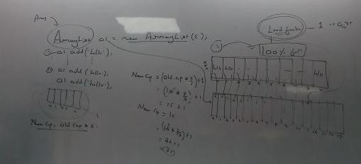

**SET**

* Set do now allow duplicates.
* Set do not have index.
* only one null value can be stored.
* insertion order is not preserved.

## (a) Set do not allow duplicates Program

package com.cf.set; import java.util.HashSet; public class Mainclass1 {

public static void main(String[] args) {

HashSet<String> h = new HashSet<String>(); h.add(new String("hello"));

h.add(new String("hello")); h.forEach(s4-> System.out.println(s4));

}}

## op – hello

* **Set do not have index.**

**Program**

import java.util.HashSet;

import java.util.function.Consumer; public class Mainclass1 {

public static void main(String[] args) { HashSet<String> h = new HashSet<String>();

h.add(new String("hello"));

h.add(new String("hi"));

h.add(new String("java"));

h.forEach(s4-> System.out.println(s4));

}}

## op - hi java hello

* **only one null value can be stored.**

**Program**

import java.util.HashSet;

public class Mainclass1 {

public static void main(String[] args) { HashSet<String> h = new HashSet<String>(); h.add(new String("hello"));

String s=null; String b = null; h.add(s);

h.add(b);

h.add(new String("java")); h.forEach(s4-> System.out.println(s4));

}}

## op – null java hello

* **insertion order is not preserved.**

**Program**

import java.util.HashSet;

import java.util.function.Consumer; public class Mainclass1 {

public static void main(String[] args) {

HashSet<String> h = new HashSet<String>(); h.add(new String("hello"));

h.add(new String("hi"));

h.add(new String("java"));

h.forEach(s4-> System.out.println(s4));

}}

## op - hi java hello

**hashSet**

* hashSet implements iterable, collection, set, clonable and serializable interfaces.
* The underline data structure for hashset is hash table.
* hashSet preserve uniqueness by compairing hashcode value of given objects.

## Constructors of hashSet:

1. public hashSet()

construct a new empty set with default initial capacity(16) and load factors (0.75)

1. public hashSet(int initialcapacity)

construct a new empty set with given initial capacity and load factor(0.75)

1. public hashset(int initialcapaicty, float loadfactor)

construct a new empty set with given initial capacity and load factor.

1. public hashSet(Collection c)

construct a new set with given collection.

* if you try to add duplicates value, we don’t get any compile time error and runtime exceptions.

## Adding unique user defined object :

* if you want to add unique user defined object to the set then you should override hashcode method and equals method in the given user defined class.

## Program

package com.cf.set; public class Employee {

String name; int id; double sal;

Employee(String name, int id, double sal)

{ this.name=name;

this.id=id; this.sal=sal;

}

@Override

public boolean equals(Object obj)

{

Employee emp=(Employee)obj; if(this.hashCode()==emp.hashCode())

{

else

{

}}

@Override

return true; }

return false;

public int hashCode()

{

return id;

}

@Override

public String toString()

{

}}

## 2nd Program

String info = name + " " +id + " "+ sal; return info;

package com.cf.set; import java.util.HashSet; public class Mainclass3 {

public static void main(String[] args) { HashSet<Employee> hs = new HashSet<Employee>();

hs.add(new Employee("Blake",101,2012.2)); hs.add(new Employee("Rohit",102,2052.2)); hs.add(new Employee("Blake",101,2012.2)); hs.forEach(emp -> System.out.println(emp));

}}

## op - Blake 101 2012.2

**Rohit 102 2052.2**

**LinkedHashSet**

* The underline data structure is hashtable and linkedList.
* LinkedHashSet preserve insertion order

## Program

import java.util.HashSet; import java.util.LinkedHashSet;

public class Mainclass5 {

public static void main(String[] args) { LinkedHashSet<String> hs = new LinkedHashSet<String>();

hs.add(new String("hello")); hs.add(new String("java")); hs.add(new String("android"));

hs.forEach(str -> System.out.println(str));

}

}

## op – hello java android

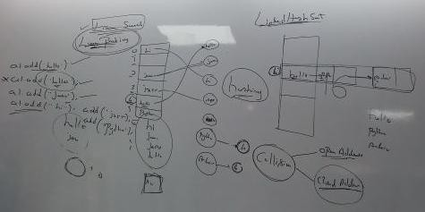

**TREE DATA STRUCTURE**

* A tree is a **non-linear data structure** which contains group of nodes and links.
* Nodes: The node of tree consists of three parts :
  1. Data
  2. Address of left node
  3. Address of right node

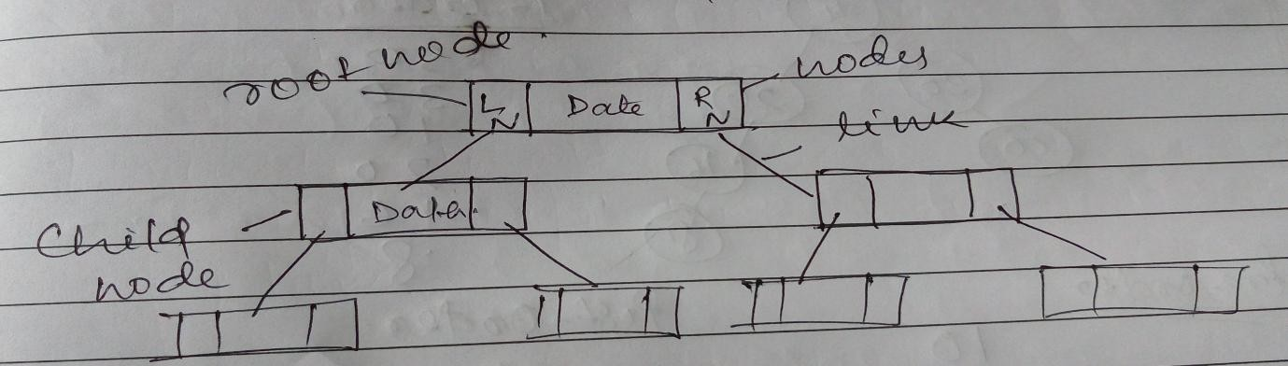

* **Link –** The link defines relation between given two nodes.
* The topmost node of the tree is called root node.

## Binary Tree

* It is a type of tree where every parent node can have minimum zero child nodes or maximum 2 child nodes.
* In Order to retrieve the elements from the tree we have to traverse through every nodes of the given tree.
* we can traverse through the tree using three different order

1. inorder- left, parent, right
2. pre-order – Parent, left, right
3. post-order – left, right, parent

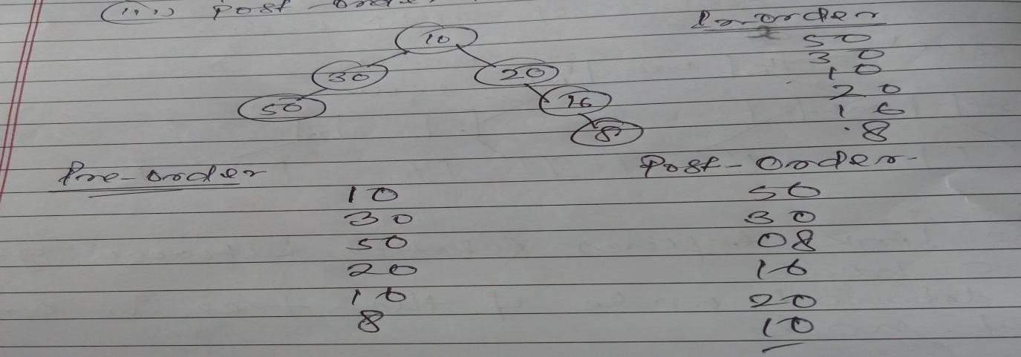

## Tree Collection

* TreeSet do not allow duplicates.
* Treeset do not have any index, **but return sorted result.**
* TreeSet do not allow null values.
* TreeSet do not preserve insertion order.
* All elements inserted into the set must implements the comparable interfaces.
* The elements added to the treeSet can be ordered(sorted) in two ways:

1. Natural Ordering
2. Customized Ordering

## TreeSet do not allow duplicates.

**Program**

import java.util.TreeSet; public class Mainclass {

public static void main(String[] args) {

TreeSet<String> ts = new TreeSet<String>(); ts.add("java");

ts.add("android");

ts.add("java");

ts.forEach(str -> System.out.println(str));

## }} op – android

**java**

1. **Treeset do not have any index, but return sorted result.**

**Program**

import java.util.TreeSet; public class Mainclass {

public static void main(String[] args) {

TreeSet<String> ts = new TreeSet<String>(); ts.add("java");

ts.add("android");

ts.add("java");

ts.add("bigdata");

ts.add("python");

ts.add("eclipse");

ts.add("class");

ts.forEach(str -> System.out.println(str));

}}

## op - android bigdata class eclipse java python

1. **TreeSet do not allow null values.**

package com.jsp.treeset;

import java.util.TreeSet; public class Mainclass {

public static void main(String[] args) {

TreeSet<String> ts = new TreeSet<String>(); ts.add("java");

ts.add("android"); ts.add(null);

ts.forEach(str -> System.out.println(str));

}}

## op – here it throw a runtime exception as

**Exception in thread "main" java.lang.NullPointerException**

**at java.base/java.util.TreeMap.put(Unknown Source) at java.base/java.util.TreeSet.add(Unknown Source) at com.jsp.treeset.Mainclass.main(Mainclass.java:10)**

**(i) Insertion order is not preserved Program**

import java.util.TreeSet; public class Mainclass {

public static void main(String[] args) {

TreeSet<String> ts = new TreeSet<String>(); ts.add("java");

ts.add("android");

ts.add("java");

ts.add("bigdata");

ts.add("python");

ts.add("eclipse");

ts.add("class");

ts.forEach(str -> System.out.println(str));

}}

## op - android bigdata class eclipse java python

**Comparable Interface**

* This interface helps in compairing the java object with the user defined order.
* Comparable interface contains one abstract method by the name compareTo(Object ref).
* compareTo method returns positive number, if given object is greater than another object.
* compareTo method return negative number if given object is smaller or lesser than another object.
* compareTo method returns zero if given object is equal to another object or having same value.

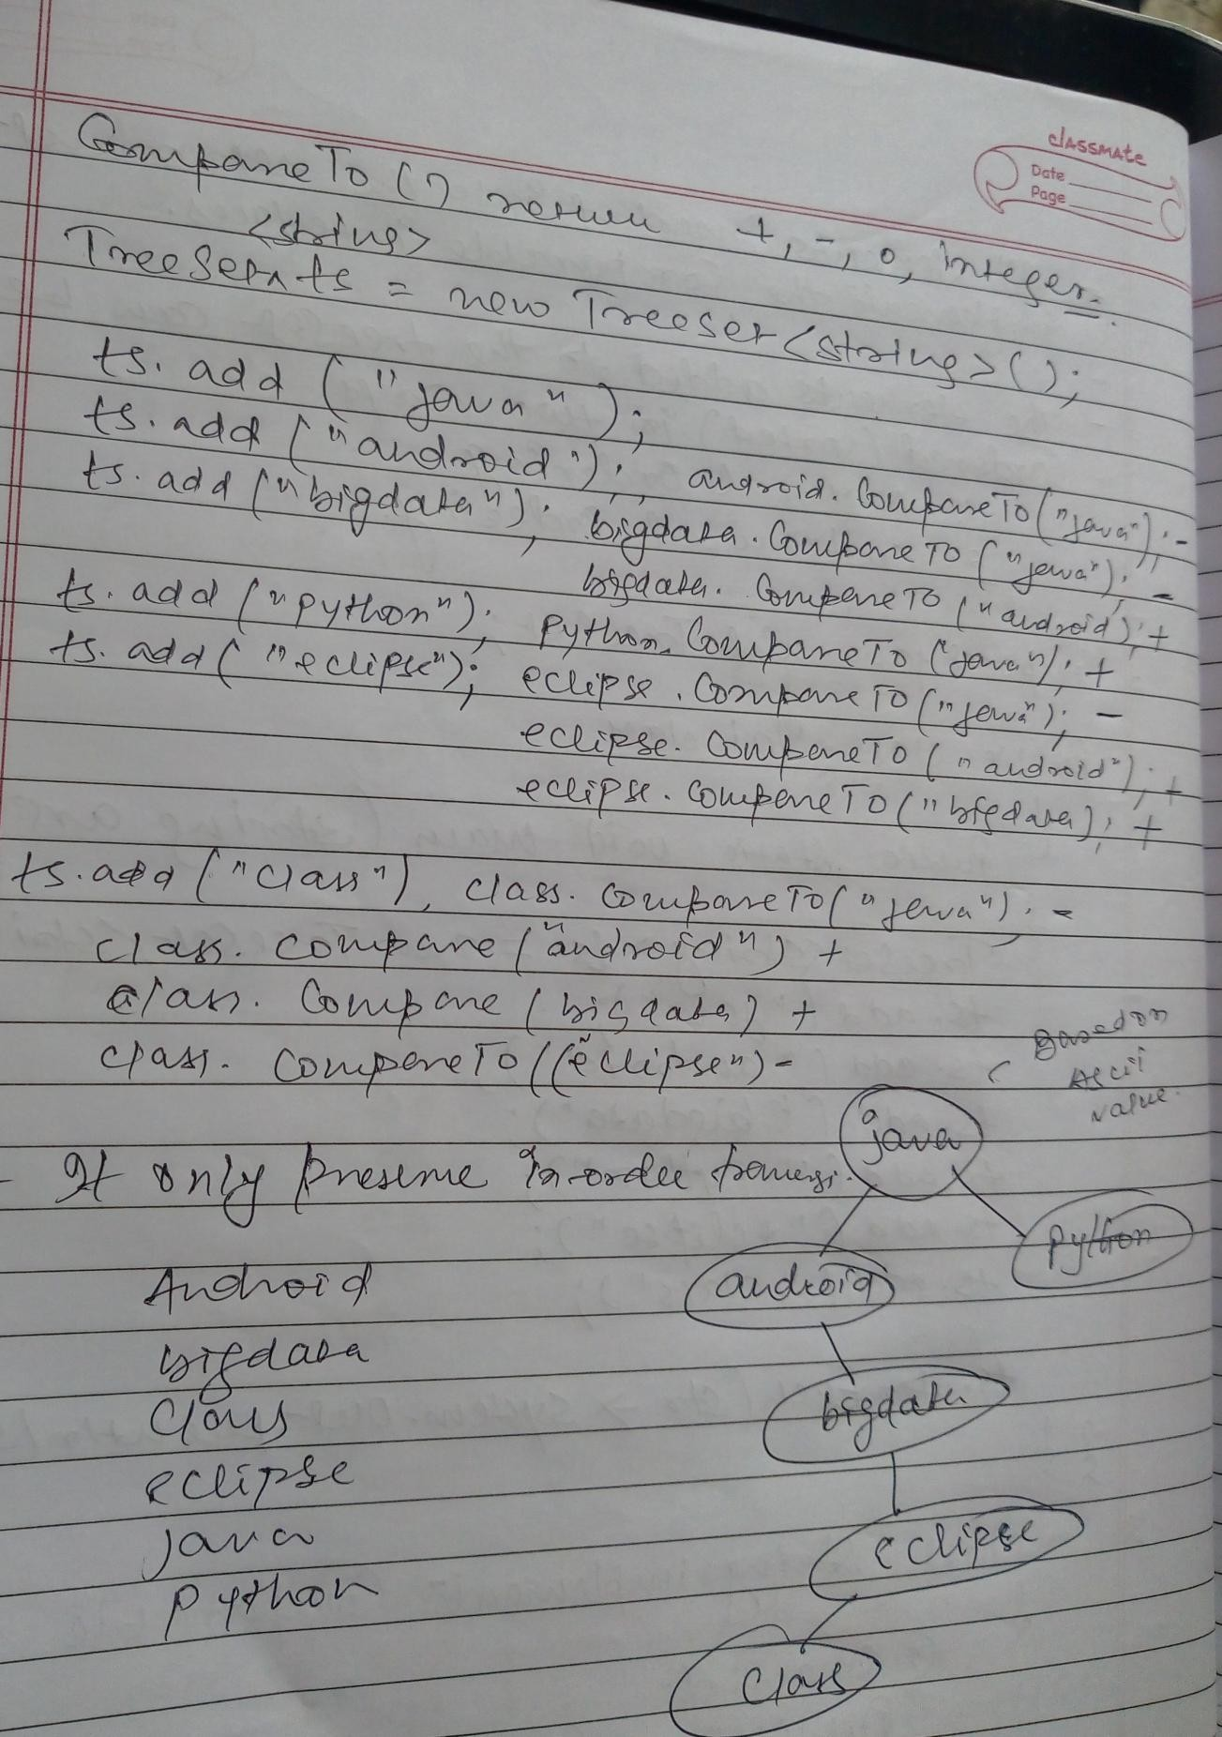

## Saving User Defined Class in TreeSet Program 1st

package com.jsp.treeset;

class Employee implements Comparable<Employee>

{

String name; int id; double sal;

Employee(String name, int id, double sal)

{ this.name=name;

this.id=id; this.sal=sal;

}

@Override

public String toString()

{

String info = name + " " +id + " "+ sal; return info;

}

## /* @Override // sorted on the base of id

public int compareTo(Employee emp) {

int val=this.id-emp.id; return val;

} */

## /*@Override // sorted on the base of salary

public int compareTo(Employee emp) { int val=(int)(this.sal-emp.sal); return val;

}*/

## @Override // sorted on the base of name

public int compareTo(Employee emp) { String n1=this.name;

String n2=emp.name;

int val = n1.compareTo(n2); return val;

}}

**2nd Program to implement it** package com.jsp.treeset; import java.util.TreeSet; public class Mainclass1

{

public static void main(String[] args) {

TreeSet<Employee> emplist = new TreeSet<Employee>(); emplist.add(new Employee ("Blake", 1234, 2341.3));

emplist.add(new Employee ("Sundar", 1274, 2346.3));

emplist.add(new Employee ("Satya", 1525, 9684.3));

emplist.add(new Employee ("Aatif", 1895, 2358.3));

emplist.add(new Employee ("aatif", 1895, 2358.3)); emplist.forEach(emp -> System.out.println(emp));

}}

## op- It returns output on the basis of sorting of name in ascending order Aatif 1895 2358.3

**Blake 1234 2341.3**

**Satya 1525 9684.3**

**Sundar 1274 2346.3**

**aatif 1895 2358.3**

**Customized Sorting**

* Sorting of inbuilt classes such as String according to programmer choice.
* Comparator interface is used for Customized Sorting.
* Comparator interface is a part of java.util. package.
* Comparator interface is a functional interface having one abstract method as compare(T o1, T o2)

## Program

package com.jsp.treeset; import java.util.Comparator; import java.util.TreeSet; public class Mainclass2 {

public static void main(String[] args) {

## // using lambda function here because Comparator is an functional interface

Comparator<String> c1= (String s1, String s2)->

{

int v1 = s2.compareTo(s1); return v1;

};

**passing the reference of interface to the constructor of TreeSet** TreeSet<String> ts = new TreeSet<String>(c1); ts.add("java");

ts.add("android");

ts.add("bigdata");

ts.add("python");

ts.add("eclipse");

ts.add("class");

ts.forEach(str -> System.out.println(str));

}}

## op – in descending order python

**java eclipse class bigdata android**

**Comparator interface**

* It is a functional interface which is used to perform customized sorting.
* If the programmer want to use customized sorting and do not want to use the natural ordering then we use comparator interface.
* Using comparator we can sort both comparable(eg. String) and non- comparable (eg, StringBuffer) object.
* Comparator contains only one abstract method by the name compare.
* compare() method returns positive number, if given object is greater than another object.
* compare() method return negative number if given object is smaller or lesser than another object.
* compare() method returns zero if given object is equal to another object or having same value.

## Use of Comparator interface in StringBuffer Program

**package** com.jsp.treeset; **import** java.util.Comparator; **import** java.util.TreeSet; **public class** Mainclass3 {

**public static void** main(String[] args) {

sb2)->

Comparator<StringBuffer> c1= (StringBuffer sb1, StringBuffer

{

String str1=sb1.toString(); String str2=sb2.toString();

**int** v1 = str1.compareTo(str2);

**return** v1;

};

TreeSet<StringBuffer> ts = **new** TreeSet<StringBuffer>(c1); ts.add(**new** StringBuffer("java"));

ts.add(**new** StringBuffer("android")); ts.add(**new** StringBuffer("bigdata")); ts.add(**new** StringBuffer("python")); ts.add(**new** StringBuffer("eclipse")); ts.add(**new** StringBuffer("class"));

ts.forEach(str -> System.***out***.println(str));

}}

## op- android bigdata class

**eclipse**

**java python**

**QUEUE TYPE OF COLLECTION**

* Duplicates are allowed.
* Index is present
* Insertion Order is preserve.
* Multiple null values are allowed.

## Duplicates are allowed Program

**package** com.ds.queuecollection; **import** java.util.LinkedList; **public class** Mainclass {

**public static void** main(String[] args) {

LinkedList<String> list = **new** LinkedList<String>(); list.add("java");

list.add("java");

list.add("java");

list.forEach(str -> System.***out***.println(str));

}}

## op- java java java

1. **Index is present Program**

**package** com.ds.queuecollection; **import** java.util.LinkedList; **public class** Mainclass {

**public static void** main(String[] args) {

LinkedList<String> list = **new** LinkedList<String>(); list.add("java");

list.add("android"); list.add("bigdata"); String a= list.get(2); System.***out***.println(a);

}}

## op- bigdata

1. **Insertion Order is preserve Program**

**package** com.ds.queuecollection; **import** java.util.LinkedList; **public class** Mainclass {

**public static void** main(String[] args) {

LinkedList<String> list = **new** LinkedList<String>(); list.add("java");

list.add("android"); list.add("bigdata");

list.forEach(str -> System.***out***.println(str));

}}

## op- java android

**bigdata**

1. Multiple Null values are allowed.

## Program

**package** com.ds.queuecollection; **import** java.util.LinkedList; **public class** Mainclass {

**public static void** main(String[] args) { LinkedList<String> list = **new** LinkedList<String>(); list.add(**null**);

list.add(**null**); list.add(**null**);

list.forEach(str -> System.***out***.println(str));

}}

## op- null null

**null**

**LinkedList Collection**

* The underline data structure for linked list collection is LinkedList data structure.
* LinkedList implements List and Queue interface.
* LinkedList can be used as a list and as well as queue.
* We can retrieve the elements from the linkedList using two method.
  1. get(index)
  2. poll()

## Constructor of LinkedList :

1. **public LinkedList()**

construct an empty list.

## public LinkedList(Collection c)

Construct a list from the given collection.

## Poll()

* It returns the head elements from the queue and also removes it from the queue.

## Peek()

* It returns head elements from the queue but doesn’t remove it from queue.

## Use of Poll method Program

**package** com.ds.queuecollection; **import** java.util.LinkedList; **public class** Mainclass {

**public static void** main(String[] args) {

LinkedList<String> list = **new** LinkedList<String>(); list.add("java");

list.add("android"); list.add("bigdata"); list.add("python"); list.add("eclipse"); list.add("class");

System.***out***.println("size ="+ list.size());

**int** s1=list.size(); // we declare list size here because if we directly use size() method inside for loop then it does not retrieve every element.

**for**(**int** i=0; i<s1;i++)

{

String s2 = list.poll(); System.***out***.println(s2);

}

System.***out***.println(“size=” +list.size());

}

}

## op- size =6 java

**android bigdata python eclipse class size =0**

**Directly using size() method inside for loop Program**

**package** com.ds.queuecollection; **import** java.util.LinkedList; **public class** Mainclass {

**public static void** main(String[] args) { LinkedList<String> list = **new** LinkedList<String>(); list.add("java");

list.add("android"); list.add("bigdata"); list.add("python"); list.add("eclipse"); list.add("class");

System.***out***.println("size ="+ list.size());

**for**(**int** i=0; i<list.size();i++)

{ String s2 = list.poll(); System.***out***.println(s2); }

System.***out***.println("size =" +list.size()); }}

## op- size =6

**java android bigdata size =3**

**Use of peek ()**

**import** java.util.LinkedList;

**public class** Mainclass {

**public static void** main(String[] args) { LinkedList<String> list = **new** LinkedList<String>(); list.add("java");

list.add("android"); list.add("bigdata");

System.***out***.println("size ="+ list.size());

**for**(**int** i=0; i<list.size();i++)

{

String s2 = list.peek(); System.***out***.println(s2); }

System.***out***.println("size =" +list.size()); }}

## size =3 java java java size =3

**Map**

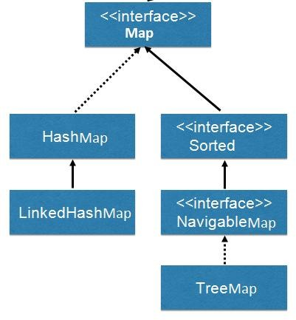

|  |  |
| --- | --- |
| key | value |
| name | phone |
| a | 1425 |
| b | 525 |
| a | 2536 |

* Within the map data is stored in key value format.
* To add the element we can use put (key, value) method and to retrieve the element we have to use get(key) method.

## Program

**package** com.ds.map; **import** java.util.HashMap; **import** java.util.Set;

**import** java.util.function.BiConsumer;

**public class** Mainclass {

**public static void** main(String[] args)

{

HashMap<String, Integer> hm1 = **new** HashMap<String, Integer>(); hm1.put("aa", 1234); // **use of put method**

hm1.put("bb", 1425);

hm1.put("cc", 4528);

hm1.put("dd", 4568);

System.***out***.println(" ");

Set <String> keys=hm1.keySet(); // **to store all keys inside a set**

**for**(String str : keys) //**using of advance for loop**

{

System.***out***.println("key ="+ str+" "+"value = "+hm1.get(str));

}}}

## op –

**key =aa value = 1234 key =bb value = 1425 key =cc value = 4528 key =dd value = 4568**

* If you pass an invalid key for get() then get() returns null values.

Program

**package** com.ds.map; **import** java.util.HashMap; **public class** Mainclass {

**public static void** main(String[] args)

{

HashMap<String, Integer> hm1 = **new** HashMap<String, Integer>(); hm1.put("aa", 1234);

hm1.put("bb", 1425);

hm1.put("cc", 4528);

hm1.put("dd", 4568); System.***out***.println(hm1.get("aaa"));

}}

## op- null

* Map do not allow duplicates. If you try to add duplicates, then the old value will be replaced with new value for the given key.

Program

package com.ds.map; import java.util.HashMap; public class Mainclass {

public static void main(String[] args)

{

HashMap<String, Integer> hm1 = new HashMap<String, Integer>(); hm1.put("aa", 1234);

hm1.put("aa", 124252); System.*out*.println(hm1.get("aa"));

}} **op – 124252**

## Map do not have an index.

**Program**

**package** com.ds.map;

**import** java.util.HashMap;

**import** java.util.function.BiConsumer;

**public class** Mainclass {

**public static void** main(String[] args)

{

HashMap<String, Integer> hm1 = **new** HashMap<String, Integer>(); hm1.put("ab", 1234);

hm1.put("bdsa", 124252);

hm1.put("ccd", 1242);

hm1.put("dd", 14252);

hm1.put("edf", 21454252);

BiConsumer<String, Integer> c1= (String key, Integer value) ->

{

System.***out***.println("key ="+ key+" "+"value = "+value);

};

hm1.forEach(c1); }}

## op - key =dd value = 14252 key =ab value = 1234 key =ccd value = 1242

**key =edf value = 21454252 key =bdsa value = 124252**

* Key can not be duplicates.
* **Values can be duplicates. import** java.util.HashMap;

**import** java.util.function.BiConsumer;

**public class** Mainclass {

**public static void** main(String[] args)

{HashMap<String, Integer> hm1 = **new** HashMap<String, Integer>(); hm1.put("ab", 1234);

hm1.put("bb", 1234);

BiConsumer<String, Integer> c1= (String key, Integer value) ->

{

System.***out***.println("key ="+ key+" "+"value = "+value);

};

hm1.forEach(c1);

}}

## op - key =bb value = 1234 key =ab value = 1234

* **null can be used as key and values both.**

Program

**package** com.ds.map;

**import** java.util.HashMap;

**import** java.util.function.BiConsumer;

**public class** Mainclass {

**public static void** main(String[] args)

{

HashMap<String, Integer> hm1 = **new** HashMap<String, Integer>(); hm1.put("a", **null**);

hm1.put(**null**,1425);

System.***out***.println(hm1.get("a")); System.***out***.println(hm1.get(**null**));

}}}

## Simple Program

**op- values = null values = 1425**

**package** com.ds.map; **import** java.util.HashMap; **import** java.util.Set;

**import** java.util.function.BiConsumer;

**public class** Mainclass {

**public static void** main(String[] args)

{

HashMap<String, Integer> hm1 = **new** HashMap<String, Integer>(); hm1.put("aa", 1234);

hm1.put("bb", 1425);

hm1.put("cc", 4528);

hm1.put("dd", 4568);

BiConsumer<String, Integer> c1= (String key, Integer value) ->

{

System.***out***.println("key ="+ key+" "+"value = "+value);

};

hm1.forEach(c1); System.***out***.println(" ");

//or we can also do like

hm1.forEach( (String key, Integer value) -> System.***out***.println("key ="+ key+" "+"value = "+value));

//or we can also do like

System.***out***.println(" ");

Set <String> keys=hm1.keySet();

**for**(String str : keys)

{

// System.out.println(hm1.get(str)); System.***out***.println("key ="+ str+" "+"value = "+hm1.get(str));

}

}

}

## op-

**key =aa value = 1234 key =bb value = 1425 key =cc value = 4528 key =dd value = 4568**

**-----------**

**key =aa value = 1234 key =bb value = 1425 key =cc value = 4528 key =dd value = 4568**

**-----------------**

**key =aa value = 1234 key =bb value = 1425 key =cc value = 4528 key =dd value = 4568**

**WRAPPER CLASSES**

* Wrapper classes are used to convert primitive to java objects.
* Wrapper classes provides many inbuilt methods to perform basic operations on the given primitive values.
* For every primitive datatype one corresponding java class is present at java.lang package.

## Boxing

* Converting a primitive value to wrapper class object using new operator is called as Boxing.

Program

**package** com.jsp.wrapperclasses;

**public class** Mainclass {

**public static void** main(String[] args) {

**int** x1=10;

**double** y1=22.13;

Integer i1=**new** ~~Integer~~(x1); // boxing Double d1=**new** ~~Double~~(y1); // boxing System.***out***.println("x1 = "+x1); System.***out***.println("i1="+i1); System.***out***.println("y1 = "+y1); System.***out***.println("d1 = "+d1);

}

}

## op –

**x1 = 10 i1=10**

**y1 = 22.13**

**d1 = 22.13**

**Auto-Boxing**

* Converting a primitive value to wrapper class object without using new operator is called auto-boxing.

## Program

**public class** Mainclass {

**public static void** main(String[] args) {

**int** x1=10;

**double** y1=22.13;

Integer i1=x1; // auto-boxing Double d1=y1; // auto-boxing System.***out***.println("x1 = "+x1); System.***out***.println("i1="+i1); System.***out***.println("y1 = "+y1); System.***out***.println("d1 = "+d1);

}}

## Unboxing

op –

## x1 = 10 i1=10

**y1 = 22.13**

**d1 = 22.13**

* Converting wrapper class object back to primitive value using value methods is called as unboxing.

## Program

**public class** Mainclass {

**public static void** main(String[] args) {

**int** x1=10;

Integer i1=x1; // auto-boxing

**int** x3=i1.intValue(); // unboxing System.***out***.println("x1 = "+x1); System.***out***.println("i1="+i1); System.***out***.println("x3 = "+x3);

}}

## op-

**x1 = 10 i1=10 x3 = 10**

**Auto-unboxing**

* Converting wrapper class object to primitive value without using value methods is called as auto-boxing.

## Program

**package** com.jsp.wrapperclasses;

**public class** Mainclass {

**public static void** main(String[] args) {

**double** y1=22.13;

Double d1=y1; // auto-boxing

Double d4=d1; // auto-unboxing without using new operator

System.***out***.println("y1 = "+y1); System.***out***.println("d1 = "+d1); System.***out***.println("d4 = "+d4);

}}

## op-

**y1 = 22.13**

**d1 = 22.13**

**d4 = 22.13**

* toString() of object class is overridden in every wrapper class which returns the value present in the given object.
* If you try to assign a primitive value to object class reference then jvm performs two operations –
  1. It creates an wrapper class object for the given primitive value (auto-boxing)
  2. The wrapper class object will be upcasted to object class reference.

## Program

**public class** Mainclass2 {

**public static void** add(Object i1, Object i2)

{

System.***out***.println("this is add method");

}

**public static void** disp(Integer i1, Integer i2)

{

System.***out***.println("this is disp()");

}

**public static void** main(String[] args) {

// Integer i1 = new Integer(10);

// Object obj=i1; // upcasting // we can also write like that

Integer in1=**new** ~~Integer~~(10); Integer in2 = **new** ~~Integer~~(20); *add*(in1,in2);

*disp*(in1,in2);

}

}

## op-

**this is add method this is disp()**

**Question : Can we store primitive values within the collection. Ans :** No, if you try to add primitive value to the collection then JVM

* creates a wrapper class object for the given primitive.
* Upcast that wrapper class object to object class references and this upcasted references will be stored within the collection.

## Program

**public class** Mainclass2 {

**public static void** disp(Integer i1, Integer i2)

{

System.***out***.println("this is disp()");

}

**public static void** main(String[] args) {

disp(10,20); **// here we pass the primitive to wrapper class**

}

## } op – this is disp()

* **Using a wrapper class we can convert given string value to primitive value with the help of parse methods.**

**Program**

**package** com.jsp.wrapperclasses;

**public class** Mainclass3 {

**public static void** main(String[] args) { String n1="100";

String n2= "200";

System.***out***.println("res = " +n1+n2);

**int** i1=Integer.*parseInt*(n1);

**int** i2 = Integer.*parseInt*(n2);

System.***out***.println("res = " +(i1+i2));

}}

## op-

**res = 100200**

**res = 300**

* **String class provides a static methods called valueOf() which converts any given primitive value to String object.**

**Program**

**package** com.jsp.wrapperclasses;

**public class** Mainclass3 {

**public static void** main(String[] args) {

**int** a = 150;

**int** b = 150;

System.***out***.println("res = " +(a+b));

String s1 = String.*valueOf*(a); String s2 = String.*valueOf*(b); System.***out***.println("res = " +s1+s2);

}

}

## op –

**res = 300**

**res = 150150**

**Thread & MultiThreading**

* Thread is an independent part of same program which gets its own stack and cpu-time for the execution.
* Threads are used to achieve program level multitasking and concurrency.
* Whenever jvm starts the execution it will create three threads.

(i) Main Thread (ii)Thread Schedular

1. Garbage collector

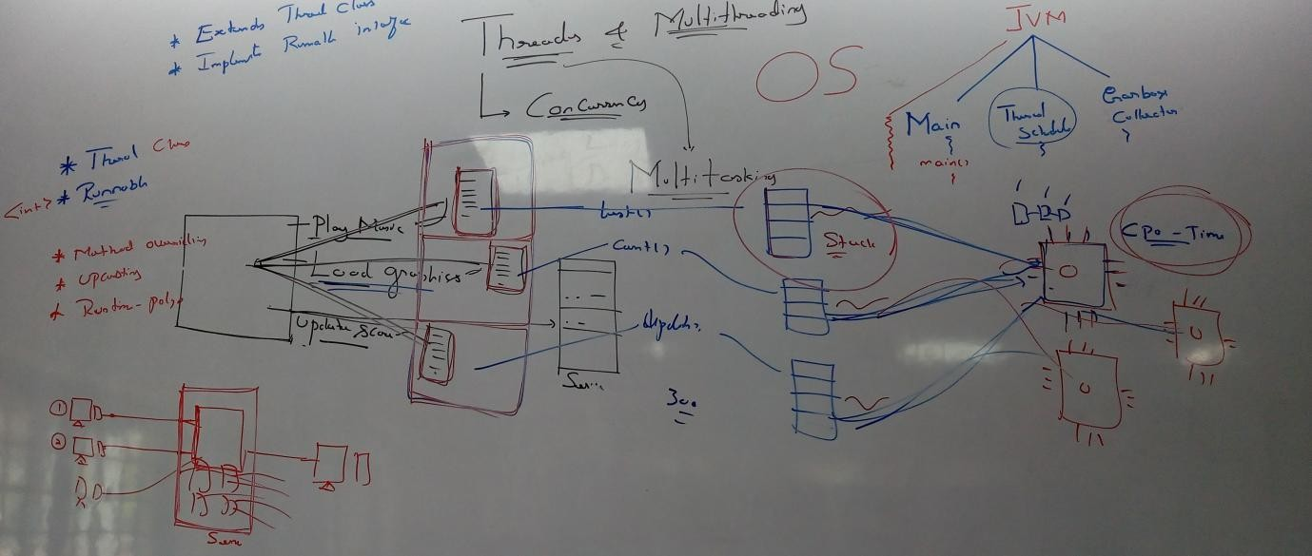

* By default all the programs in java will be executed in main thread.
* To creat threads in java, we hae two approaches.
  1. Extending thread class.
  2. implementing runnable interface.

## Extending Thread Class

* Create a class extending thread class.
* Override run method of thread class in subclass and write the business logics that has to be executed concurrently.
* create the object of subclass and using the subclass object call **Start**

method.

* If you call run method from the subclass object then you always execute all the business logics in run method within the main thread.
* Start method creats a new thread and calls run method implicitely.

## Program

**package** com.threads;

**//Create a class extending thread class. class** ThreadOne **extends** Thread

{

## //Override run method of thread class in subclass and write the business logics that has to be executed concurrently.

@Override

**public void** run() {

System.***out***.println("executing task one ");

}

}

**class** ThreadTwo **extends** Thread

{

@Override

**public void** run() {

System.***out***.println("executing task two");

}

}

**public class** Mainclass {

**public static void** main(String[] args) { System.***out***.println("Program starts");

## // create the object of subclass and using the subclass object call Start method.

ThreadOne t1 = **new** ThreadOne(); ThreadTwo t2 = **new** ThreadTwo();

t1.start(); // start method internally call run method and execute business logic t2.start();

System.***out***.println("Program end");

}}

## op –

**Program starts Program end executing task one executing task two**

**note – here output change every time, because start method provide a cpu time to every thread, in which time cpu is free the thread is executed.**

**Implementing Runnable Interface**

* Runnable is a functional interface and supports lambda function.
* create a lambda function for runnable interface.

1. create the object of thread class and pass the lambda function references to the constructor of thread class.
2. use the thread object and call start method.
3. Start method is the method of Thread class only.

## Program

**package** com.threads;

**public class** Mainclass2 {

**public static void** main(String[] args) {

System.***out***.println("program start");

## //create a lambda function for runnable interface.

Runnable r1 = () ->

{

System.***out***.println("executing task one ");

};

Runnable r2 = () ->

{

System.***out***.println("executing task two ");

};

## create the object of thread class and pass the lambda function references to the constructor of thread class.

Thread t1 = **new** Thread(r1);

t1.start(); **use the thread object and call start method.**

Thread t2 = **new** Thread(r2); t2.start(); System.***out***.println("Program end");

}}

## op –

**Program starts Program end executing task one executing task two**

**note – here output change every time, because start method provide a cpu time to every thread, in which time cpu is free the thread is executed.**

* **Question : Why runnable interface was introduced in java.**

Ans : - If a class is already extending another super class then it is not possible to extend thread class because it leads to multiple inheritance and multiple inheritance is not supported in java.

## Every Thread will have three property

* Name
* id
* priority

## Name :

* The name of the thread can be assign by the programmer to identify every thread uniquely by the programmer.

Program

**package** com.threads;

**public class** Mainclass4 {

**public static void** main(String[] args) { System.***out***.println("program start"); Runnable r1 = () ->

{

System.***out***.println("executing task one ");

};

Runnable r2 = () ->

{

System.***out***.println("executing task two ");

};

Thread t1 = **new** Thread(r1); Thread t2 = **new** Thread(r2); String t1Name = t1.getName();

System.***out***.println("t1 name default name = " +t1Name);

String t2Name = t2.getName();

System.***out***.println("t2 name default name = " +t2Name);

t1.setName("task 1 ");

String t3Name = t1.getName();

System.***out***.println("t3 name user define name = " +t3Name);

t2.setName("tast 2");

String t4Name = t2.getName();

System.***out***.println("t4 name user definmed name = " +t4Name);

}}

## Id :

t1.start();

t2.start();

## op-

**program start**

**t1 name default name = Thread-0 t2 name default name = Thread-1 t3 name user define name = task 1**

**t4 name user definmed name = tast 2 executing task one**

**executing task two**

* The id of the thread will be assigned by the thread scheduler and hence it can not be changed by the programmer.

Program

**package** com.threads;

**public class** Mainclass4 {

**public static void** main(String[] args) {

Runnable r1 = () ->

{

};

Runnable r2 = () ->

{

};

Thread t1 = **new** Thread(r1); Thread t2 = **new** Thread(r2);

**long** t1Id = t1.getId(); System.***out***.println("t1 id = " +t1Id);

**long** t2Id = t2.getId(); System.***out***.println("t2 id = " +t2Id);

t1.start();

t2.start();

}}

## op -

**t1 id = 12 t2 id = 13**

**Priority :**

* The priority of the thread helps the thread scheduler to order the execution of the threads.
* The priority of the thread can be changed by using setPriority method.
* The priority of the thread should be always within the range of 1 to 10, where 1 is the lowest priority, 5 is the normal priority and 10 is the highest priority.

Program

**package** com.threads;

**public class** Mainclass4 {

**public static void** main(String[] args) { System.***out***.println("program start");

Runnable r1 = () ->

{

System.***out***.println("executing task one ");

};

Runnable r2 = () ->

{

System.***out***.println("executing task two ");

};

Thread t1 = **new** Thread(r1); Thread t2 = **new** Thread(r2);

**int** t1P = t1.getPriority(); // default priority is 5 System.***out***.println("t1 Prioiry = " +t1P);

**int** t2P = t2.getPriority(); System.***out***.println("t2 Prioiry = " +t2P);

t2.setPriority(8); // t2 executed first t1.start();

t2.start();

}}

## op –

**program start t1 Prioiry = 5 t2 Prioiry = 5**

**executing task two executing task one**

* To Pause the execution of thread we have three methods in thread class.

1. yield()
2. sleep()
3. join()

## yield()

* yield() will pause the execution of current thread and gives the chance for another thread which is having same or higher priority.
* It is a static method calling using **Thread.yield().**
* we use when we don’t know the time.

## Program

**package** com.threads;

**public class** Mainclass4 {

**public static void** main(String[] args) { System.***out***.println("program start"); Runnable r1 = () ->

{

**Thread.*yield*(); for**(**int** i =1; i<3;i++)

{

System.***out***.println("executing task one ");

} };

Runnable r2 = () ->

{

**for**(**int** i =1; i<3;i++)

{

System.***out***.println("executing task two ");

}

};

Thread t1 = **new** Thread(r1); Thread t2 = **new** Thread(r2);

t1.start();

t2.start();

}}

## op –

**program start executing task two executing task two executing task one executing task one**

**sleep() :**

* sleep() will pause the execution of given thread for the specified time limit in millisecond and gives the chance for the other thread which is having same or higher priority.
* here in this program there is a limit of 1 second.

## Program

**package** com.threads;

**public class** Mainclass4 {

**public static void** main(String[] args) { System.***out***.println("program start"); Runnable r1 = () ->

{

## try {

}

Thread.*sleep*(1000);

**catch** (InterruptedException e)

{

e.printStackTrace();

}

**for**(**int** i =1; i<3;i++)

{

System.***out***.println("executing task one ");

}};

Runnable r2 = () ->

{

**for**(**int** i =1; i<3;i++)

{

System.***out***.println("executing task two ");

}

};

Thread t1 = **new** Thread(r1); Thread t2 = **new** Thread(r2); t1.start();

t2.start();

}}

## op –

**program start executing task two executing task two executing task one executing task one**

**join() :**

* join() will pause the execution of all threads until the given thread completes the execution.
* join() is a non static method of thread class and it should be called only from the thread object.
* join() is used after the start method.

## Program

**package** com.threads;

**public class** Mainclass4 {

**public static void** main(String[] args) { System.***out***.println("program start");

Runnable r1 = () ->

{

**for**(**int** i =1; i<3;i++)

{

System.***out***.println("executing task one ");

}

};

Runnable r2 = () ->

{

**for**(**int** i =1; i<3;i++)

{

System.***out***.println("executing task two ");

}

};

Thread t1 = **new** Thread(r1); Thread t2 = **new** Thread(r2);

t1.start();

t2.start();

## try {

}

t1.join();

**catch** (InterruptedException e) { e.printStackTrace();

}

System.***out***.println("Program end");

}}

## op - program start executing task one executing task two executing task two executing task one Program end

**output changes Race Condition**

t1

customer

print

{

}

Resource

t1

Account

t1

Bank

…..

…….

…..

……

inconsistent data

## Race Condition:

* Multiple threads tyring to access same resources at the same time is called as race condition.
* It leads data inconsistency.
* Race condition can be avoided with the help of synchronized keyword.

## Thread Synchronization:

* If a method is declared with synchronized keyword then the given method can be accessed by only one thread at any given point of time.
* Only method of the class can declared as synchronized and variable can not be declared as synchronized.
* If a thread tries to access a synchronized method then the thread aquires object lock on the given object. Once a thread acquires object lock other threads will not be able to access the same object at the same time.

t1

object lock

t2

**Program without synchronized** expected output for this question t1 = 1 t2 = 1

t2 =0 t1 = 0

Program

**package** com.threads;

**class** Count

{

**static int** *value* = 0;

**public void** intcrement()

{

*value*++; }

**public void** decrement()

{

*value*--; }

**public void** showValue()

{

System.***out***.println("value = "+*value*);

}}

**public class** Mainclass5 {

**public static void** main(String[] args) { System.***out***.println("program start"); Count c1=**new** Count();

Runnable r1 = () ->

{

c1.intcrement(); c1.showValue(); };

Runnable r2 = () ->

{

c1.decrement(); c1.showValue(); };

Thread t1 = **new** Thread(r1); Thread t2 = **new** Thread(r2); t1.start();

t2.start(); }}

## op –

**program start value = 0**

**value = 0**

**Output will be changed. But the above output is not expected Program with syncrhonized keyword**

**package** com.threads;

**class** Count

{

**static int** *value* = 0;

**public synchronized void** intcrement()

{

*value*++; }

**public void** decrement()

{

*value*--; }

**public synchronized void** showValue()

{

System.***out***.println("value = "+*value*);

}}

**public class** Mainclass5 {

**public static void** main(String[] args) { System.***out***.println("program start"); Count c1=**new** Count();

Runnable r1 = () ->

{

c1.intcrement(); c1.showValue();

};

Runnable r2 = () ->

{

c1.decrement(); c1.showValue();

};

Thread t1 = **new** Thread(r1); Thread t2 = **new** Thread(r2); t1.start();

t2.start(); }}

## op-

**program start value = 1**

**value = 0**

**Synchronized Block**

* Synchronized blocks are used to perform thread safe operations on the object which are not threadsafe.
* Synchronized blocks locks the given objects until all the codes written in the body of synchronized blocks are executed.
* Syntax :

synchronized (ref_var of object)

{

statement ;

}

## Program

**package** com.threads;

**public class** Mainclass6 {

**static** String *s1*= **new** String("hi");

**public static void** main(String[] args) { System.***out***.println("program start"); Runnable r1 = () ->

{ System.***out***.println("t1 waitingg to lock s1");

**synchronized**(*s1*)

{

System.***out***.println("t1 locked to s1");

*s1*=*s1*+"java"; System.***out***.println("s1 = "+*s1*);

}

System.***out***.println("t1 released lock on s1"); }; Runnable r2 = () ->

{

System.***out***.println("t2 waiting to lock s1");

**synchronized**(*s1*)

{

System.***out***.println("t2 locked to s1"); *s1*=*s1*+"hello"; System.***out***.println("s1 = "+*s1*);

}

System.***out***.println("t2 released lock on s1");

};

Thread t1 = **new** Thread(r1); Thread t2 = **new** Thread(r2);

t1.start(); t2.start(); }}

## Deadlock

**output program start**

**t1 waitingg to lock s1 t2 waiting to lock s1 t1 locked to s1**

**s1 = hijava**

**t1 released lock on s1 t2 locked to s1**

**s1 = hijavahello**

**t2 released lock on s1**

* Deadlock is a situation where thread one is waiting to acquire the object lock of thread two and thread two and thread two is waiting to acquire object lock on thread one and both threads wait for infinite period of time.

t1

s1

t1

s2

* Deadlock can be overcome with the help of **Interthread Communication (ITC).**
* **Interthread Communiction** can be done with the help of wait() and notify() of object class.

**Program for deadlock package** com.threads; **public class** Mainclass7 {

**static** String *s1*= **new** String("hi");

**static** String *s2*= **new** String("android");

**public static void** main(String[] args) {

System.***out***.println("program start");

Runnable r1 = () ->

{

System.***out***.println("t1 waiting to lock s1");

**synchronized**(*s1*)

{

System.***out***.println("t1 locked to s1");

System.***out***.println("t1 waiting to lock s2");

**synchronized**(*s2*)

{

System.***out***.println("t1 locked to s2"); System.***out***.println("t1 released lock on s2");

}

}

System.***out***.println("t1 released lock on s1");

};

Runnable r2 = () ->

{

System.***out***.println("t2 waiting to lock s2");

**synchronized**(*s2*)

{

System.***out***.println("t2 locked to s2");

**synchronized**(*s1*)

{

System.***out***.println("t2 locked to s1"); System.***out***.println("t2 released lock on s1");

}

}

System.***out***.println("t2 released lock on s2");

};

Thread t1 = **new** Thread(r1); Thread t2 = **new** Thread(r2);

t1.start();

t2.start();

}}

## output will be changed.

**op-**

**program start**

**t1 waiting to lock s1 t1 locked to s1**

**t1 waiting to lock s2 t2 waiting to lock s2 t2 locked to s2**

**wait() :**

* wait() will pause the execution of the thread and also releases all the object locks the given thread is holding.
* wait() can be called only from synchronized block or synchronized method.
* If you call wait() from a non-synchronized method or non-synchronized block then JVM throws **IllegalMonitorStateException**

## notify()

* notify() is used to communicate termination state of one thread to another thread.

## notifyAll()

* This methods is used to communicate the termination status of one thread to every other thread of the given programmes.

## Program

**package** com.threads;

**public class** Mainclass8 {

**static** String *s1*= **new** String("hi");

**static** String *s2*= **new** String("android");

**public static void** main(String[] args) {

System.***out***.println("program start");

//s1.wait(); // we can not call it from non-synchronized method Runnable r1 = () ->

{

System.***out***.println("t1 waiting to lock s1");

**synchronized**(*s1*)

{

System.***out***.println("t1 locked to s1");

## try {

}

System.***out***.println("t1 going to wait state ");

*s1*.wait();

**catch** (InterruptedException e)

{

e.printStackTrace();

}

System.***out***.println("t1 waiting to lock s2");

**synchronized**(*s2*)

{

System.***out***.println("t1 locked to s2"); System.***out***.println("t1 released lock on s2");

}}

System.***out***.println("t1 released lock on s1");

};

Runnable r2 = () ->

{

System.***out***.println("t2 waiting to lock s2");

**synchronized**(*s2*)

{

System.***out***.println("t2 locked to s2");

**synchronized**(*s1*)

{

System.***out***.println("t2 locked to s1"); System.***out***.println("t2 released lock on s1"); *s1*.notify();

}}

System.***out***.println("t2 released lock on s2");

};

Thread t1 = **new** Thread(r1); Thread t2 = **new** Thread(r2);

t1.start();

t2.start();

}}

## op

**program start**

**t1 waiting to lock s1 t1 locked to s1**

**t1 going to wait state t2 waiting to lock s2 t2 locked to s2**

**t2 locked to s1**

**t2 released lock on s1 t1 waiting to lock s2 t2 released lock on s2 t1 locked to s2**

**t1 released lock on s2 t1 released lock on s1**

**Differences**

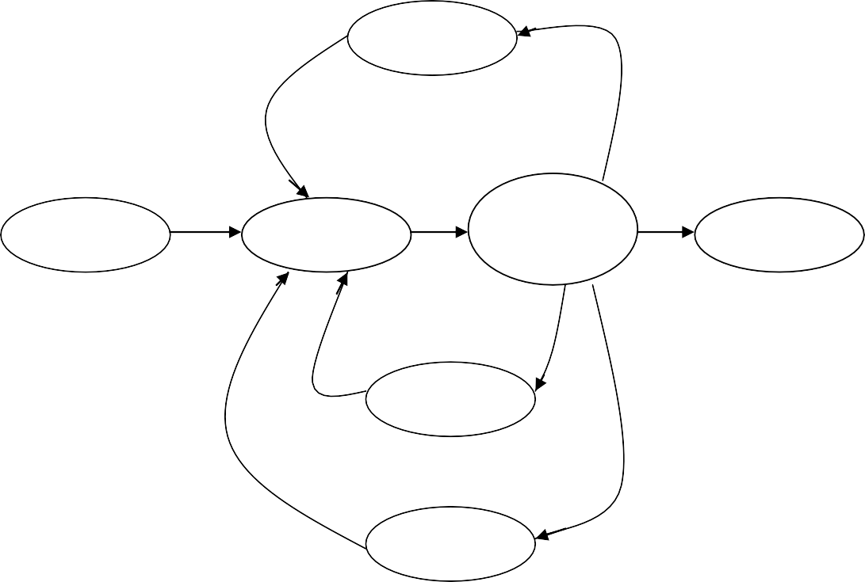

**Thread Life Cycle**

wait

new

Runnable

Running/

execution

Dead

start() run() stop()

blocked

yield() join()

sleep()

sleep

|  |  |
| --- | --- |
| **Run()** | **Sleep** |
| 1- Run() executes all the business logic written in main thread | 1- It creates a new thread and executes all the business logics  of run() in the new thread |
| 2- Run method should be overridden to write the business logics. | 2- It can be overridden but not recommended because all the business logic will be executed  in main thread. |

|  |  |
| --- | --- |
| **Sleep()** | **wait()** |
| 1- sleep() pause the execution and does not release the object lock | 1- wait() pause the execution of the thread and release the object  lock. |
| 2- it can not be used for Inter  Thread Communication | 2- It should be used for Inter  Thread Communication |
| 3- sleep() is present in thread class | 3- wait() is present in object class |

**Garbage Collector**

* Garbage collector is used to remove the unused objects which are de- referenced from the heap area.
* Garbage collector can be called explicitely by using System.gc().
* finalize() of object class will be called implicitely by the garbage collector just before the object is removed from the heap area.
* If you want to execute any lines of codes just before the object is removed from heap area, then we should override finalize of object class.
* It is always a best practice to re-initialize referenced variables to **NULL**, once the uses of object is over.
* Garbage collector only clear the de-referenced object.

**package** com.jsp.garbagecollector;

**class** Student{

String name = "Smith"; **int** id=1234; @Override

**protected void** finalize()

{

System.***out***.println("Object removed ");

}}

**public class** Mainclass {

**public static void** main(String[] args) { System.***out***.println("Program starts ");

Student s1= **new** Student(); System.***out***.println(s1.id + " "+s1.name); s1=**null**; // dereference

System.*gc*();

**for**(**int** i=1; i<=5;i++)

{

System.***out***.println(i);

}

System.***out***.println("Program ends ");

}}

## op - Program starts....

**1234 Smith**

**1**

**2**

**3**

**Object removed....**

**Program ends....**

* If we use object after calling garbage collector then it show

## java.lang.NullPointerException Program

**package** com.jsp.garbagecollector;

**class** Student{

String name = "Smith"; **int** id=1234; @Override

**protected void** finalize()

{

System.***out***.println("Object removed ");

}}

**public class** Mainclass {

**public static void** main(String[] args) { System.***out***.println("Program starts ");

Student s1= **new** Student(); System.***out***.println(s1.id + " "+s1.name); s1=**null**; // dereference

System.*gc*();

System.***out***.println(s1.id + " "+s1.name); **//returns a runtime error**

**for**(**int** i=1; i<=5;i++)

{

System.***out***.println(i);

}

System.***out***.println("Program ends ");

}}

## op-

**Program starts....**

**1234 Smith**

**Object removed....**

**Exception in thread "main" java.lang.NullPointerException**

**at com.jsp.garbagecollector.Mainclass.main(Mainclass.jav a:23)**

**File Handling**

* **File :** File is an entity which contains information.
* **Folder/Directory :** It is a container where file are stored.
* **File System :** It is a logical arrangement done by the operating system to manage files and folders.
* **File Handling :** Writing java programs to manage or create, delete, read, write etc. the files is called file handling.

## Creating a Folder Program

**import** java.io.File;

**public class** Mainclass {

**public static void** main(String[] args) {

File f1 = **new** File("G:\\JavaFile"); // create a folder

**if**(f1.exists()==**false**) // to check files is already present or not

{

}

**else**

{

}}}

f1.mkdir(); // for make directory System.***out***.println("folder created ");

System.***out***.println("folder is already exists");

## op – folder created….

**Creating a new file Program**

**import** java.io.File;

**public class** Mainclass {

**public static void** main(String[] args) {

File f1 = **new** File("G:\\JavaFile/File1.txt"); // create a file

**if**(f1.exists()==**false**) // to check files is already present or not

{

## try {

}

f1.createNewFile(); //create the file System.***out***.println("file created");

**catch** (IOException e) { e.printStackTrace();

}

}

**else**

{

}}}

System.***out***.println("folder is already exists");

## op- file created

**Write the data to file** import java.io.FileWriter; import java.io.IOException; public class Mainclass3 {

public static void main(String[] args) { String path = "G:\\JavaFile/File1.txt"; FileWriter fw=null;

try {

fw = new FileWriter(path); fw.write("this is file handling classes");

## fw.flush(); // without this method file is not write inside a file

System.out.println("writing data completed ");

}

catch (IOException e) {

System.out.println("error in writing data to file "); e.printStackTrace();

}

finally //these blocks executed even exception is occured or not

{ //used to execute the code irrespective of occurance of exception try {

fw.close();

}

catch (IOException e)

{

}}}

e.printStackTrace();

}

## op- writing data completed....

**Reading data from file Program**

import java.io.File; import java.io.FileReader;

import java.io.IOException; public class Mainclass4 {

public static void main(String[] args) {

String path = "G:\\JavaFile/File1.txt"; File f1 = new File(path);

FileReader fr=null; try {

fr = new FileReader(path);

int size = (int) f1.length(); // return long char [] c1 = new char [size]; fr.read(c1);

System.out.println(c1); System.out.println("reading data completed ");

}

catch (IOException e) {

System.out.println("error in reading data to file "); e.printStackTrace();

}

finally //these blocks executed even exception is occured or not

{ //used to execute the code irrespective of occurance of exception try {

fr.close();

}

catch (IOException e)

{

e.printStackTrace();

}

}

}}

## op-

**this is file handling classes reading data completed....**

**File Class**

* The file class allows the user to create files and folders in the system.

## Methods of File Class

1. **mkdir() –** make directory - This method creates a new folder of directory in the specified location.
2. **exists() –** This method checks if the given file or folder is present in the specified location and returns true, if the file or folder already exists, else it return false.
3. **createNewFile() –** This method creates a new file at the specified location.
4. **length() –** This method returns number of characters present in the given file. The return type of this method is long.

## FileWriter class

* FileWriter helps the programmer to write the data to the file specified in the location.

## Method of FileWriter

1. **write ()** – This methods writes all the data with the output stream.
2. **flush()** – This method writes all the data from the stream to the gien file.

**Note :** The stream should be closed by the programmer explicitely by using **close()** methods. It always a good practice to call close methods of the stream within the finally blocks.

## FileReader class

* FileReader reads the data from the file one character at a time.

## Methods of FileReader

(i) **read()** – The read() reads one character at a time and stores it within the given character array.

To pass the character Array we have to create a character array matching the number of characters present in given file.

## Finally block :

* It is a block of code which will be executed irrespective of occurance of exception, means exception occurred or not occurred.
* Finally block should be always written after catch block.

Serialization

* The process of converting into java object into stream of byte is known as serialization.

Jvm Hard Disk

fout

o/p and byte

Heap

E1

object

F1

## There are two types of Stream :

* InputStream
* OutputStream

## There are two types of value present

* Char stream
* Byte stream

## Steps to Achieve Serialization

1. Establish the o/p and byte stream using FileOutputStream class.
2. Create an object for ObjectOutputStream for converting java object into byte stream.
3. Invoke writeObject method.
4. Close the connection which is written in finally block.

## Program

//serialization

**package** com.jsp.file_handling;

**import** java.io.File;

**import** java.io.FileOutputStream; **import** java.io.IOException; **import** java.io.ObjectOutputStream; **import** java.io.Serializable;

**class** Employee **implements** Serializable

{

**int** id;

String name;

**public** Employee(**int** id, String name)

{

**super**(); **this**.id=id; **this**.name=name;

}}

**public class** Mainclass5 {

**public static void** main (String ar[])

{

Employee e1 = **new** Employee(123,"Abc"); FileOutputStream fout=**null**;

File f1 = **new** File ("G:\\JavaFile/emp.ser"); // extension for serializable file = ser

## try {

f1.createNewFile();

fout=**new** FileOutputStream(f1); // creating output byte stream ObjectOutputStream out = **new** ObjectOutputStream(fout); // object stream out.writeObject(e1); // used to convert java object into stream of bytes and make it to transfer0

System.***out***.println("Object written");

}

**catch** (IOException e) {

e.printStackTrace();

}

**finally**

{

## try {

fout.close();

} **catch** (IOException e) {

e.printStackTrace();

}}}}

## Op –

**Object written**

**Deserilization**

Jvm Hard Disk

fin

i/p and byte

Heap

E1

object

Emp.ser

## Constructor also throws an exception Steps to Achieve Serialization

1. Establish the input & byte stream.
2. Create an object for object inputStream.
3. Invoke read object method.
4. Close the connection.

## Use of Marker interface

* To make class eligible for any operation such as serializable, clonable is a marker interface which helps class to perform serialization.

## Program

//De-serialization

**package** com.jsp.file_handling;

**import** java.io.File;

**import** java.io.FileInputStream; **import** java.io.IOException; **import** java.io.ObjectInputStream; **import** java.io.Serializable;

**class** Employee **implements** Serializable

{

**int** id; String name;

**public** Employee(**int** id, String name)

{

**super**(); **this**.id=id; **this**.name=name;

}

}

**public class** Mainclass6 {

**public static void** main (String ar[])

{

File f1 = **new** File ("G:\\JavaFile/emp.ser"); // extension for serializable file = ser

FileInputStream fin=**null**;

**try**

{

fin=**new** FileInputStream(f1);

ObjectInputStream in = **new** ObjectInputStream(fin); // object stream Object ob=in.readObject();

Employee e = (Employee)ob; System.***out***.println(e.id); System.***out***.println(e.name);

}

**catch** (Exception e)

{

e.printStackTrace();

}

**finally**

{

## try {

fin.close();

} **catch** (IOException e) {

}}}}

e.printStackTrace();

## Op - 123

**Abc**

**Object Cloning**

* Creating an object from an existing object with the same data is called as object cloning.
* If you want to clone an object then the class should implements clonable interface(which is market interface).
* You should also override clone method of object class to perform cloning.

## Copying all the data from exisiting object to cloned object is called as deep-copying.

**Program**

**package** com.jsp.clone;

**class** Emp **extends** Object **implements** Cloneable

{ String name;

**int** id;

Double salary;

Emp(String name, **int** id, Double salary){

**this**.name=name; **this**.id=id; **this**.salary=salary;

}

@Override

**public** String toString()

{

String info = id+ " "+name+ " "+salary;

**return** info; } @Override

**protected** Object clone() **throws** CloneNotSupportedException {

**return super**.clone();

}}

**public class** Mainclass2 {

**public static void** main (String ar[])

{

Emp e1 = **new** Emp("Blake", 123, 2314.14); System.***out***.println("Hashcode =" +e1.hashCode()); System.***out***.println(e1);

**try**

{

Emp e2 = (Emp) e1.clone(); System.***out***.println("Hashcode = " +e2.hashCode()); System.***out***.println(e2);

}

**catch** (CloneNotSupportedException e)

{

}}}

e.printStackTrace();

## Op-

**Hashcode =792791759**

**123 Blake 2314.14**

**Hashcode = 434176574**

**123 Blake 2314.14**

- **Copying only required data from the existing object to cloned object is called as shallow copying.**

**Program**

**package** com.jsp.clone;

**class** Emp **extends** Object **implements** Cloneable

{

String name;

**int** id;

Double salary;

Emp(String name, **int** id, Double salary){

**this**.name=name; **this**.id=id; **this**.salary=salary;

}

@Override

**public** String toString()

{

String info = id+ " "+name+ " "+salary;

**return** info;

}

@Override

**protected** Object clone() **throws** CloneNotSupportedException

{

Emp emp = **new** Emp (name, 0, salary);

**return** emp;

}

}

**public class** Mainclass2 {

**public static void** main (String ar[])

{

Emp e1 = **new** Emp("Blake", 123, 2314.14); System.***out***.println("Hashcode =" +e1.hashCode()); System.***out***.println(e1);

**try**

{

Emp e2 = (Emp) e1.clone(); System.***out***.println("Hashcode = " +e2.hashCode()); System.***out***.println(e2);

}

**catch** (CloneNotSupportedException e)

{

}}}

e.printStackTrace();

## Op-

**Hashcode =792791759**

**123 Blake 2314.14**

**Hashcode = 434176574**

**0 Blake 2314.14**

- If you try to clone an object using clone method without implementing clonable interface then JVM throws cloneNotSupportedException.

## Program

**package** com.jsp.clone;

## class Emp extends Object // here we not implement clonable interface

{

String name;

**int** id;

Double salary;

Emp(String name, **int** id, Double salary){

**this**.name=name; **this**.id=id; **this**.salary=salary;

}

@Override

**public** String toString()

{

String info = id+ " "+name+ " "+salary;

**return** info; }

@Override

**protected** Object clone() **throws** CloneNotSupportedException {

**return super**.clone();

}}

**public class** Mainclass2 {

**public static void** main (String ar[])

{

Emp e1 = **new** Emp("Blake", 123, 2314.14); System.***out***.println("Hashcode =" +e1.hashCode()); System.***out***.println(e1);

**try**

{

Emp e2 = (Emp) e1.clone(); System.***out***.println("Hashcode = " +e2.hashCode()); System.***out***.println(e2);

}

**catch** (CloneNotSupportedException e)

{

Op-

}}}

e.printStackTrace();

## Hashcode =792791759

**123 Blake 2314.14**

**java.lang.CloneNotSupportedException: com.jsp.clone.Emp**

**at java.base/java.lang.Object.clone(Native Method)**

**at com.jsp.clone.Emp.clone(Mainclass2.java:23) at**

**com.jsp.clone.Mainclass2.main(Mainclass2.java:35)**

- Clonable is a market interface which is used to mark the permission as the object can be cloned by JVM.

**Normal Program package** com.jsp.clone;

**class** Emp **extends** Object **implements** Cloneable

{

String name;

**int** id;

Double salary;

Emp(String name, **int** id, Double salary)

{

**this**.name=name; **this**.id=id; **this**.salary=salary;

}

@Override

**public** String toString()

{

String info = id+ " "+name+ " "+salary;

**return** info;

}

@Override

**protected** Object clone() **throws** CloneNotSupportedException {

**return super**.clone();

}}

**public class** Mainclass2 {

**public static void** main (String ar[])

{

Emp e1 = **new** Emp("Blake", 123, 2314.14); System.***out***.println("Hashcode =" +e1.hashCode()); System.***out***.println(e1);

**try**

{

Emp e2 = (Emp) e1.clone(); System.***out***.println("Hashcode = " +e2.hashCode()); System.***out***.println(e2);

}

**catch** (CloneNotSupportedException e)

{

}}}

* 1. rintStackTrace();

## Op –

**Hashcode =792791759**

**123 Blake 2314.14**

**Hashcode = 434176574**

**123 Blake 2314.14**

**Class.forName()**

**Note :**

* In java static block load before the main method.
* If any block declare with static is known as static block
* If any block declare without any static keyword is known as non-static block

Syntax :

Static

{ }

## Program

**package** classfornam;

**public class** Mainclass3 {

**static**

{

System.***out***.println("this is static block ");

}

**public static void** main(String[] args)

{ System.***out***.println("Program start"); System.***out***.println("Program end"); }}

## Output

**this is static block Program start Program end**

**Program : refer to any static members of class**

**package** classfornam;

**public class** Mainclass3 { **static int** *a* = 10; **static**

{

System.***out***.println("this is static block ");

}

**public static void** main(String[] args)

{

System.***out***.println(*a*); System.***out***.println("Program start"); System.***out***.println("Program end");

}}

## this is non-static block 10

**Program start Program end**

**Another Program for static block**

**package** classfornam;

**public class** Mainclass3 {

**static**

{

}

System.***out***.println("this is static block-1 ");

**public static void** main(String[] args)

{

}

**static**

{

}

}

## Op

System.***out***.println("Program start"); System.***out***.println("Program end");

System.***out***.println("this is static block 2");

## this is static block-1 this is static block 2 Program start

**Program end**

* If any block is non-static block then we can call the non-static block only by creating the object of that class.

## Program

**package** classfornam;

**public class** Mainclass3 {

{

System.***out***.println("this is non-static block ");

}

**public static void** main(String[] args)

{ Mainclass3 m = **new** Mainclass3(); System.***out***.println("Program start"); System.***out***.println("Program end");

}}

## this is non-static block Program start

**Program end**

* If in a class there is non-static block and static block both present, and non-static block comes before the static block, in this case also static block executed first.

## Program

**package** classfornam;

**public class** Mainclass3 {

{

}

**static**

{

}

System.***out***.println("this is non-static block ");

System.***out***.println("this is static block-1 ");

**public static void** main(String[] args)

{

}

**static**

{

}

}

Mainclass3 m = **new** Mainclass3(); // for calling non-static block System.***out***.println("Program start"); System.***out***.println("Program end");

System.***out***.println("this is static block 2");

## Op –

**this is static block-1 this is static block 2 this is non-static block Program start**

**Program end**

* The .class file of the program will be loaded to the memory in two cases :
  + 1. If you create the object of class.
    2. Refer to any static members of class.
* We can load the .class file to the memory explicitely by using class.forName()
* If the constructor of the class is private and there is no static data members and methods present in the class, then to create the object of the class in another class is not possible, due to private constructor, and in this case if we want to create the object it throw a compile time error. then in this case we have to use Class.forName().

## Class.forName()

* For this method we have to pass fully qualified classname as the arguments in string data type.

Class loads

* create the object
* refer to any static members Of class.

Demo.class

**package** classfornam;

**class** Sample1

{

Static block Once class load will be executed

**private** Sample1()

{

}

**static**

{

System.***out***.println("this is static block");

}}

**public class** Mainclass3 {

**public static void** main(String[] args)

{

System.***out***.println("Program start");

## try {

Class.*forName*("classfornam.Sample1");

}

**catch** (ClassNotFoundException e) { e.printStackTrace();

}

System.***out***.println("Program end");

}}

## Program start

**this is static block Program end**

* If the given class is not present in the given package, then this method will throw **ClassNotFoundException.**

## Program

**package** classfornam;

**class** Sample1

{ **private** Sample1()

{

}

**static**

{

System.***out***.println("this is static block");

}}

**public class** Mainclass3 {

**public static void** main(String[] args)

{

}}

## Op-

System.***out***.println("Program start");

## try {

Class.*forName*("classfornam.Sample2"); // class name is different

}

**catch** (ClassNotFoundException e) { e.printStackTrace(); }

System.***out***.println("Program end");

## Program start

**java.lang.ClassNotFoundException: classfornam.Sample2 at**

**java.base/jdk.internal.loader.BuiltinClassLoader.load Class(Unknown Source)**

**at java.base/jdk.internal.loader.ClassLoaders$AppClassLo ader.loadClass(Unknown Source)**

**at java.base/java.lang.ClassLoader.loadClass(Unknown Source)**

**at java.base/java.lang.Class.forName0(Native Method)**

**at java.base/java.lang.Class.forName(Unknown Source)**

**at classfornam.Mainclass3.main(Mainclass3.java:18) Program end**

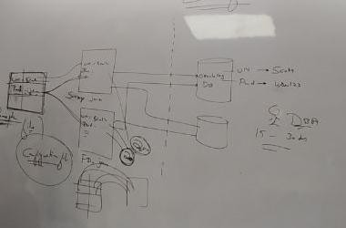**Properties File**

* Properties file is a type of the file where the data is stored in key value format.
* We can write the data to properties file using setProperty().

## Program

**public static void** createProp() // to create properties file

{

Properties p1 = **new** Properties(); p1.setProperty("username", "scott"); p1.setProperty("Password","tiger"); String path = "G:\\JavaFile/DB.prop"; FileOutputStream fos;

## try {

fos = **new** FileOutputStream(path); p1.store(fos, "Oracle 10g details"); System.***out***.println("File created ");

}

* Once the data is set, we can store the key and value to the properties file by using store()

## Program

fos = **new** FileOutputStream(path); p1.store(fos, "Oracle 10g details");

* To read the data from the properties file we can use load().

## Program

FileInputStream fis = **new** FileInputStream(path); p1.load(fis);

* To load() creates a temporary hashtable and copies all the key, values, from properties file to hashtable.
* We can get the values from the hashtable using getProperty() by passing valid keys.

## Program

**public static void** readProp() // to read properties file

{

String path = "G:\\JavaFile/DB.prop"; Properties p1 = **new** Properties();

## try {

FileInputStream fis = **new** FileInputStream(path); p1.load(fis);

String us=p1.getProperty("username"); String pwd = p1.getProperty("Password"); System.***out***.println(us); System.***out***.println(pwd);

}

**catch** (Exception e) { e.printStackTrace();

}

}

## Program

//properties file nothing but hashtable

**package** classfornam;

**import** java.io.FileInputStream; **import** java.io.FileOutputStream; **import** java.util.Properties; **public class** Mainclass2 {

**public static void** createProp() // to create properties file

{

Properties p1 = **new** Properties(); p1.setProperty("username", "scott"); p1.setProperty("Password","tiger"); String path = "G:\\JavaFile/DB.prop"; FileOutputStream fos;

## try {

fos = **new** FileOutputStream(path); p1.store(fos, "Oracle 10g details"); System.***out***.println("File created ");

}

**catch** (Exception e) {

e.printStackTrace();

}

}

**public static void** readProp() // to read properties file

{

String path = "G:\\JavaFile/DB.prop"; Properties p1 = **new** Properties();

## try {

FileInputStream fis = **new** FileInputStream(path); p1.load(fis);

String us=p1.getProperty("username"); String pwd = p1.getProperty("Password"); System.***out***.println(us); System.***out***.println(pwd);

}

**catch** (Exception e) { e.printStackTrace();

}

}

**public static void** main(String ar[])

{

System.***out***.println("program start");

// createProp();

*readProp*(); System.***out***.println("Program end ");

}

}

## Op-

**program start scott user123 Program end**

**Singleton Class**

* A class for which we can create only one single object is called as singleton clas.
* To create a singleton class, we have to follow two steps :

## Declare the constructors of the class as private.

**Program private** Demo()

{

System.***out***.println("Object created");

}

## Create a public static method which returns address of same objects.

Program

**public static** Demo getObject()

{

**if**(*ref*==**null**)

{

Demo ref = **new** Demo();

}

**return** *ref*;

}

Simple Program

**package** com.jsp.singletonclass;

**class** Demo

{

**static** Demo *ref* = **null**; **private** Demo()

{

System.***out***.println("Object created");

}

**public static** Demo getObject()

{

**if**(*ref*==**null**)

{

ref = **new** Demo();

}

**return** *ref*;

}

}

**public class** Mainclass {

**public static void** main(String[] args) {

Demo d1 = Demo.*getObject*(); System.***out***.println("d1 = "+d1);

Demo d2= Demo.*getObject*(); System.***out***.println("d2 = "+d2);

}

}

Op –

## Object created

**d1 = com.jsp.singletonclass.Demo@2f410acf d2 = com.jsp.singletonclass.Demo@2f410acf**

**Factory Method**

* A method which returns object of same class using which it is called is known as factory methods.

Eg : **Demo d1 = Demo.*getObject*(); What is the use of Singelton Class**

* In the case of thread, every interface can be created the object of class, so in this case, there will be a chance of multiple resources, so here no race condition will be occurred. To create a race condition, we can use singleton class.

## Program

**package** com.jsp.singletonclass;

**class** Count

{

**static int** *value* = 0; **static** Count *ref* = **null**; **private** Count()

{

System.***out***.println("Object created");

}

**public static** Count getObject()

{

**if**(*ref*==**null**)

{

*ref*=**new** Count();

}

**return** *ref*;

}

**public void** intcrement()

{

*value*++;

}

**public void** decrement()

{

*value*--;

}

**public void** showValue()

{

System.***out***.println("value = "+*value*);

}

}

**public class** Mainclass2 {

**public static void** main(String[] args) { System.***out***.println("program start"); Runnable r1 = () ->

{

Count c1 = Count.*getObject*(); c1.intcrement(); c1.showValue();

};

Runnable r2 = () ->

{

Count c1 = Count.*getObject*(); c1.decrement(); c1.showValue();

};

Thread t1 = **new** Thread(r1); Thread t2 = **new** Thread(r2);

t1.start();

t2.start();

}}

## Op

**program start Object created value = 1**

**value = 0**

**output will be changed.**

**EXTRA TOPICS**

**BLOCKS IN JAVA**

**Initialization of Datamembers in java :**

1. At declaration
2. Using blocks
3. Using Constructors

## Blocks

* Set of statements enclosed within curly braces without any declaration is known as blocks.
* There are two types of blocks
  1. Static block
  2. Non-static bloc

## Flow of JVM

1. Load
2. Initialize
   1. Declaration
   2. Block
   3. Constructor – non static
   4. Execute

## Static block

* The blocks declared with static key word are known as static blocks.
* Static blocks are used to initialized only static data members of the class not, not non-static methods.
* Within the class if both main method and static blocks are present first static blocks are executed then main method.

**Program package** practice; **class** Demo

{

## static double *b* ;

**static**

{ *b* = 3.2;

System.***out***.println("executing static block");

}

**public static void** main(String[] args)

{ System.***out***.println("main method started..."); System.***out***.println("b= "+Demo.*b*); System.***out***.println("Main method end"); }}

## Op-

**executing static block main method started... b= 3.2**

**Main method end**

* Static blocks get executed at class loading time.
* Static blocks get executed only once per class.
* Within a same class first static block are executed when the class loading then main() executed.

## But for a different class class, first main() executed then static block get executed at time of class loading.

**Program**

**package** practice;

**class** Abc_1

{

## static double *b* ;

**static**

{

*b* = 3.2;

System.***out***.println("executing static block");

}

}

**class** Demo

{

**public static void** main(String[] args)

{

}}

Op-

System.***out***.println("main method started..."); System.***out***.println("b= "+Abc_1.*b*); System.***out***.println("Main method end");

## main method started... executing static block b= 3.2

**Main method end**

**Multiple Static blocks within a Class:**

Program **package** practice; **class** Demo

{

**static char** *ch* ;

**static**

{

}

**static**

{

}

*ch* ='a';

System.***out***.println("executing static block-1");

*ch* ='b';

System.***out***.println("executing static block-2");

**public static void** main(String[] args)

{

}

**static**

{

}

}

System.***out***.println("main method started..."); System.***out***.println("ch= "+*ch*); System.***out***.println("Main method end");

*ch* = 'c';

System.***out***.println("executing of static block 3");

## Op-

**executing static block-1 executing static block-2 main method started... ch= b**

**Main method end**

* With static block JVM can access blocks before main methods.

## Non-static Block

* The blocks which are declared without static keyword is known as non- static block.

Syntax

{

}

* It can be initialized both static members as well as non-static members of the class.

## Non-static block can be executed only at the time of object creation.

**Program package** practice; **class** Demo

{

## static int *a*;

**double** b;

{

*a*=133; b=7.6;

System.***out***.println("executing non-static block-1");

}

**public static void** main(String[] args)

{

System.***out***.println("main method started..."); System.***out***.println("a = "+*a*);

Demo d = **new** Demo();

System.***out***.println("after object creation, a = "+*a*); System.***out***.println("b = "+d.b);

System.***out***.println("Main method ended");

}}

## Op –

**main method started... a = 0**

**executing non-static block-1 after object creation, a = 133 b = 7.6**

**Main method ended**

* Without ‘new’ operator non static blocks can not be executed.
* Without creating object non static can not be executed.

**Program package** practice; **class** Demo

{

## static int *a*;

**double** b;

{

*a*=133; b=7.6;

System.***out***.println("executing non-static block-1");

}

**public static void** main(String[] args)

{

System.***out***.println("main method started..."); System.***out***.println("a = "+*a*); System.***out***.println("Main method ended");

}

}

## Op-

**main method started... a = 0**

**Main method end**

* Non-static blocks get executed multiple times depending upon no. of object creation.

**package** practice;

**class** Demo

{

{

System.***out***.println("executing non-static block-1");

}

{

System.***out***.println("executed non-static block-2");

}

**public static void** main(String[] args)

{

System.***out***.println("main method started...");

Demo d = **new** Demo(); Demo d1 = **new** Demo();

System.***out***.println("Main method ended");

}}

## Op –

**main method started... executing non-static block-1 executed non-static block-2 executing non-static block-1 executed non-static block-2 Main method ended**

* **Non-static block executed before constructor executed.**

**Program package** practice; **class** Demo

{

**public** Demo()

{

System.***out***.println("this is const");

}

{

System.***out***.println("executing non-static block-1");

}

**public static void** main(String[] args)

{

System.***out***.println("main method started..."); Demo d = **new** Demo(); System.***out***.println("Main method ended");

}

}

## Op-

**main method started... executing non-static block-1 this is const**

**Main method ended**

